Online UPS household energy storage power supply product specification

ES-10000A/B/C

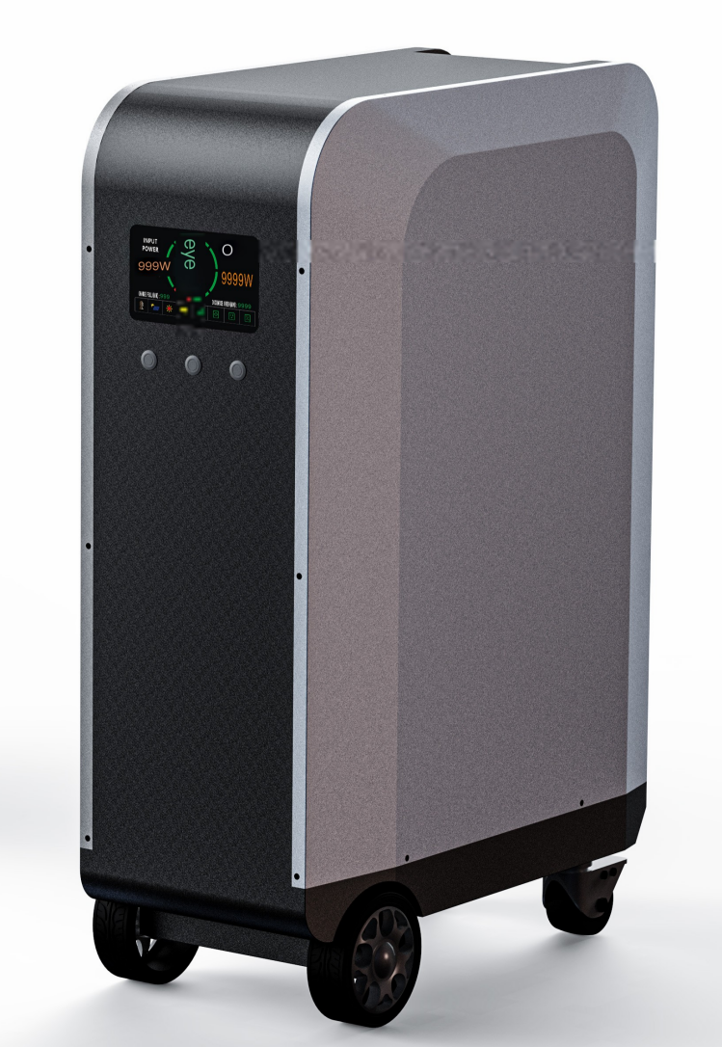

1、Overview:
ES-10000 series, our company's latest online UPS household energy storage power supply, adopts sheet metal baking process, lightweight and portable,
stylish and elegant appearance, using power type lithium iron phosphate batteries as energy storage to provide continuous power for the host.
This product is a dedicated online UPS household energy storage power supply designed for areas with power shortages, unstable grid voltage, frequent power outages, and high precision equipment requirements.
The product is designed with ultra wide voltage input and automatic voltage regulation output to ensure stable load operation. The product is designed for zero second switching, ensuring that the load will not shut down due to power outages during use. Can meet 100% of the power outage needs of all electrical equipment! The product comes with a stable frequency function, which ensures that electrical appliances will not be burned out due to low or high frequency when carrying inductive loads.
This design, applied in energy storage systems, can solve the problems of unstable grid voltage, frequent power outages, and easy damage to electrical appliances during household use. Both mains power and solar energy charge the energy storage simultaneously, ensuring that the equipment can operate for a long time. Solved the problem of electricity consumption in people's daily life, it is a product that truly benefits humanity and is also a necessary product!

2、 Appearance display:
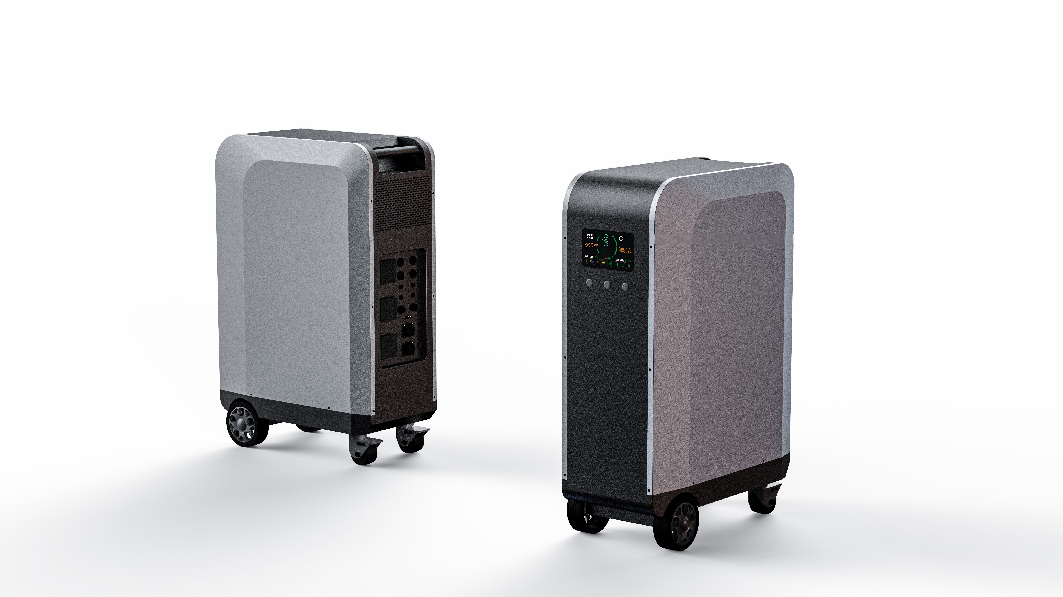
3、Function display:
Front Panel Control
Rear panel output
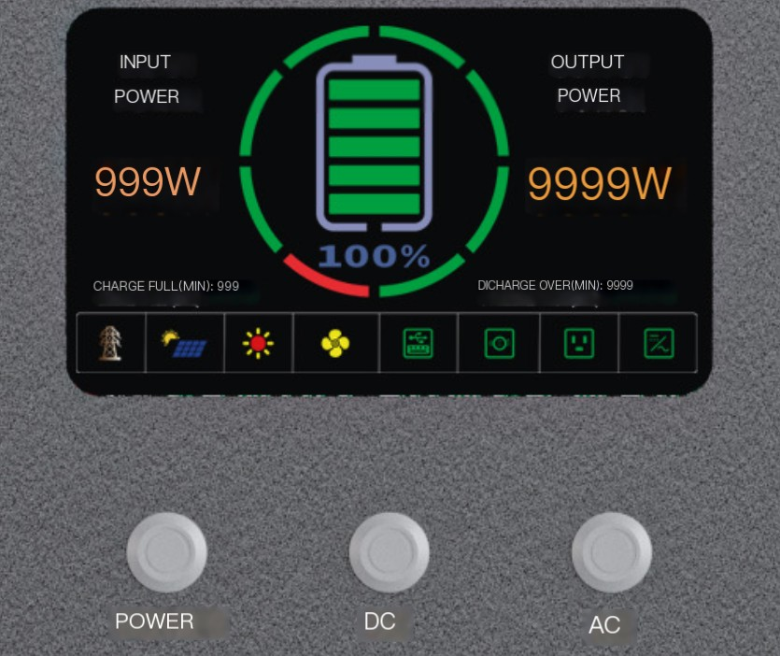
AC inverter output touch switch
System startup touch switch
7-inch display screen of the device
DC output tactile switch

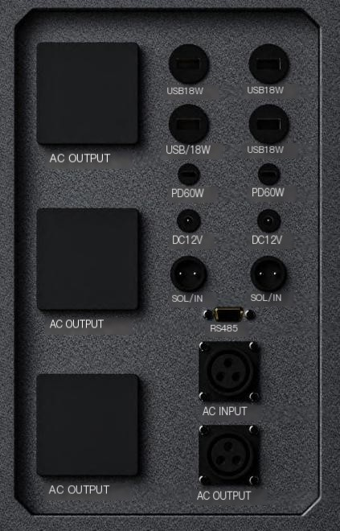
Inverter AC output socket 16A
Inverter AC output socket 16A
Four USB-A ports with 18W independent output
Two PD60W independent outputs
Two parallel 12V 100W outputs
Two way solar input interface GX-20
Communication high-power input interface 50A
Inverter AC high-power output interface 50A
Inverter AC output socket 32A
RS485 communication output

4、Power parameters:
Name | Parameter | Unit | Product model
AC Input |  |  | ES-10000A | ES-10000B | ES-10000C
AC Input | Input Voltage | V/AC | AC85V-310V | AC85V-310V | AC85V-310V
AC Input | Input frequency | HZ | 30-100HZ | 30-100HZ | 30-100HZ
AC Input | Input voltage to efficiency ratio | AC/85V | 75% | 75% | 75%
AC Input | Input voltage to efficiency ratio | AC/95V | 85% | 85% | 85%
AC Input | Input voltage to efficiency ratio | AC/110V | 90% | 90% | 90%
AC Input | Input voltage to efficiency ratio | AC/130V | 95% | 95% | 95%
AC Input | Input voltage to efficiency ratio | AC/310V | 98% | 98% | 98%
AC Input | Input power factor | 1 | 0.99 | 0.99 | 0.99
AC Input | Power on mode |  | Soft start mode | Soft start mode | Soft start mode
AC Input | Under voltage protect | AC | 80V | 80V | 80V
AC Input | Over voltage protect | AC | 320V | 320V | 320V
AC Input | Input temperature Protection | ℃ | 85℃ | 85℃ | 85℃
AC Input | Input overload protection | W | 12800W | 12800W | 12800W
AC Charging | Charging input voltage range | V/AC | AC85V-310V | AC85V-310V | AC85V-310V
AC Charging | Charging input frequency | HZ | 30-100HZ | 30-100HZ | 30-100HZ
AC Charging | Charge efficiency | % | 95% | 95% | 95%
AC Charging | charging power | W | 2800W | 2800W | 2800W
AC Charging | Charging Voltage | V | 55.2V | 55.2V | 55.2V
AC Charging | Charging current | A | 50A | 50A | 50A
AC Charging | Charging method | CC/CV | Constant current first, then constant voltage | Constant current first, then constant voltage | Constant current first, then constant voltage
Solar Charging | Input Voltage | DC/V | DC/60-100V | DC/60-100V | DC/60-100V
Solar Charging | Charging method |  | MPPT | MPPT | MPPT
Solar Charging | Input maximum power | W | 2400W | 2400W | 2400W
Solar Charging | Charge efficiency | % | 98% | 98% | 98%
Solar Charging | Overvoltage protection | DC/V | 150V | 150V | 150V
Solar Charging | Under voltage protection | DC/V | 55V | 55V | 55V
On line  AC mode output | Standard output voltage | AC/V | 220V | 220V | 220V
On line  AC mode output | No-load output voltage | AC/V | 228V | 228V | 228V
On line  AC mode output | Load output voltage | AC/V | Between 210V-220V | Between 210V-220V | Between 210V-220V
On line  AC mode output | Output frequency | HZ | 50HZ | 50HZ | 50HZ
On line  AC mode output | Output frequency fluctuation range | HZ | 48-52HZ | 48-52HZ | 48-52HZ
On line  AC mode output | Output power | W | 8000W | 8000W | 8000W
On line  AC mode output | Over load protection | W | 11KW | 11KW | 11KW
On line  AC mode output | Output efficiency | % | 98% | 98% | 98%
On line  AC mode output | Switch mode |  | Touch switch (soft start mode) | Touch switch (soft start mode) | Touch switch (soft start mode)
On line  AC mode output | Output waveform |  | AC pure sine wave | AC pure sine wave | AC pure sine wave
On line  AC mode output | Temperature protection | ℃ | 85℃ | 85℃ | 85℃

Name | Parameter  With grid power load power source | Unit | Product model
Online switching mode | Parameter  With grid power load power source | Unit | ES-10000A | ES-10000B | ES-10000C
Online switching mode | Parameter  With grid power load power source | Unit | Originating from AC power supply | Originating from AC power supply | Originating from AC power supply
Online switching mode | Without grid power load power source |  | Originating from battery inverters | Originating  from battery inverters | Originating from battery inverters
Online switching mode | With grid power, load power supply after power outage |  | Battery inverter switches power supply in 0 seconds | Battery inverter switches power supply in 0 seconds | Battery inverter  switches power supply in 0 seconds
Online switching mode | No grid power, load power supply after power outage |  | Switching power supply from the mains in 0 seconds | Switching  power supply from the mains in 0 seconds | Switching power supply from the mains in 0 seconds
Online switching mode | Switching time |  | 0 seconds | 0 seconds | 0 seconds
Online switching mode | Voltage fluctuation range | V | ±5% | ±5% | ±5%
Online switching mode | Frequency fluctuation range | HZ | 48-52HZ | 48-52HZ | 48-52HZ
Offline inverter output | Standard output voltage | AC/V | 220V | 220V | 220V
Offline inverter output | No-load output voltage | AC/V | 228V | 228V | 228V
Offline inverter output | Load output voltage | AC/V | Between 210V-220V | Between 210V-220V | Between 210V-220V
Offline inverter output | Output frequency | HZ | 50HZ | 50HZ | 50HZ
Offline inverter output | Output frequency fluctuation range | HZ | 48-52HZ | 48-52HZ | 48-52HZ
Offline inverter output | Output power | W | 10KW | 10KW | 10KW
Offline inverter output | Over load protection | W | 11KW | 11KW | 11KW
Offline inverter output | Output average efficiency | % | 92% | 92% | 92%
Offline inverter output | Output overload protection time | ms | 50 milliseconds | 50 milliseconds | 50 milliseconds
Offline inverter output | Short Circuit Protection |  | Yes | Yes | Yes
Offline inverter output | Switch mode |  | Touch switch (soft start mode) | Touch switch (soft start mode) | Touch switch (soft start mode)
Offline inverter output | Output waveform |  | AC pure sine wave | AC pure sine wave | AC pure sine wave
Temperature | Output temperature protection | ℃ | 85℃ | 85℃ | 85℃
Temperature | Fan start temperature | ℃ | 45℃ | 45℃ | 45℃
DC  12V Output  Voltage | Standard output voltage | V | 12V/DC | 12V/DC | 12V/DC
DC  12V Output  Voltage | Output voltage range | V | 12V-12.8V | 12V-12.8V | 12V-12.8V
DC  12V Output  Voltage | Output overcurrent protection | A | Automatic recovery with/without load | Automatic recovery with/without load | Automatic recovery with/without load
DC  12V Output  Voltage | Short Circuit Protection |  | Automatic recovery with/without load | Automatic recovery with/without load | Automatic recovery with/without load
DC  12V Output  Voltage | Output power | W | 100W | 100W | 100W
DC  12V Output  Voltage | Output two channels of DC |  | Two shared routes | Two shared routes | Two shared routes
USB Output | Output voltage | V | 5V/9V/12V | 5V/9V/12V | 5V/9V/12V
USB Output | Maximum output power | W | 24W | 24W | 24W
USB Output | Protocol method |  | QC3.0 standard | QC3.0 standard | QC3.0 standard
USB Output | Short circuit protection function |  | Automatic recovery with/without load | Automatic recovery with/without load | Automatic recovery with/without load
USB Output | Output four channels |  | Four independent outputs | Four independent outputs | Four independent outputs
Type Output | Output voltage | V | 5V/9V/12V/15V/20V | 5V/9V/12V | 5V/9V/12V
Type Output | Maximum output power | W | 60W | 60W | 60W
Type Output | Protocol method |  | PD protocol standard | PD protocol standard | PD protocol standard
Type Output | Short circuit protection function |  | Automatic recovery with/without load | Automatic recovery with/without load | Automatic recovery with/without load
Type Output | Output four channels |  | Four independent outputs | Four independent outputs | Four independent outputs

Name | Parameter | Unit | Product model
Parameters of lithium iron battery pack | Charging time of lithium iron battery | H | 90% in 4 hours/100% in 5 hours | 90% in 5 hours/100% in 6 hours | 7 hours 80%/8 hours 100%
Parameters of lithium iron battery pack | Rated voltage | V/DC | 51.2V | 51.2V | 51.2V
Parameters of lithium iron battery pack | Voltage range | V/DC | 44.8V-55.2V | 44.8V-55.2V | 44.8V-55.2V
Parameters of lithium iron battery pack | Type |  | Lithium iron phosphate square cell  aluminum shell | Lithium iron phosphate square cell  aluminum shell | Lithium iron phosphate square cell  aluminum shell
Parameters of lithium iron battery pack | Cycle life |  | 4500 times ≥ 80% capacity | 4500 times ≥ 80% capacity | 4500 times ≥ 80% capacity
Parameters of lithium iron battery pack | Battery model and capacity |  | 50160118/100AH | 50160118/100AH | 50160118/100AH
Parameters of lithium iron battery pack | Composition |  | 16 strings in 2 parallel | 16 strings in 4 parallel | 16 strings and 8 parallel
Parameters of lithium iron battery pack | Total capacity |  | 10240WH (10.24 kWh) | 20480WH (20.48 kWh) | 30720WH (30.72 kWh)
Parameters of lithium iron battery pack | Protection method |  | BMS hardware+software protection | BMS hardware+software protection | BMS hardware+software protection
 | Product communication method |  | RS485 protocol | RS485 protocol | RS485 protocol
Product size and weight | Length | CM | 80 | 80 | 80
Product size and weight | Product width | CM | 34 | 34 | 34
Product size and weight | Product height | CM | 65 | 95 | 127
Product size and weight | Net weight | KG | 100 | 169 | 238
Product size and weight | Size after packaging | CM | 80*34*65 | 80*34*95 | 80*34*127
Product size and weight | Weight after packaging |  | 110 | 179 | 248

5、Functional principle diagram:
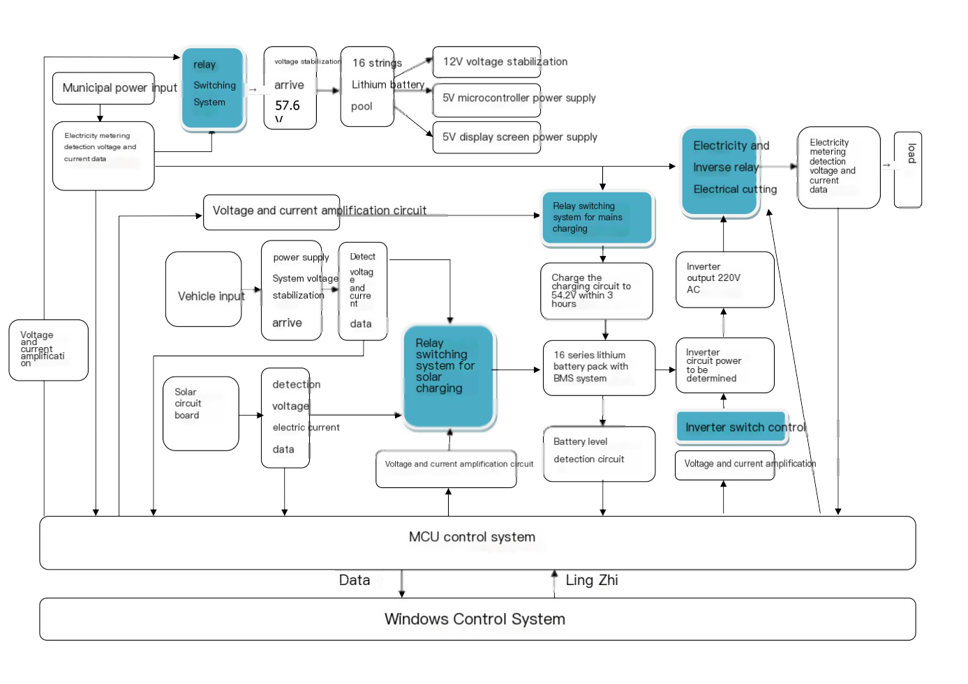
6、PCB wiring diagram:
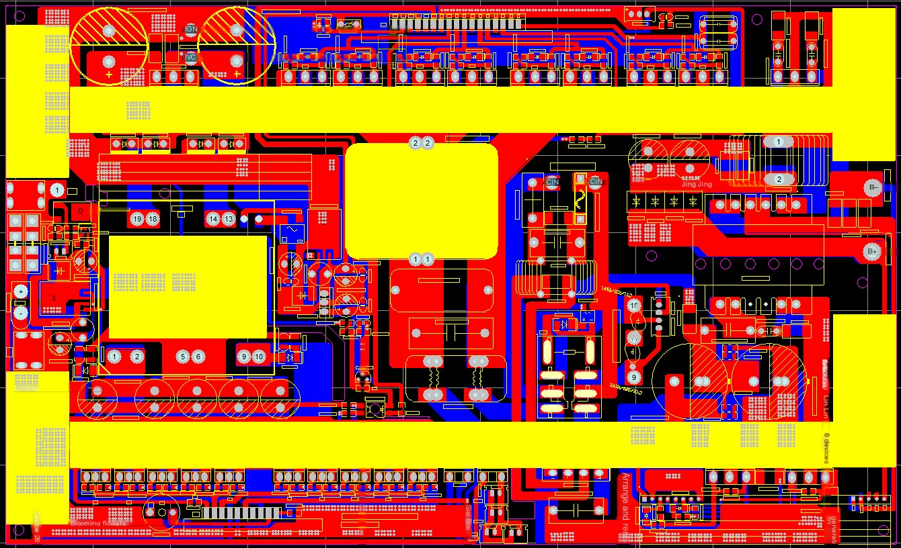
Boost section, Inverter section, UPS switching, Charging control
7、Function panel operation instructions:
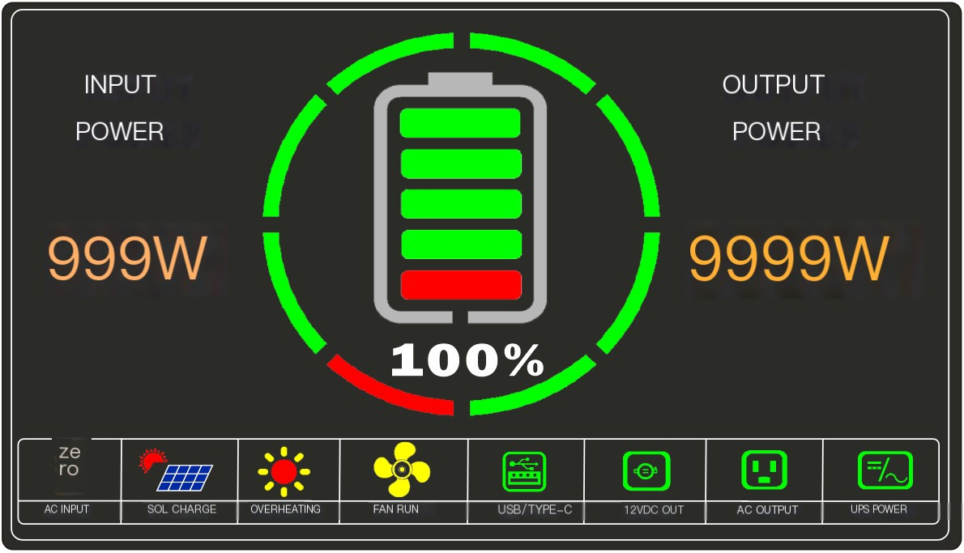
（1）The "AC INPUT" character indicates the presence of AC mains power input, while the "SOL CHARGE" character indicates the presence of solar charging. When solar charging occurs, the characters light up, and the input power character on the display panel constantly shows the solar charging power.
（2）The temperature display character (OVERHEATING) indicates that during the charging or discharging process, the internal temperature of the battery pack exceeds 55 degrees. When the temperature exceeds 65 degrees, the battery will not output to the outside world and the machine will shut down.
（3）The fan character (FAN RUN) indicates that the temperature of the heat sink on the motherboard has exceeded 45 degrees and the fan is automatically running.
（4）The mobile phone charging character (USB/TYPE-C) indicates that the USB and TYPE-C circuits are working properly. It is possible that mobile products such as phones are being charged, and during use, the output power on the panel will constantly display the current discharge power.
（5）When the DC discharge character (12VDC OUT) lights up, it indicates that the 12V output is normal and the 12V output function can be used. When there is a load, the output power on the panel will constantly display the current discharge power.
（6）AC OUTPUT indicates that when there is an inverter output or AC output, the character will light up. When there is an inverter output, the character will light up. When there is a load, the current discharge power will be displayed on the display panel at all times; When there is a mains input, the display panel only shows the charging power and not the discharging power. At the same time, the character (UPS POWER) lights up, indicating that the UPS power is enabled when there is mains input. The load output uses the power of the input mains, so the discharging power will not be displayed on the display panel.
（7）The battery character on the display panel displays the current battery level and percentage in real-time. If it is only a host, it will only display the current battery level of one battery pack on the host. After adding a battery pack, we calculate the power of two batteries and then perform an average algorithm to display the average power of the two batteries; After adding two battery packs, we calculate the power of the three batteries and then perform an average algorithm to display the average power of the three batteries.
（8）To turn on the power, press and hold for 3 seconds until the display screen lights up. At this time, you can release the power button. After turning on, the current battery level and other parameters will not be displayed immediately. It will wait for 3 seconds before displaying normally because communication data will be delayed.
（9）When using a mobile phone for DC charging, press and hold for 3 seconds to activate the DC and mobile phone charging functions.
（10）Inverter AC output input is required. After pressing the AC power button for 3 seconds, the display screen will not immediately show the inverter output character. It is necessary to wait for 3 seconds for the character to appear because the device's startup AC output is a soft start process, and the AC inverter voltage first changes from low to high to a certain value before stabilizing.
8、Packing list
Serial Number | name | quantity
1 | Power host | 1
2 | Communication input adapter cable | 1
3 | Communication output adapter cable | 1
3 | Output line DC5.5 * 2.1 | 1
4 | Solar input line (GX-20) | 1
5 | Instruction manual, warranty card, certificate of conformity | 1

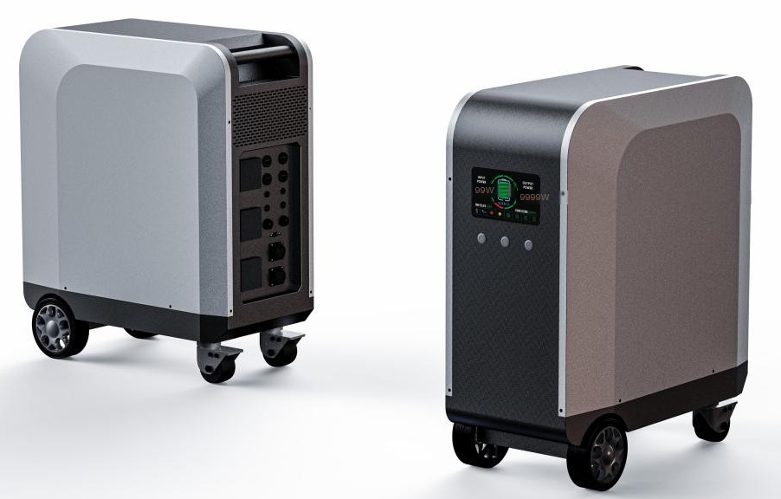 ES-10000A
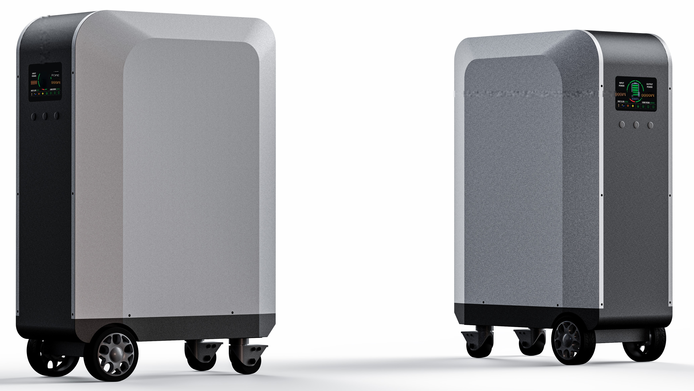 ES-10000B

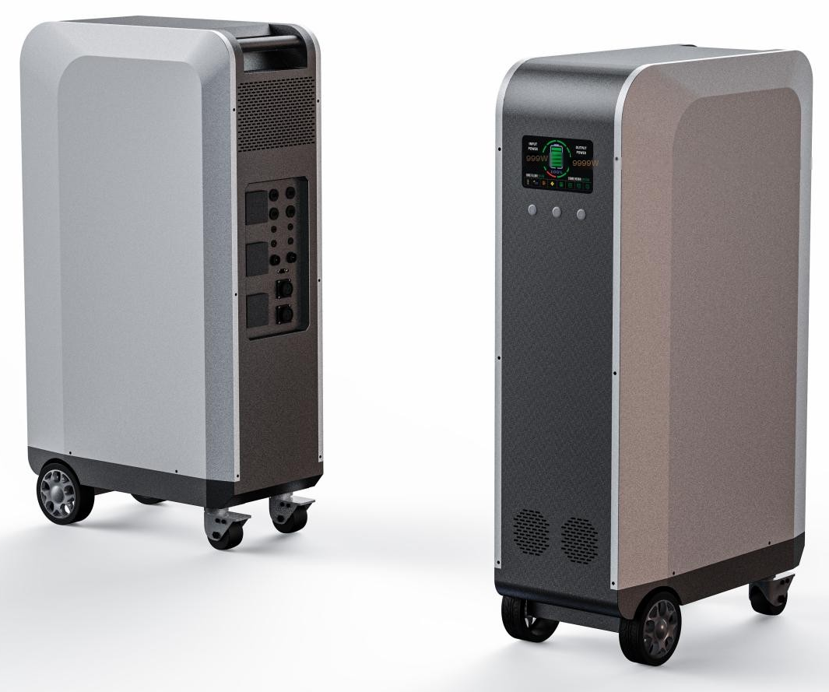 ES-10000C

