BLE Smart Gateway Product Specification Sheet
Product Introduction
The ZNWG-S-P gateway, a standard Bluetooth Low Energy (BLE) network relay device developed by Agriot, functions as an information converter within a BLE communication system. It facilitates communication between the network server and end nodes, enabling the conversion and forwarding of message communication protocols between terminal devices and the server. This gateway supports BLE communication standards, allowing for the integration of numerous BLE nodes, which is crucial for achieving low-cost, low-power positioning. It also supports wireless 4G communication, mains power, and is designed to withstand harsh environmental conditions, including extreme temperatures ranging from -40℃ to 70℃.
Product Topology

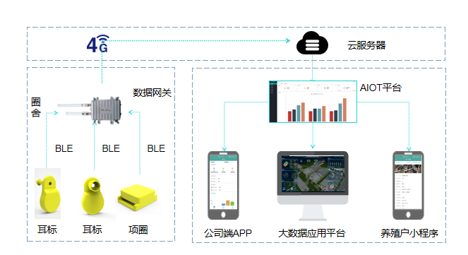
Product Specifications
Product Name | Smart Gateway | Product Model | ZNWG-S-P
Product Appearance
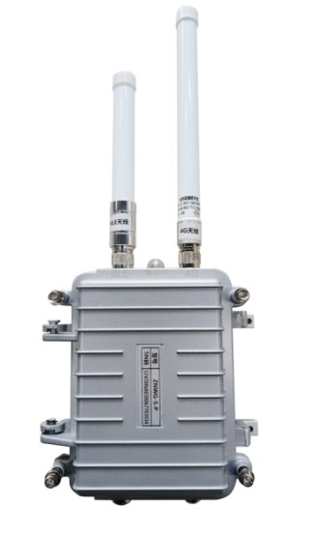
No. | Category | Item | Product Parameters
1 | Basic Parameters | Communication Method | BLE to 4G
2 | Basic Parameters | Bluetooth Connectivity | Broadcasting
3 | Basic Parameters | Coverage | Up to 200 meters (line of sight) / 100 meters (stable)
4 | Basic Parameters | Node Capacity | 100 nodes
5 | Basic Parameters | location mode | GPS
6 | Basic Parameters | Power Consumption | ≤5W
7 | Basic Parameters | Operating Temperature | -40℃ to 70℃
8 | Basic Parameters | Operating Humidity | 0 to 95% (relative humidity)
9 | Basic Parameters | Power Supply | AC220V / Internal lithium battery
10 | Basic Parameters | Shell protection rating | IP65
11 | Basic Parameters | Size | 160mm*110mm*60mm
12 | Product features | Data relay from BLE smart ear tags, power-off endurance, and GPS positioning
Functions and characteristics
Data relay via Bluetooth Low Energy (BLE) smart terminals, extended operational capacity during power outages, and GPS-based positioning.
● Reception of broadcast data from third-party Bluetooth devices.
● Real-time forwarding of Bluetooth device broadcast data.
● 4G network communication.
● GPS location tracking.
● Data communication and operational status indicators.
● Low-power design for energy efficiency.
Service 0verview and Architecture
The cornerstone of IoT service management for smart terminals is a smart centralized network management platform, facilitating the centralized remote management of devices. Leveraging a browser/server (B/S) architecture, users can remotely monitor, configure, and manage devices via a web browser, ensuring ease of use and significantly reducing device management costs. The architecture of this smart centralized network management platform encompasses:
Hardware Components: Intelligent terminals, BLE gateways.
System Software: Management system web interface, mobile applications, etc.
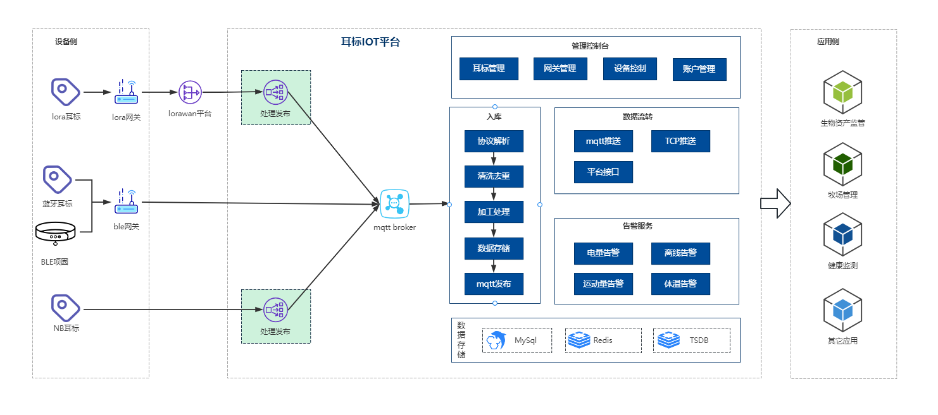
Data Integration
Agriot offers four data integration methods to accommodate diverse client needs.
Method 1: MATT Subscription
Method 2: Webhook
Method 3: Platform API Integration
Method 4: Direct Gateway Transmission
Refer to the "Agriot Smart Terminal Integration Documentation" for detailed integration instructions.

