Livestock Manager - BLE Collar S402-H-B Product Specification Sheet
Product Introduction
The Agriot Smart Collar – Livestock Manager (S402-H-B) is engineered for inventory management and health monitoring in confined cattle and sheep environments. The S402-H-B BLE collar utilizes BLE and wireless 4G (Bluetooth gateway) data communication, ensuring a stable communication radius exceeding 100 meters between the collar and the base station. Upon attachment to the livestock's neck, the collar automatically collects and transmits activity data, enabling automated inventory, step counting, and geofencing functionalities. This data is relayed via a BLE gateway to a cloud server.
The collar incorporates a 3-axis accelerometer to measure the hourly activity of cattle and sheep, allowing for the inference of health and estrus cycles based on activity patterns. It features automated inventory capabilities, analyzing the activity of livestock to automatically update the herd count. When used on sheep, the collar serves as a marking and restraint tool, facilitating quick immobilization and handling. Livestock Manager offers a cost-effective solution for livestock farming operations.
Furthermore, the asset monitoring data can be made accessible to third-party entities, such as banks and guarantee companies, to facilitate bio-asset collateralization. The Agriot collar is equipped with RFID functionality, enabling integration with smart weighing scales and automated grouping systems.
Product Topology
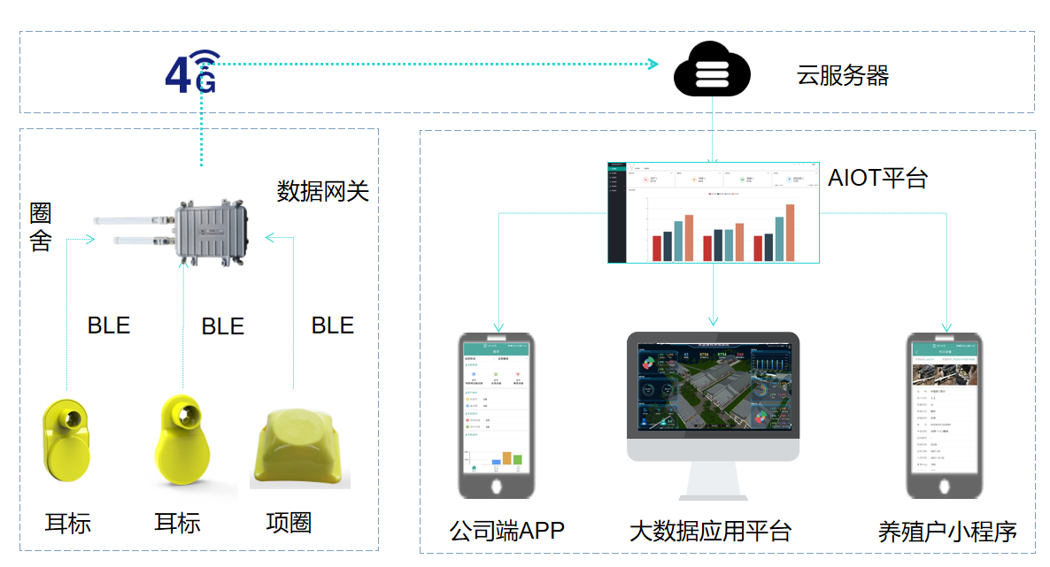
Product Specifications
Product Name | BLE Collar | Product Model | S402-H-B
Product Appearance
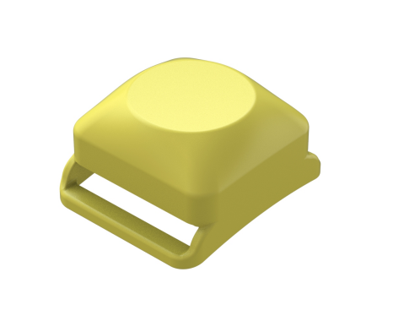
No. | Category | Item | Product Parameters
1 | Basic Parameters | Communication Method | BLE
2 | Basic Parameters | Ambient Temperature | -30℃—60℃
3 | Basic Parameters | Upload Rate | Default: 1 hours (adjustable frequency related to power consumption)
4 | Basic Parameters | Endurance capabilities | 48 months (replaceable battery)
5 | Basic Parameters | location mode | Base station positioning
6 | Basic Parameters | Shell protection rating | IP67
7 | Basic Parameters | Size | 48mm*40mm*24mm
8 | Basic Parameters | Weight (excluding strap) | 30 g
9 | Product features | Counting, inventory management, electronic fencing, radio-frequency identification
10 | Usage Scenario | Confined cattle and sheep

Functions and characteristics
● Precision Monitoring: Integrated with a smart, high-precision triaxial accelerometer for accurate tracking of livestock activity levels.
● Communication Range: Stable transmission up to 100 meters, with a maximum range of 200 meters.
● RFID Integration: Enables smart interaction and interoperability with other smart devices.
● Superior Materials: The housing is constructed from high-grade engineering plastics (plastic alloy), ensuring durability and environmental friendliness.
● Extended Battery Life: Equipped with a high-capacity, high-density, non-destructive lithium battery and ultra-low power consumption design, providing over 4 years of continuous operation.
● Compact and Lightweight: Designed for ease of wear, weighing only 30g to minimize stress on the animals.
● Simple Installation: Features a clasp-based installation system, allowing for adjustment of the collar's tightness to accommodate animal growth.
● One-Button Inventory: Real-time online status checks of the collars enable quick and accurate livestock counts, preventing loss or incidents.
● Disease Monitoring: Comprehensive analysis of livestock activity data allows for rapid identification of abnormal animals, triggering platform-based alerts for early disease detection and prevention of widespread outbreaks.
● Estrus Detection: Analysis of livestock activity data facilitates the quick identification of animals in estrus, with platform-based alerts to prevent missed breeding opportunities.
● Location Tracking: Utilizes base station positioning for individual livestock location management, including the setup of geofences with timely alerts for boundary breaches, preventing livestock loss.
● Convenient Remote Management: User-friendly WEB/APP interfaces for remote farm management, enhancing simplicity and efficiency.
Service 0verview and Architecture
The core of the Collar Management (BLE version) IoT service is a smart, centralized network management platform designed for the remote, centralized management of smart collars. Utilizing a browser/server (B/S) architecture, users can remotely monitor, configure, and manage devices via a web browser, ensuring ease of use and significantly reducing device management costs.
The architecture of the Collar Management (BLE version) IoT service includes:
Hardware Components: BLE collars, BLE gateways.
System Software: Management system web interface, mobile applications, etc.
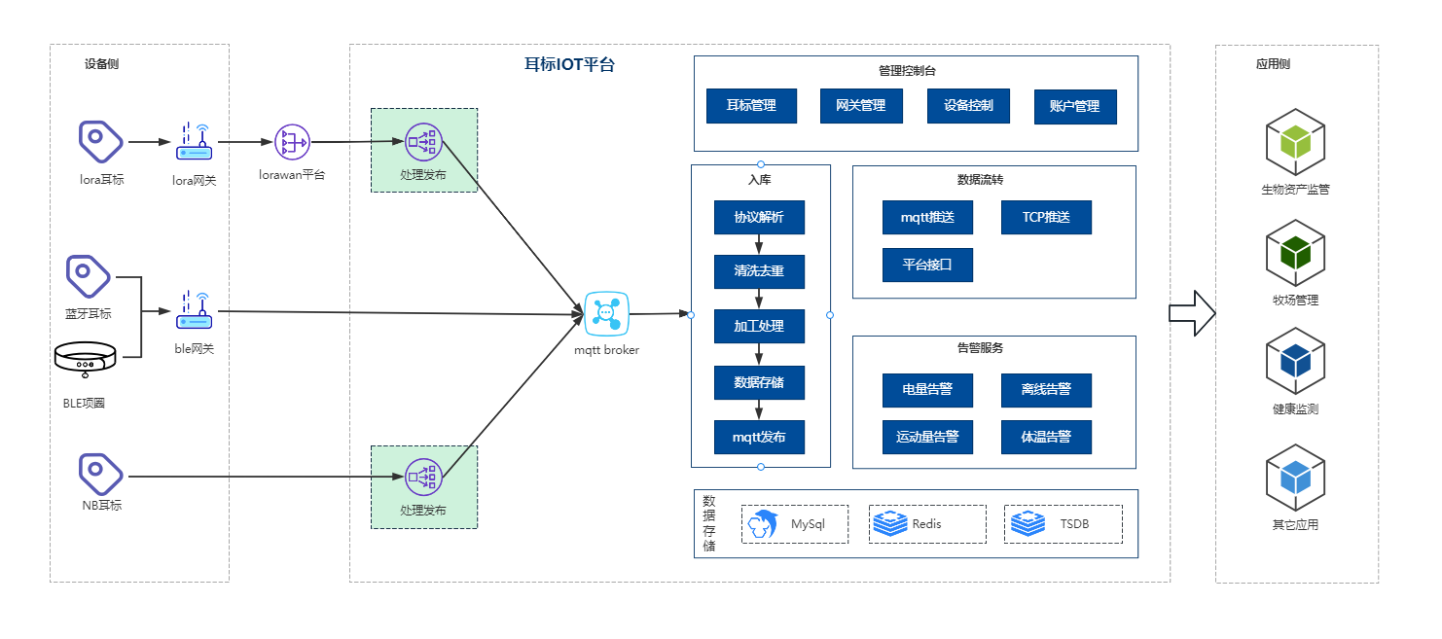
Data Integration
Agriot offers four data integration methods to accommodate diverse client needs.
Method 1: MATT Subscription
Method 2: Webhook
Method 3: Platform API Integration
Method 4: Direct Gateway Transmission
Refer to the "Agriot Smart Terminal Integration Documentation" for detailed integration instructions.

