BeiDou MuXun Collar - Positioning Collar S505-H-L Product Specification Sheet
Product Introduction
Agriot Positioning Collar - BeiDou MuXun Collar (S505-H-L), designed specifically for the scenario of free-range livestock positioning. This collar integrates BeiDou/GPS positioning with LoRaWAN communication technology, enabling a communication radius of up to 5 kilometers between the collar and the base station. Upon attachment to the necks of cattle or sheep, the device collects location and activity data, transmitting this information via LoRaWAN base stations through Ethernet, 4G, or satellite connections to a cloud server.
The collar utilizes a dual-mode BeiDou/GPS positioning module, supplemented by base station triangulation, to accurately capture livestock location data while maintaining low power consumption. Equipped with a 3-axis accelerometer, the collar measures the number of steps taken by the animals within each cycle, allowing for the inference of health and estrus status based on changes in activity levels. Furthermore, the collar facilitates livestock tracking and data transmission even in the absence of cellular network coverage, representing a significant advancement in free-range livestock management.
Product Topology
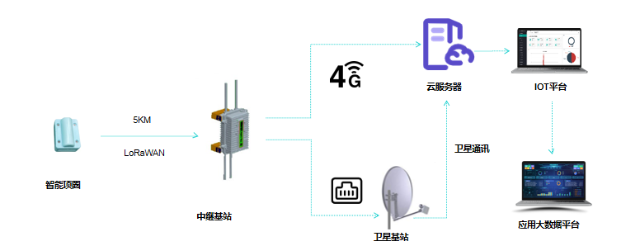
- The smart collar utilizes a BeiDou/GPS dual-mode positioning system to collect latitude and longitude data, transmitting it to a relay base station via LoRaWAN communication.
- In areas with 4G network coverage, the relay base station forwards the terminal data directly to the cloud server through the 4G network.
- In areas lacking 4G connectivity, the relay base station leverages a BeiDou satellite base station to relay the terminal data to the cloud server via satellite communication.
Product Specifications
Product Name | Smart Collar | Product Model | S505-H-L
Product Appearance
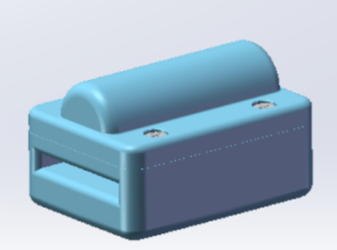
No. | Category | Item | Product Parameters
1 | Basic Parameters | Communication Method | LoRaWAN (up to 5 km range with the gateway, 3 km stable)
2 | Basic Parameters | Ambient Temperature | -30℃—60℃
3 | Basic Parameters | Upload Rate | Default: 2 hours (adjustable frequency related to power consumption)
4 | Basic Parameters | Endurance capabilities | 8 months (replaceable battery)
5 | Basic Parameters | location mode | BeiDou/GPS Dual-Mode Positioning
6 | Basic Parameters | Positioning Accuracy | 5 m—10 m (Accuracy dependent on weather conditions and obstructions)
7 | Basic Parameters | Shell protection rating | IP67
8 | Basic Parameters | Size | 61.7mm*45mm*37mm
9 | Basic Parameters | Weight (excluding strap) | 77 g
10 | Product features | Livestock positioning
11 | Usage Scenario | Positioning of free-range cattle, sheep, and camels
Functions and characteristics
● Precise Positioning: The collar utilizes GPS and BeiDou dual-mode positioning, enabling the accurate collection of real-time location data for grazing livestock, which is then displayed on the platform.
● Superior Material: The outer casing is constructed from high-grade, robust, and environmentally friendly engineering plastics.
● Extended Battery Life: Features a high-capacity, high-density, non-destructive lithium battery coupled with an ultra-low power consumption design, ensuring prolonged operational duration.
● Compact and Lightweight: Designed for ease of wear, weighing approximately 77 g, to minimize stress responses in livestock.
● One-Button Inventory: By monitoring the real-time status of the collars, a quick count of the collared livestock can be performed to prevent loss or incidents.
● Location Monitoring: Provides location management for each animal, along with the implementation of geofencing, which triggers timely alerts upon perimeter breaches, thus preventing livestock loss.
● Convenient Remote Management: User-friendly WEB/APP interface facilitates remote pasture management, enhancing simplicity and convenience.
Service 0verview and Architecture
The central component for managing the smart positioning collar (S505-H-L) IoT service is an intelligent centralized network management platform, designed for the centralized remote management of the smart collars. Utilizing a Browser/Server (B/S) architecture, users can remotely monitor, configure, and manage devices via a web browser, ensuring ease of use and significantly reducing device management costs.
The architecture of the smart positioning collar (S505-H-L) IoT service management platform includes:
Hardware: Positioning collars, LoRaWAN gateways.
System Software: Management system web interface, mobile application, etc.
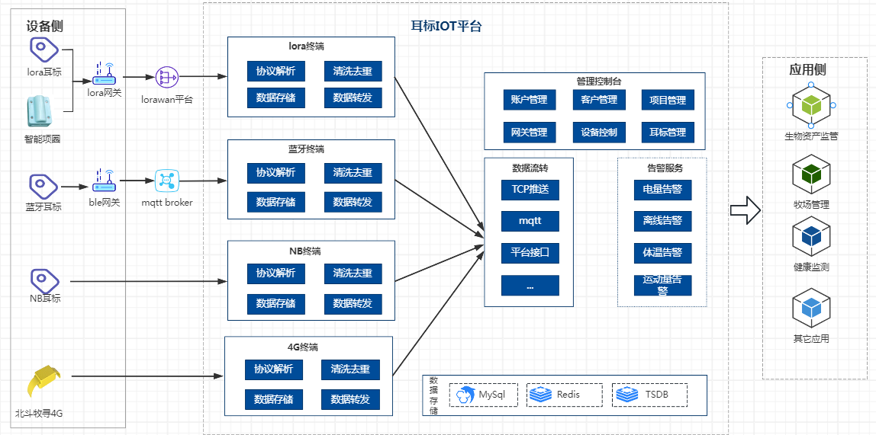
Data Integration
Agriot offers three data integration methods to accommodate diverse client needs.
Method 1: MATT Subscription
Method 2: Webhook
Method 3: Platform API Integration
Refer to the "Agriot Smart Terminal Integration Documentation" for detailed integration instructions.

