LoRaWAN Smart Gateway Product Specification Sheet
Product Introduction
The LoRaWAN gateway, developed by Agriot, is an outdoor LoRaWAN communication gateway. This standard IoT relay device functions as an information converter within the LoRaWAN communication system, facilitating communication between the network server and end nodes. It manages the protocol conversion and forwarding of message communications between end devices and the server. The gateway adheres to LoRaWAN communication standards, implementing the LoRa physical layer. Operating in the CN 470-510MHz frequency band, it supports simultaneous reception across eight wireless channels and employs frequency hopping technology for interference mitigation. It accommodates a large number of diverse LoRa nodes and supports uplink communication with servers via 4G, 5G, or Ethernet networks. Additional features include GPS positioning, Wi-Fi connectivity for local wireless configuration and management, and high-precision clock synchronization. Power options include AC220V, PoE, and various deployment methods such as pole mounting and wall mounting. The device has an IP65 protection rating, operates within a wide temperature range of -40°C to 70°C, and is designed as an industrial-grade device to withstand harsh outdoor environments.
Product Topology
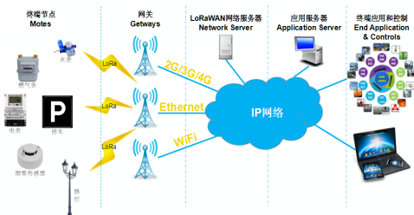
Product Specifications
Product Name | Smart Gateway | Product Model | ZNWG-S-L
Product Appearance
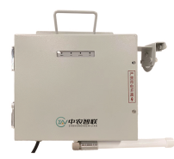
No. | Category | Item | Product Parameters
1 | Basic Parameters | Communication Method | LoRaWAN to 4G/Ethernet/WiFi
2 | Basic Parameters | Operating Frequency Band | CN 470-510MHz
3 | Basic Parameters | Coverage | Up to 5 km / stable at 3 km
4 | Basic Parameters | Node Capacity | 100 nodes
5 | Basic Parameters | Operating Temperature | -40℃ to 70℃
6 | Basic Parameters | Operating Humidity | 10% to 95%
7 | Basic Parameters | Power Supply | AC 220V±20% power supply/solar power/Power over Ethernet (PoE)
8 | Basic Parameters | Power Consumption | ≤5W
9 | Basic Parameters | Shell protection rating | IP65
10 | Basic Parameters | Size | 260mm*220mm*100mm
11 | Product features | Relay of LoRaWAN Ear Tag and Collar Data
Functions and characteristics
● Facilitates protocol conversion and forwarding of message communication between end-devices and the server.
● Server-specified downlink LoRa message transmission data and methods.
● Employs LoRa modulation technology, adhering to the LoRaWAN wireless transmission protocol.
● Supports up to 8 uplink and 1 downlink wireless channels, enabling full-duplex communication.
● Incorporates power-off detection and reporting functionality.
● Includes local debugging and maintenance capabilities via WiFi.
● Offers remote server firmware upgrades and other debugging and maintenance features.
● Provides status indicators for power, operational status, and communication status.
Service 0verview and Architecture
The cornerstone of IoT service management for smart terminals is a smart centralized network management platform, facilitating the centralized remote management of devices. Leveraging a browser/server (B/S) architecture, users can remotely monitor, configure, and manage devices via a web browser, ensuring ease of use and significantly reducing device management costs. The architecture of this smart centralized network management platform encompasses:
Hardware Components: Intelligent terminals, LoRaWAN gateways.
System Software: Management system web interface, mobile applications, etc.
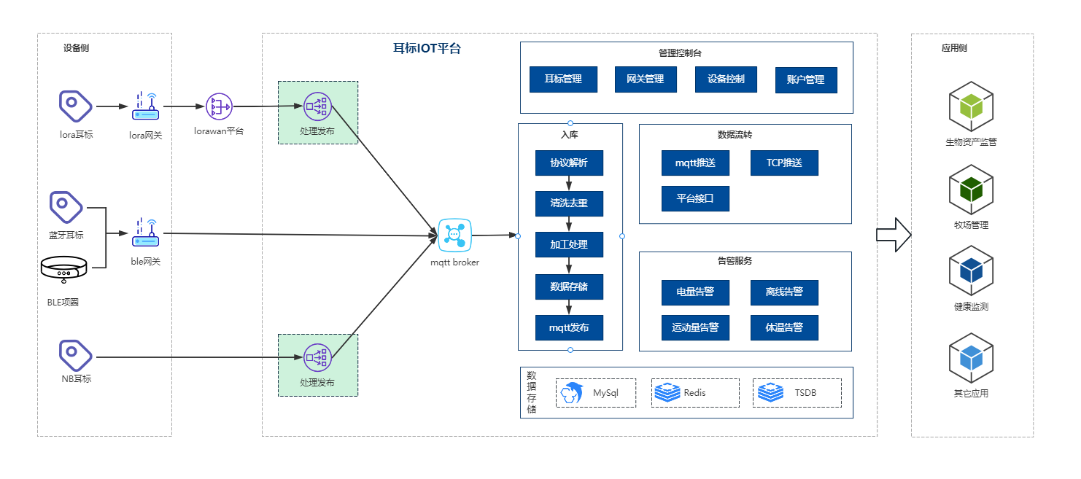
Data Integration
Agriot offers three data integration methods to accommodate diverse client needs.
Method 1: MATT Subscription
Method 2: Webhook
Method 3: Platform API Integration
Refer to the "Agriot Smart Terminal Integration Documentation" for detailed integration instructions.

