LoRaWAN Gateway Product Specification Document
Product Introduction
The LoRaWAN gateway is an outdoor LoRaWAN communication gateway, serving as a standard IoT relay device. It acts as an information converter in the LoRaWAN communication system, responsible for connecting the network server and end devices, enabling protocol conversion and forwarding of message communication between end devices and servers. It supports the LoRaWAN communication protocol, implements LoRa physical layer functions, operates in the CN 470-510MHz frequency band, supports simultaneous reception on 8 wireless channels, utilizes frequency hopping anti-interference technology within the frequency band, can connect to a large number of LoRa nodes, supports 4G and Ethernet uplink communication networks to servers, enables Wi-Fi for nearby wireless configuration management, supports high-precision clock synchronization, can be powered by mains electricity, pole-mounted, or wall-mounted, offers an IP67 protection level, meets wide temperature ranges from -40°C to 70°C, and is an outdoor industrial-grade device resistant to harsh environments.

Product Topology

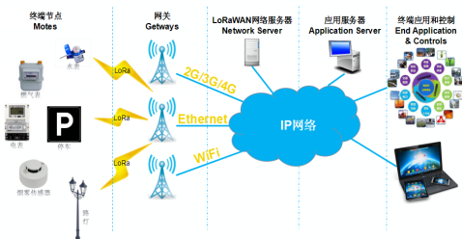

Product Specifications

product Name | Smart Ear Tag | Product Model | ZNWG-S-L
Product Appearance
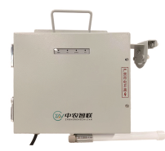
No. | Category | Item | Product Parameter
1 | Basic Parameters | Communication Method | Lorawan to 4G/Ethernet/WiFi
2 | Basic Parameters | Operating Frequency Band | CN 470-510MHz
3 | Basic Parameters | Coverage Range | Up to 5KM stable at 3KM
4 | Basic Parameters | Operating Temperature | －40℃～70℃
5 | Basic Parameters | Relative Humidity | 10％～95％
6 | Basic Parameters | Power Supply | AC 220V ±20%/Solar powered
7 | Basic Parameters | Power Consumption | ≤5W
8 | Basic Parameters | Dimensions | 260mm×220mm×100mm
9 | Basic Parameters | Protection Level | IP65
10 | Product Function | Data relay for lorawan ear tag and collar

Function Features
- Realize message communication protocol conversion and forwarding between terminal devices and servers;
- Downlink LoRa message sending data and methods are specified by the server;
- Using LoRa modulation technology, following LoRaWAN wireless transmission protocol;
- Up to 8 wireless uplink channels, 1 downlink channel, full-duplex communication;
- Has functions for power-on and power-off detection reporting;
- Has local debugging and maintenance functions such as WiFi;
- Has debugging and maintenance functions such as remote server firmware upgrades;
- Has status indicators for power, working status, communication status, and other states.
Service 0verview and Architecture
The core of managing IoT services for intelligent terminals lies in the intelligent centralized network management platform used for centralized remote device management. Based on the Browser/Server (B/S) architecture, users can remotely monitor, configure, and manage devices through a web browser, making it user-friendly and significantly reducing device management costs.
The core of managing IoT services for intelligent terminals includes:
Hardware Devices: Intelligent terminals, LoRaWAN gateways.
System Software: Management system web interface, APP, etc.
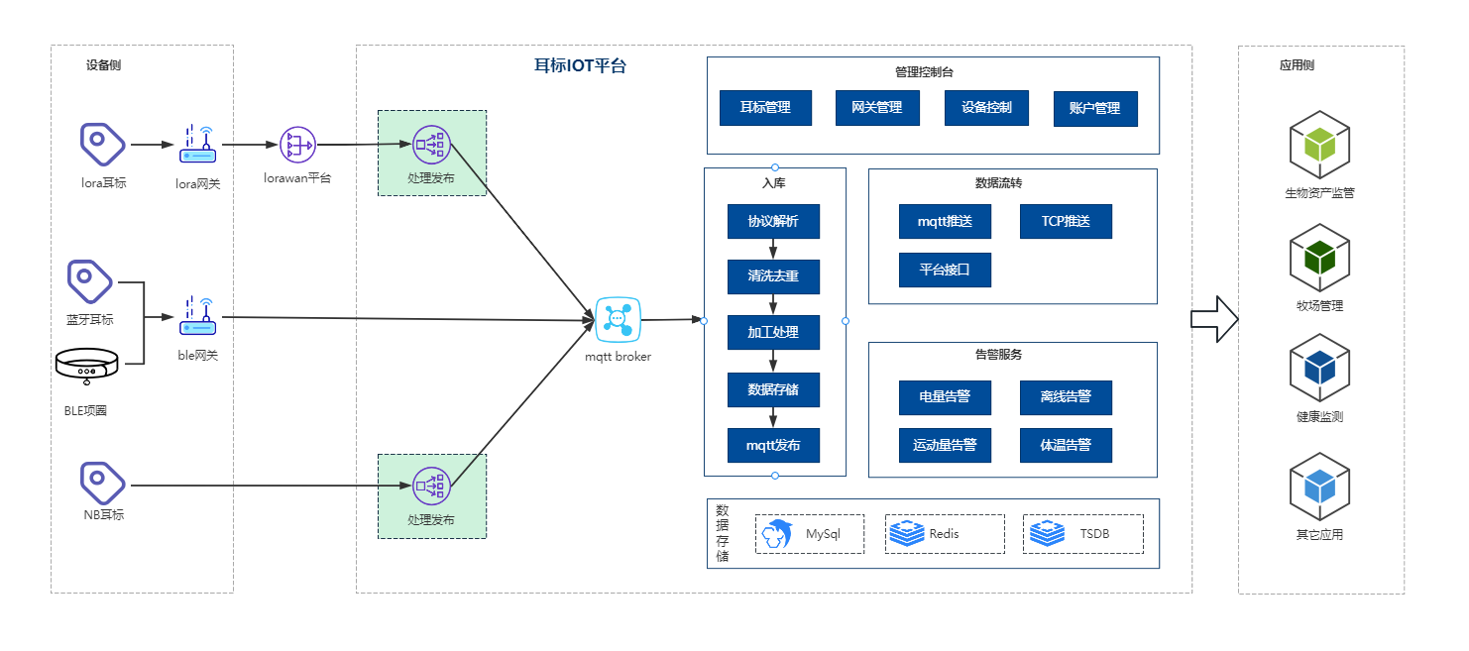
Data Integration
We provide three data integration methods to meet the integration needs of different customers.
Method 1: Subscribe to MQTT.
Method 2: WEBHOOK.
Method 3: Integration via platform interfaces.
For detailed integration methods, please refer to the "Intelligent Terminal Integration Document".

