BeiDou Cow Collar MINI - Positioning Collar S502-H-L Product Specification Manual
Product Introduction
Positioning Collar - BeiDou Cow Collar MINI (S502-H-L), designed specifically for the scenario of free-range livestock positioning. This collar combines BeiDou/GPS positioning and lorawan communication technology, with a communication radius of up to 5KM between the collar and the base station. Once worn on the neck of cattle and sheep, it can collect location information and movement data, and upload them to the cloud server through the BeiDou relay base station. The collar uses BeiDou/GPS dual-mode positioning modules to accurately collect the location information of livestock under low power conditions. Equipped with a 3-axis accelerometer, the collar can measure the hourly movement steps of cattle and sheep, and infer their health and estrus status based on the step changes. BeiDou Cow Collar can perform livestock positioning and data upload without the need for an operator network, making it a revolutionary product for the localization of free-range livestock.

Product Topology

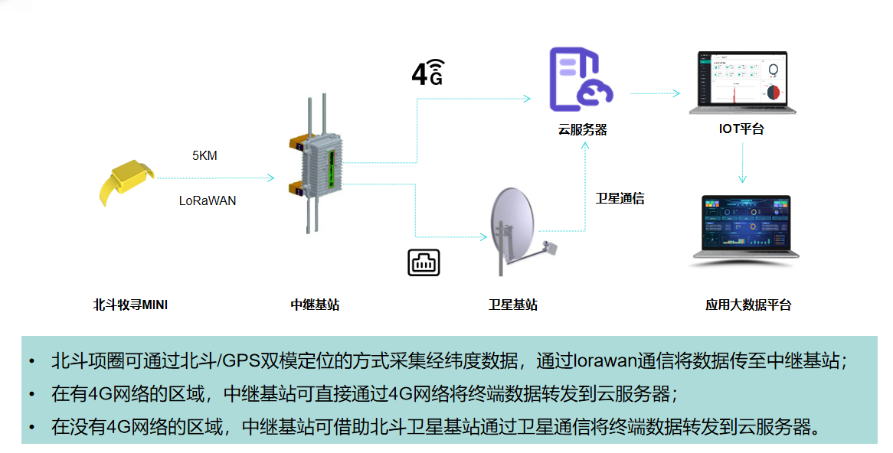

Product Specifications

Product Name | BeiDou Cow Collar MINI | Product Model | S502-H-L
Product Appearance
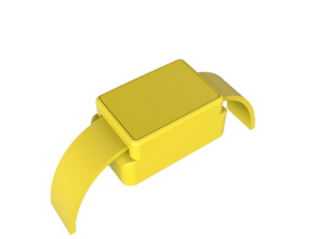
No. | Category | Item | Product Parameters
1 | Basic Parameters | Communication Method | LoRaWAN (up to 5KM with the gateway, stable at 3KM)
2 | Basic Parameters | Ambient Temperature | -30℃—60℃
3 | Basic Parameters | Upload Rate | Default: 2 hours| (adjustable frequency related to power consumption)
4 | Basic Parameters | Endurance capabilities | 18 months (replaceable battery)
5 | Basic Parameters | location mode | BeiDou/GPS dual-mode positioning
6 | Basic Parameters | Positioning accuracy | 5m-50m (accuracy depends on weather and obstructions)
7 | Basic Parameters | Shell protection rating | IP67
8 | Basic Parameters | Size | 86mm*50mm*43mm
9 | Basic Parameters | Weight (excluding strap) | 172g
10 |  | Livestock Positioning, Movement Monitoring
11 | Usage Scenario| | Locating and monitoring health of freely grazed cattle, sheep, and camels

Functions and characteristics
●Accurate Positioning: The collar adopts GPS+BeiDou dual-mode positioning, accurately collecting the location information of grazing livestock and enabling data viewing on the platform side.
● Health Monitoring: The collar monitors the activity level of grazing livestock, allowing for health assessments such as illness, well-being, and mortality based on the activity data on the platform side.
● Superior Material: The shell is made of high-quality engineering plastic (plastic alloy), which is robust and environmentally friendly.● Long Battery Life: Equipped with a high-capacity, high-density lithium battery and ultra-low power design, ensuring long-lasting battery life.
● Small Size, Light Weight: Convenient to wear, weighing around 172g, without causing stress to the livestock.
● One-Click Inventory: Real-time screening of collar status allows for quick inventory of the number of livestock wearing collars, preventing livestock loss or accidents.
● Epidemic Monitoring: By analyzing livestock activity levels, abnormal livestock can be quickly identified, triggering alerts on the platform for epidemic prevention, thereby avoiding widespread transmission.
● Heat Detection: Through comprehensive analysis of livestock activity levels, animals in heat can be swiftly identified, triggering alerts on the platform for heat detection, ensuring the heat cycle is not missed.
● Location Tracking: Individual livestock can be monitored for their location, with electronic fences set up to trigger alerts for timely action and prevent livestock loss.
● Convenient Remote Management: User-friendly WEB/APP interface for remote ranch management, ensuring a simpler and more convenient approach.
Service 0verview and Architecture
The core of managing IoT services for positioning collar (BeiDou Cow Collar MINI) lies in the intelligent centralized network management platform used for centralized remote device management. Based on the Browser/Server (B/S) architecture, users can remotely monitor, configure, and manage devices through a web browser, making it user-friendly and significantly reducing device management costs.
The core of managing IoT services for positioning collar (BeiDou Cow Collar MINI) includes:
Hardware Devices: Intelligent terminals, LoRaWAN gateways.
System Software: Management system web interface, APP, etc.

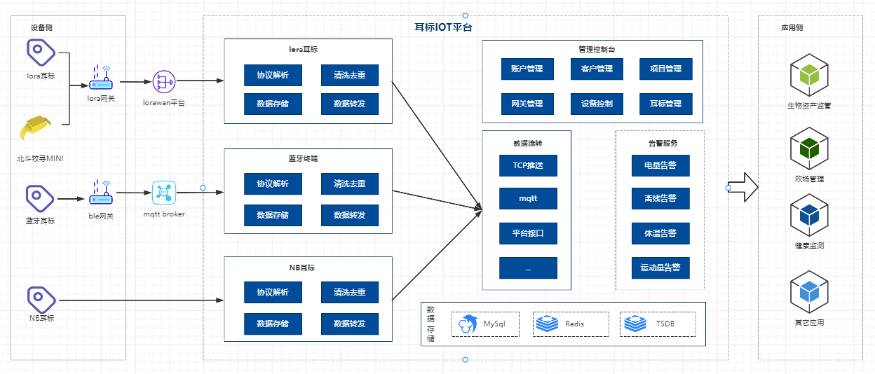
Data Integration
We provide three data integration methods to meet the integration needs of different customers.
Method 1: Subscribe to MQTT.
Method 2: WEBHOOK.
Method 3: Integration via platform interfaces.
For detailed integration methods, please refer to the "Intelligent Terminal Integration Document".

