Product description

SUP28F (V1.0)
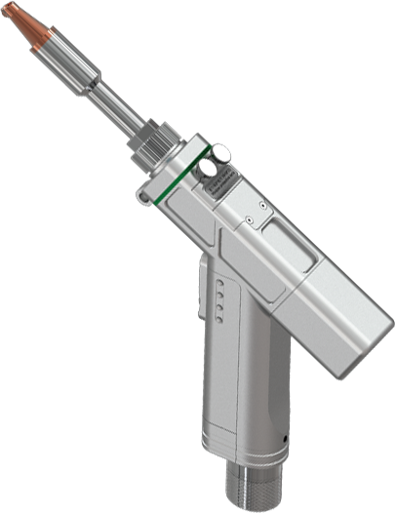

Wuxi Chaoqiang Weiye Technology Co., Ltd.

Table of contents
Update the record 2
I. Precautions 3
1.2.1 Machine hazards 4
1.2.2 Electrical hazards 4
1.2.3 Thermal hazards 4
1.2.4 Radiation hazard 4
1.2.5 External interference hazard 4
1.2.6 Confined Space Hazards 5
1.3.1 Production operation environment 5
1.3.2 Engineering protection measures 6
1.3.3 Personal protective measures 6
1.3.4 Product maintenance and protection measures 7
1.3.5 Other considerations 7
1.3.6 Safety signs 8
II. Product Overview 10
Function description: 11
1、 Status indicator light: the green light is on when the system is normal, the red light flashes when the temperature alarm occurs, and the red light of other alarms is always on. 11
三、 Product accessories and installation 12
3.2.2 Control box- [LCD] 16
3.2.3 Control box- [Laser head] 17
3.3.1 Optical fiber head connection 20
3.3.2 Control box connection 21
V. Daily maintenance of products 32
VI. Common product problems and handling measures 33

Copyright statement
Chaoqiang Weiye Technology Co., Ltd.
All rights reserved

· The copyright of this brochure is owned by Super Weiye Technology Co., Ltd. (Hereinafter referred to as "Super Weiye"), and Super Weiye reserves the right of final interpretation.
The pictures and trademarks appearing in the manual do not grant any rights to any organization or individual.
· In case of any discrepancy between the real object and the description in the manual due to product upgrade and configuration adjustment, the real object shall prevail. If in doubt, please contact your local dealer.
· Chaozhengweiye shall not be liable for any direct, indirect, incidental and unavoidable losses caused by improper understanding of this manual or improper use of this product, and Chaozhengweiye shall not be liable for such losses.
Super Weiye has the design patent right, related software copyright, and other intellectual property rights of this product. Without authorization, it is not allowed to directly or indirectly produce, manufacture and process this product and related system accessories.
· The software and hardware of this product are developed and manufactured in accordance with relevant laws and regulations, and do not endanger safety, social order and public interests.

Update the record
Version | Update the content | Time | Compiler
V1.0 | First edition | 24.7.2 | Liu Chen

I. Precautions
The product belongs to an accessory of laser processing equipment and is applied to the field of metal material processing. According to the relevant regulations, this product meets the basic safety standards for all kinds of hand-held, mobile and fixed electrical products for indoor and outdoor use. According to the actual demand, it is recommended to set up an operating area of 2 to 10 square meters for each product (the recommended indoor height is more than 3 meters).
Warning! Read all safety warnings, instructions, illustrations, and specifications in this manual. Failure to follow all of the following instructions may result in electric shock, fire, or various other serious injuries!! This product is only suitable for use in professional industrial areas and must be used by professionals! Personnel who have not obtained professional qualifications shall not use it!

1.1 Transportation and storage requirements
The hand-held laser welder shall be able to work normally under the following environmental conditions.
(1) Ambient air temperature range:
During transportation and storage: -25 ℃ ~ + 55 ℃.
(2) Air relative humidity:
Not more than 70% at 40 ℃;
Not more than 90% at 20 ℃.
(3) The dust, acid, corrosive gas or substance in the surrounding air shall not exceed the normal content, except those generated due to the welding process.
(4) No obvious vibration and impact.

1.2 Description of possible hazards

1.2.1 Machine hazards
① Pinch injury or other secondary hazards caused by fastening structure.
② bruising or other secondary hazards caused by falling equipment.

1.2.2 Electrical hazards
① Electric shock or other secondary hazards caused by leakage of equipment power supply.
② Electric shock or other secondary hazards caused by static electricity generated by equipment operation.

1.2.3 Thermal hazards
① Heatstroke, dehydration or other secondary hazards caused by a large amount of heat generated by laser processing.
② Personnel scald, environmental fire or other secondary hazards caused by high-temperature materials, residues and splashes produced by laser processing.

1.2.4 Radiation hazard
① Personnel skin injury, retinal injury or other secondary hazards caused by laser direct irradiation or secondary irradiation after reflection.
② Electrolytic plasma hazards or other secondary hazards caused by laser energy.
③ Secondary radiation or other secondary hazards caused by material decomposition and stimulated radiation caused by laser irradiation.

1.2.5 External interference hazard
The abnormal operation of the product caused by external factors may cause equipment failure and lead to dangerous situations.
External environment refers to:
① Temperature
② Humidity
③ External shock/vibration
④ Steam, dust or ambient gas
⑤ Electromagnetic interference
⑥ Interruption/fluctuation of original power supply
⑦ Lightning strike
⑧ Insufficient hardware/software compatibility or integrity
⑨ The external communication does not comply with the communication protocol.

1.2.6 Confined Space Hazards
Possible hazards of using hand-held laser processing equipment in confined spaces:
① The concentration of harmful substances in the space increases
② The concentration of process gas (argon, nitrogen, etc.) in the space is too high.
③ Hypoxia
④ Current enhancement
⑤ Temperature rise
⑥ Radiation hazard caused by laser direct or reflection and diffuse reflection.

1.2.7 High-altitude operation hazard
① Hazard of falling objects.
② Falling hazard of the user.

1.3 Precautions
In view of the above hazards, in order to ensure safe production and normal operation of the product, the following safety signs are posted on the whole product to clearly inform all personnel using, maintaining and approaching the product to pay attention to the following safety matters and take the following safety measures.
Warning! Read all safety warnings, instructions, illustrations, and specifications in this manual. Failure to follow all of the following instructions may result in electric shock, fire, or various other serious injuries!!

1.3.1 Production operation environment
① The use of products shall be divided into special laser welding areas.
② Inflammable and explosive articles shall not be placed around the product to avoid potential safety hazards.
③ When working outdoors, the product shall be protected from exposure to fog, strong wind, thunder and lightning, rain, snow, hail and other non-good weather.
④ Good ventilation and visibility (sunlight or light) shall be maintained when the product is working indoors.
⑤ Dust, acid, alkali and corrosive gas in the working environment of the product shall not exceed the normal level.
⑥ Temperature range of product working environment: -10 ~ 50 ℃, humidity range ≤ 70%.
⑦ Obvious vibration and impact shall be avoided in the working environment of the product.

1.3.2 Engineering protection measures
① quarantine protective fence should be set up around the laser welding area. The fence should be able to bear a certain amount of laser energy to prevent the laser from irradiating outside the area.
② Other personnel shall not enter the laser welding area without the authorization of the operator.
③ This product adopts 220V AC power supply, the applicable range is 220V ± 5% AC 50/60Hz, and the power supply voltage shall be stable without impact. Please pay attention to the safety of electricity and avoid the hidden danger of electric shock.
④ In order to ensure the normal operation of the product and avoid electrostatic damage and leakage of the product, the product shall adopt safety grounding measures, that is, connect the easily conductive part to the protective (grounding) conductor in the fixed wiring of the product, so that the easily conductive part will not become a live part when the basic insulation fails; Additional safety measures (such as double insulation or reinforced insulation), or separate grounding, as appropriate;
⑤ There must be an emergency stop switch control device within 2 meters of the center of the operator's working area.

1.3.3 Personal protective measures
Warning! The operator must be a professional who, in addition to being familiar with the product and related welding systems, must be familiar with the properties of the material being processed, be familiar with the possible side effects, be able to assess health risks, and be able to ensure effective preventive measure.
① Individuals should wear professional laser protective suit and protective gloves.
② Individuals should wear laser protective glasses and masks with corresponding power and wavelength.

1.3.4 Product maintenance and protection measures
① When replacing the vulnerable parts, confirm that the power of the product is cut off to avoid light.
② The control box of this product does not contain accessories that need to be operated by the user. Any installation, maintenance and disassembly of this product should be carried out at the designated maintenance point under the condition of power failure. Please contact the local distributor.

1.3.5 Other considerations
① Warning! The product is suitable for lasers with a wavelength of 1080 nm and its vicinity, which is invisible light, and its radiation is difficult to detect before it has a direct impact, so special attention should be paid! The operator must wear all protection, the work area must be protected as required, and no other person is allowed to enter the work area!
② The instantaneous output energy of the laser is very high, so it is not allowed to point the light outlet to personnel or other objects when working, placing or idling.
③ Even if the fourth type of laser does not directly irradiate the skin and eyes, it will indirectly irradiate the skin and eyes due to the diffuse reflection of the material, which will still cause irreversible damage. Operators must wear protective equipment such as glasses and protective suit.
(4) When the laser irradiates the smooth surface, it will produce specular reflection, which is especially obvious when processing high reflective materials such as copper and aluminum. When the material is processed, the reflection angle will also change due to the change of the molten pool. Operators should have a good understanding of the possible reflection angles to avoid laser reflection endangering personnel and equipment.
(5) The gas around the molten pool will form electrolytic plasma when irradiated by high-energy laser. The splashing waste and waste gas produced by laser action on materials will also cause harm to personnel. Operators must wear protective equipment such as masks.
⑥ When working, add the emergency stop switch control device within 2 meters around the individual in the working area of the operator.
⑦ When working at heights, operators shall wear safety ropes, helmets, etc., and take measures to fix the equipment to prevent falling.
⑧ When working indoors or in a confined space, adequate ventilation measures shall be taken to avoid the deposition of harmful substances. Maintain sufficient visibility to prevent the eyes from being stimulated by strong light. Appropriate measures need to be provided to remove the smoke and exhaust gas that may be generated from the processing area, which needs to be adequately purified and discharged into the atmosphere far away from the population.

1.3.6 Safety signs
The following safety signs must be fully understood and used.
Sign | Name
 | Movable fire zone
 | Warning! Be safe
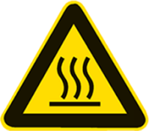 | Beware of hot surfaces
 | It is forbidden to wear chemical fiber clothes.
 | Flammable materials are prohibited
 | Laser radiation Avoid direct or scattered radiation to eyes and skin.  Class 4 Laser Products
 | Laser window  Protected from laser radiation emerging from the window
 | Blackout goggles must be worn
 | Watch out for the laser
 | Caution Ionizing Radiation
 | Be careful of electric shock
 | Must be grounded
 | The plug must be pulled off
 | Closing is prohibited

II. Product Overview
This product belongs to laser welding equipment accessories, which is used in the field of metal material processing, including carbon steel, stainless steel, aluminum, copper and other common metals and other metals that can absorb 1080 nm band laser.
It is suitable for continuous laser with laser power of 1200 W and below and wavelength of 1080 ± 10 nm.
The cooling method is air cooling, and argon is recommended as the refrigerant.
It can not be used for the processing of non-metallic materials such as wood, stone, plastics, composite materials, etc.
It cannot be used for underwater work. See [Production Operation Environment] for detailed working condition requirements.
This manual includes a general description of the basic functions, installation, operation and maintenance of SUP28F series handheld laser welding head.

2.1 Description of gun body
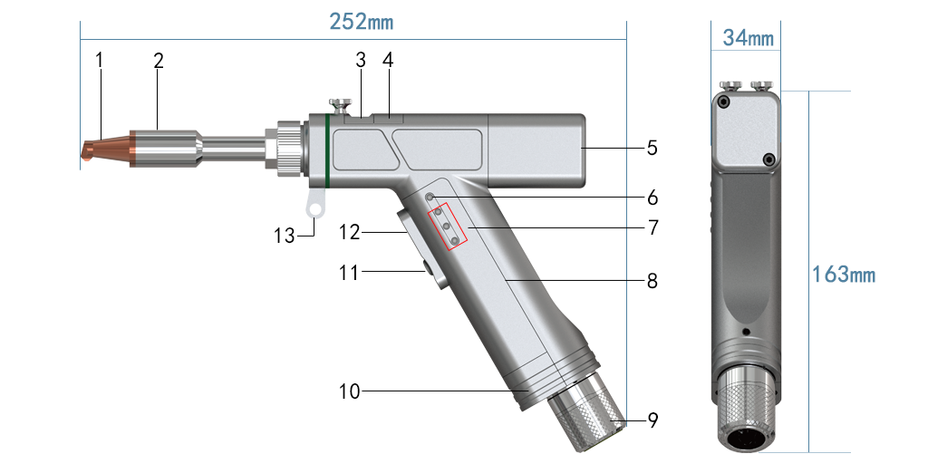
Figure 2.1 SUP28F Gun Body
1-Copper mouth | 2-Graduated tube | 3-Protective Mirror Drawer | 4-FOCUSING LISTER DRAWER
5-MOTOR REAR COVER | 6-STATUS LED | 7- Process indicator | 8-Collimating mirror position
9-QBH locking sleeve | 10-Trachea | 11- Light output switch button | 12- Process switching button
13-Wire feeding bracket

Function description:

Status indicator light: the green light is on when the system is normal, the red light flashes when the temperature alarm occurs, and the red light of other alarms is always on.
- Process indicator: 1, 2, 3 from top to bottom, corresponding to [Common Process 1, 2, 3]. If [Common Process 1] is called, No.1 indicator is green.
- Process switching button: when clicked, it will switch to [Common Process] in sequence.
- Light-emitting switch button: when the safety lock signal is on, press the light-emitting button, and the system controls the laser to emit light.

2.2 Product function
● Basic features:
① Digital servo drive motor;
② Air cooling structure;
③ Suitable for lasers of 1200 W and below;
④ Maximum weld width of 8mm is supported.
Serial number | Type F
1 | Laser cleaning function
2 | Laser cutting function
3 | Weld cleaning function
4 | Lens temperature monitoring function
5 | System fault diagnosis
6 | Support process library
7 | Fast cutting process
8 | Quickly adjust the wire feeder
● Basic functions

2.3 Product operating environment and basic parameters
The operating environment requirements and main parameters of SUP28 handheld laser welding head are shown in Table 2.1:

Table 2.1 Operating Environment Requirements and Basic Parameters
Supply voltage (V) | 220V±5% AC 50/60Hz
Operating ambient temperature (℃) | -10～50℃
Humidity of working environment (%) | ＜70
Cooling method | Air Cooling
Applicable wavelength | 1080nm（±10nm）
Applicable power | ≤1200W
Collimating mirror | D16*T5/F50
Focusing Lens | D20*T4.5/F150
Reflector | 30*14*T2
Protective glasses | D18*T2
Air Flow | ≥15L/min
Focus vertical adjustment range | ±10mm
Weight | 0.65kg
Adapt the laser | φ ≤ 10 mm after beam collimation

Product accessories and installation

3.1 Unpacking list
Taking the standard version as an example, the product delivery list is shown in Table 3.1. If the physical product is different from the schematic diagram, please refer to the specific order.
Table 3.1 Product Factory Configuration List
SUP28F packing list
 | Serial number | Material code | Name | Specification | Quantity
Product accessories 1 | 1 | A01050001 | Hand-held lase air-cooled weld head | SUP28F | 1
Product accessories 1 | 2 | A05010015 | Laser welding system | SUP-LWS-D Chinese version | 1
Product accessories 1 | 3 | K01090001 | Eight-core system connecting line | 10 meters | 1
Product Accessories 2 | 4 | C04010006 | Display screen | SUP-DW128 HJT | 1
Product Accessories 2 | 5 | C03020002 | Switching power supply | LM100-20B24(JSY) | 1
Product accessories 3 | 6 | K04020001 | Display screen line (vertical side-out) | 1M | 1
Product accessories 3 | 7 | D01010001 | Protect the lens | D18T2 | 5
Product accessories 3 | 8 | B06030003 | Double wire feeding copper nozzle | AS-20D | 1
Product accessories 3 | 9 | B06010001 | Copper mouth | AS-12 | 1
Product accessories 3 | 10 | B06010002 | Copper mouth | BS-16 | 1
Product accessories 3 | 11 | B06010003 | Copper mouth | CS-12 | 1
Product accessories 3 | 12 | B06010004 | Copper mouth | ES-12 | 1
Product accessories 3 | 13 | B06010005 | Copper mouth | FS-16 | 1
Product accessories 3 | 14 | B06020003 | Copper mouth | C | 1
Product accessories 3 | 15 | B06020005 | Cutting nozzle adapter cylinder | S | 1
Product accessories 3 | 16 | B06020006 | Nozzle | 1.5 Single layer M8 | 1
Product accessories 3 | 17 | B03210162 | Graduated tube | FT90 | 1
Product accessories 3 | 18 | J01050004 | Copper mouth packing box |  | 1
Product accessories 3 | 19 | E01090001 | Big alligator clip |  | 1

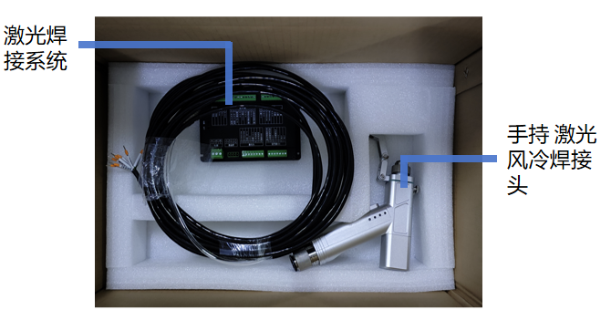
Figure 3.1 Product Accessories 1
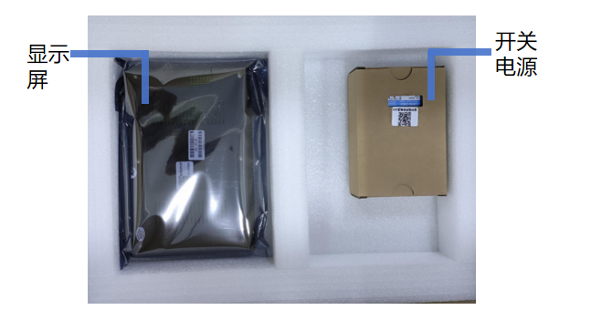
Figure 3.2 Product Accessories 2
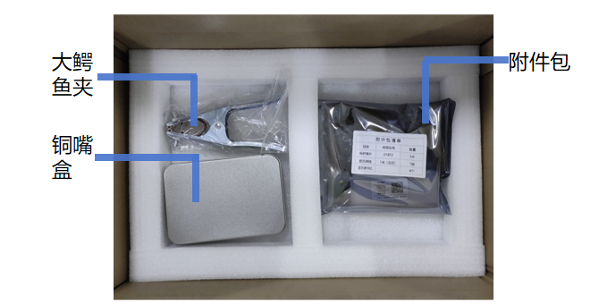
Figure 3.3 Product Accessories 3

3.2 Wiring and interface definition of control box
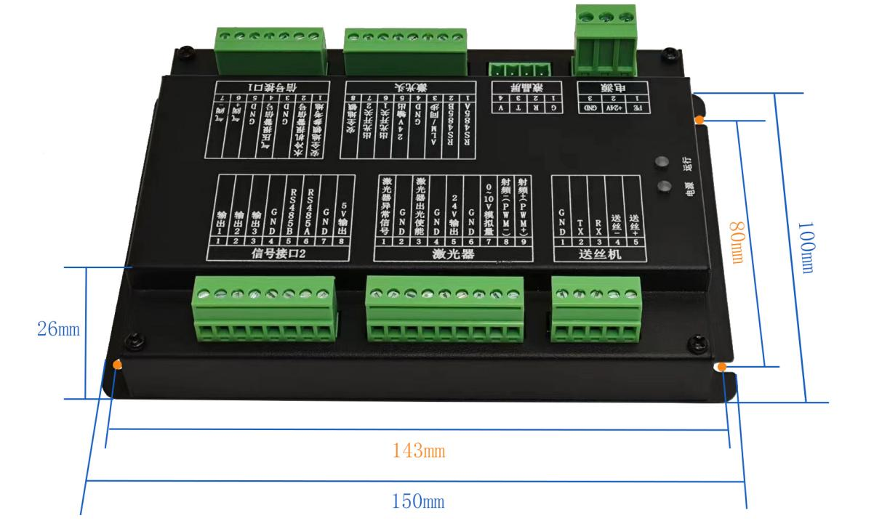
Figure 3.4 Control box
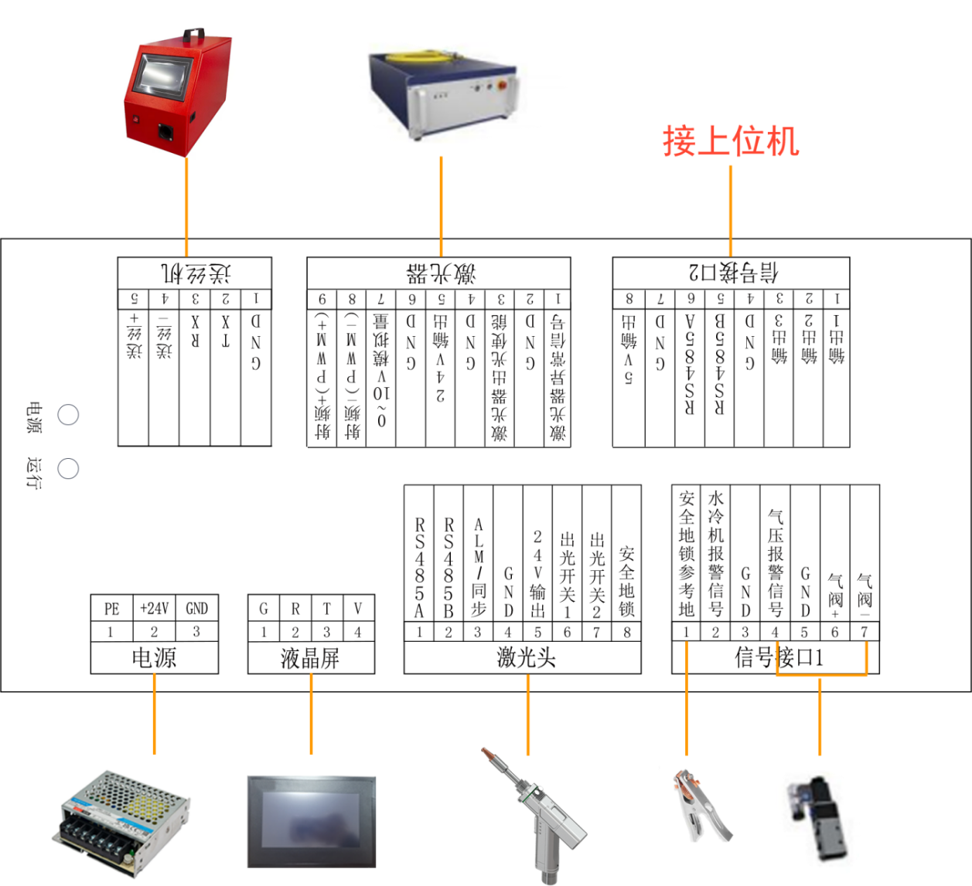
Fig. 3.5 Wiring Diagram
① In order to avoid abnormal power consumption of the product, the ground wire of the switching power supply must be effectively grounded! The product housing must be grounded!
② The icon used in Figure 3.5 only refers to a certain type of product, and does not specifically refer to the corresponding product.

3.2.1 Control box- [Power supply]
Signal [power] interface of control box, as shown in Table 3.2. Use the supplied 24 V switching power supply.
Power source
Pin number | Signal definition | Functional description
1 | PE | Ground wire.
2 | +24V | 24V input, connected to the positive output of 24V switching power supply, marked with [+ Vo].
3 | GND | Connected to the negative output of 24V switching power supply, marked with [-Vo].
Note: PE must be effectively grounded. 1. Make sure that the ground wire is connected and there is no connection or open circuit; 2. The ground wire itself is stable and uncharged (that is, the AC and DC voltages of the live wire and zero line to the PE line are less than 10 V, and it is better to maintain 0 V).

3.2.2 Control box- [LCD]
[LCD] connector, as shown in Table 3.3.
Table 3.3 [LCD] Interface Function Description
[LCD] connector
Pin number | Signal definition | Functional description
1 | G | White wire, two terminals [4 P-1 pin]- [6P-G pin], 24V power supply negative and cable shielding layer.
2 | R | Black wire, two terminals [4P-2 pin] — — [6P-R pin], 232 signal.
3 | T | Brown wire, two-end terminal [4P-3 pin] — — [6P-T pin], 232 signal.
4 | V | Blue wire, two-end terminal [4P-4 pin] — — [6P-V pin], 24V power supply positive.
Note: Comes with a full screen cable, plug and play.

3.2.3 Control box- [Laser head]
The [laser head] interface is shown in Table 3.4.
Table 3.4 [Laser Head] Interface Function Description
Signal interface 3
Pin number | Signal definition | Functional description
1 | RS485A | Blue line, marked [RS485A]
2 | RS485B | Blue and white line, marked [RS485B]
3 | ALM/Sync | Yellow line, marked [ALM]
4 | GND | Black wire + shielding layer, marked with [GND]
5 | 24V output | Red line, marked with [24V output]
6 | Light output switch 1 | Green line, marked with [Optical switch 1]
7 | Light output switch 2 | Green and white line, marked with [Optical switch 2]
8 | Safely locked | Brown wire, marked [securely locked]
3.2.4 Control box- [Signal interface 1]
Signal interface 1 is connected to air valve, safety lock, etc.
Table 3.5 Function Description of [Signal Interface 1]
Signal interface 1
Pin number | Signal definition | Functional description
1 | Safely lock the reference ground | Connect the safety ground clamp. Clamped on the workpiece, the gun head contacts the workpiece, and the [safety ground lock] is connected with the [safety ground lock reference ground].
2 | Alarm signal of water chiller | Input port. Receive the alarm signal of water cooler, and set [alarm level of water cooler] according to the alarm output voltage of water cooler. Air cooling equipment is not connected.
3 | GND | Signal ground
4 | Air pressure alarm signal | Input port. After receiving the air pressure alarm signal, set [air pressure alarm level] according to the alarm output voltage of the air valve.
5 | GND | Signal ground
6 | Air valve + | Air valve open: [air valve +] output 24 V; air valve closed: [air valve +] no output.
7 | Air valve- | Signal ground
3.2.5 Control box- [Signal interface 2]
The signal interface 2 is a reserved port, which is used for external expansion equipment with customized functions. Not usually used.
Table 3.6 Function Description of Signal Interface 2
Signal interface 2
Pin number | Signal definition | Functional description
1 | Output 1 | Reserved opening
2 | Output 2 | Reserved opening
3 | Output 3 | Reserved opening
4 | GND | Signal ground
5 | RS485B | 485 communication
6 | RS485A | 485 communication
7 | GND | Signal ground
8 | 5V output | Normal 5V output

3.2.6 Control Box- [Laser]
Used to control the laser.
Table 3.7 [Laser] Interface Function Description
[Laser] Interface
Pin number | Signal definition | Functional description
1 | Laser abnormal signal | Input port. Connected to laser alarm. Signal device according to laser [laser alarm level]
2 | GND | Signal ground
3 | Laser light output enable | Connected to laser enable +, output 24 V when emitting light
4 | GND | Signal ground
5 | 24V output | Normal 24V output
6 | GND | Signal ground
7 | 0 ~ 10 V analog | Analog output (default 0 to 10 V analog voltage).
8 | RF- (PWM-) | PWM-modulated signal
9 | RF + (PWM +) | PWM + modulated signal

3.2.7 Control box- [Wire feeder]
Control the work of Super Weiye Wire Feeder.
Table 3.8 [Wire Feeder] Interface Function Description
[Wire feeder] interface
Pin number | Signal definition | Functional description
1 | GND | Signal ground. Wire transfer machine signal line, marked with [GND]
2 | TX | 232 communication. Wire transfer machine signal line, marked with [RXD]
3 | RX | 232 communication. Signal line of wire transfer machine, marked with [TXD]
4 | Wire feed- | Signal ground. Wire feeder signal line, marked with [wire feeding-]
5 | Wire feeding + | Wire feeding is enabled, and [Wire feeding +] and [Wire feeding-] are conducted during wire feeding. Connecting and sending machine signal line, marked with [wire feeding +]
The standard wire feeder only needs to be connected to [4, 5 pins], and the process warehouse only needs to be connected to [1, 2, 3 pins] for communication.

3.3 Equipment connection
The gun body interface is shown in Figure 3.6, mainly including the gas circuit interface, QBH and system connection line interface.
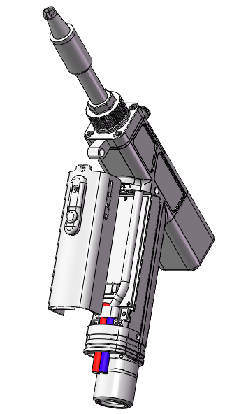
Fig. 3.6 Interface diagram of welding head
As shown in the figure:
Red indicates the system connection line. [Laser head]- [System connection line]- [Control box] connection.
Blue indicates the trachea. Adopt φ6mm air pipe interface.

3.3.1 Optical fiber head connection
The product [QBH] interface is suitable for most industrial lasers. Attention should be paid to the following when installing:
① Keep the device clean;
② Install the optical fiber head and place it horizontally with [QBH];
③ According to the scale of [Lock] and [Unlock] in Fig. 3.7, first rotate and loosen QBH, insert the optical fiber head and then lock it. After locking, the optical fiber head shall be placed in [QBH] without shaking.
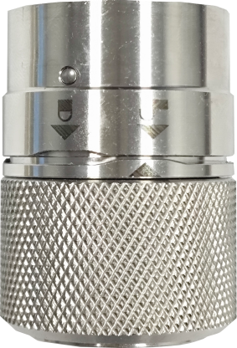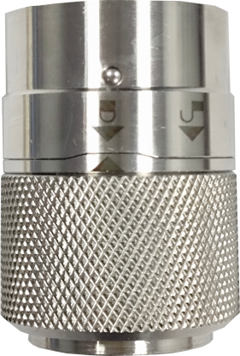
Figure 3.7 QHB [Unlock] and [Lock] Status

3.3.2 Control box connection
The handheld laser welding head is connected to the control box through the [system connection line]. This is shown in Figure 3.8. [Bond Head]- [System Cable] is connected. [System connection line]- [Control box] is connected by (3.81-8P) terminal. For detailed definition, refer to 3.2.3 Control box- [Laser head].
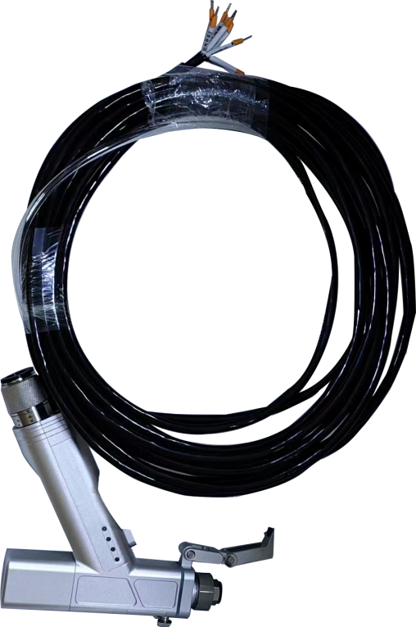
Figure 3.8 Bond Head and System Connection Line

IV. Interface operation and function switching
① Switch between [welding system] and [cleaning system] through the screen.
② When using the cutting function, set [Scan Width] to [0] under [Welding System]. And replace the [copper cutting nozzle], as shown in Figure 4.1.
③ When using the weld cleaning function, in [Welding Mode], set [Scan Width] slightly larger than [Weld Width]. Replace [AS-20D copper nozzle] as shown in Fig. 4.2.
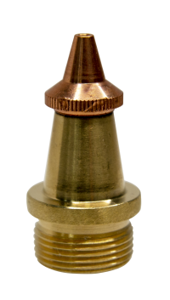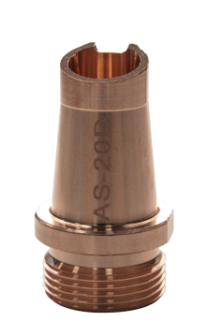
Fig. 4.1 Cutting Copper Nozzle Fig. 4.2 AS-20D Copper Nozzle

4.1 First page
The switches used to display the current process, alarm information and adjust the main output signals are shown in Figure 4.3, 4.4 and 4.5.
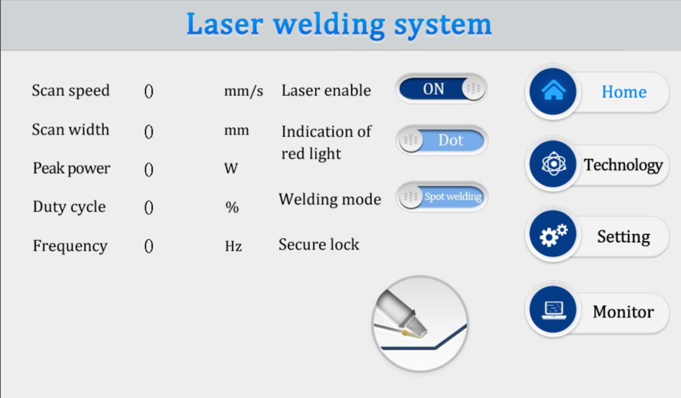
Figure 4.3 Laser Welding System Interface Operation Home Page
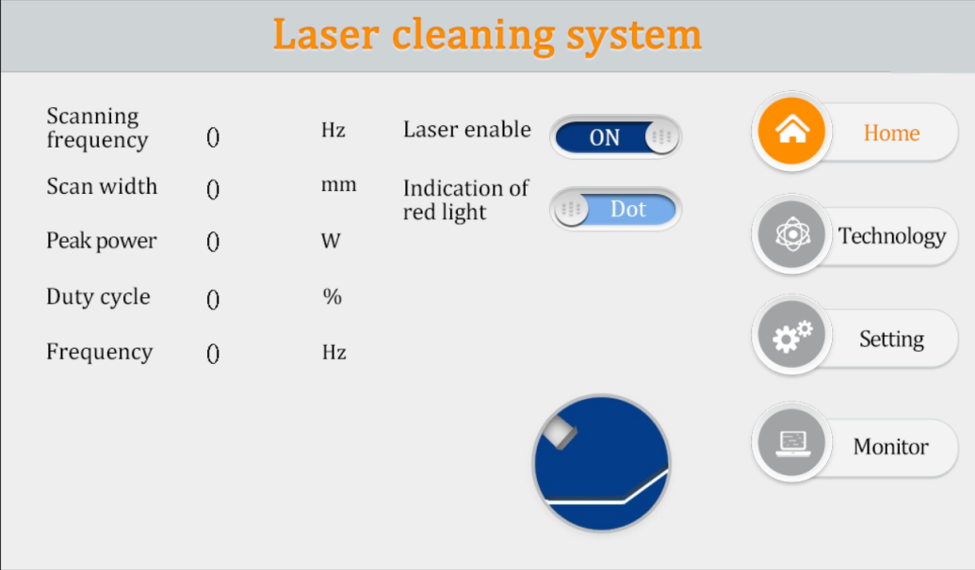
Figure 4.4 Laser Cleaning System Interface Operation Home Page
① [Laser Enable-On/Off]: control and indicate whether to output [laser emission enable signal].
② [Indicate red light-point/line]: control and indicate whether the galvanometer motor swings. Adjust the red light to [point] or [line] without affecting the presence of the red light.
③ [Welding Mode-Spot Welding/Continuous]: [Continuous] is usually used. [Spot Welding] is an intermittent light output according to the parameters on the setting page, which is used for fish-scale welding.
④ [Switching Mode]: The upper right corner is the switching button, which is used to switch [Welding Mode] or [Cleaning Mode].

4.2 Process page
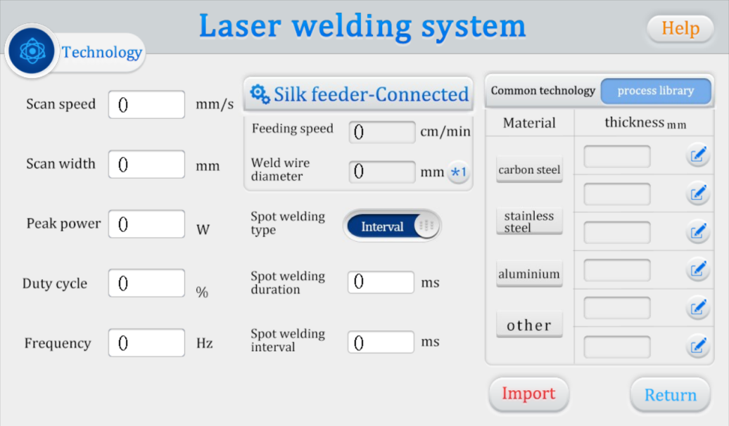
Figure 4.5 Common Process Page of Laser Welding System
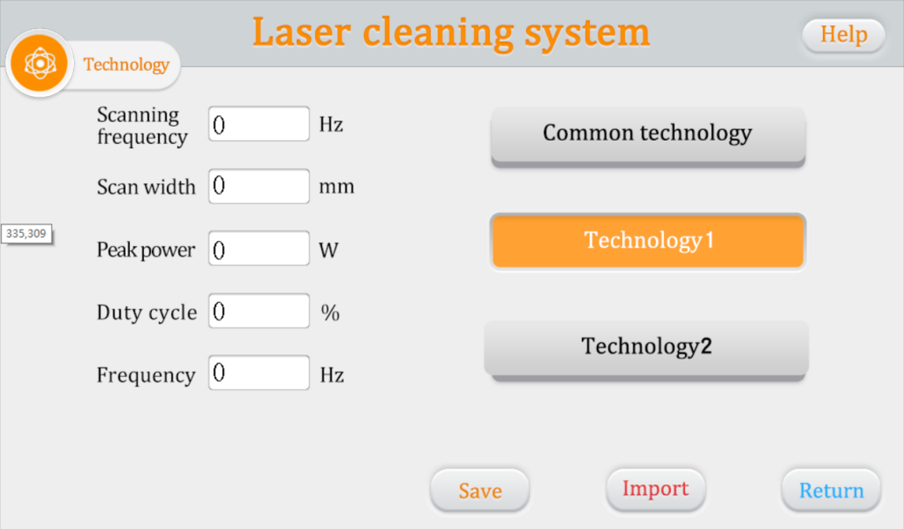
Figure 4.6 Laser Cleaning System Adjustment Parameters Page
① [Scanning speed]: The linear speed of the focus spot movement, which affects the welding quality. Taking [scan width] 3 mm as an example, it is usually set to 600 to 1200. The [welding speed] increases and the [scanning speed] correspondingly increases.
[Scanning frequency]: the number of cycles of back and forth scanning of the focusing spot in 1 second, which affects the accuracy or fineness of the cleaning surface. Typically set to 50 to 100 Hz.
② [Scanning width]: control the spot size corresponding to the theoretical width of the spot. Adjust according to the weld size.
③ [peak power]: the maximum power at the time of light output, or processing power, welding power.
④ [Duty cycle, pulse frequency]: [Duty cycle 100%] [Pulse frequency 2000] is usually set. The equivalent processing power can be changed by adjusting the duty cycle and pulse frequency according to the characteristics of the laser, and usually no adjustment is made.
⑤ [Common process]: indicates the number of the current process group. The welding mode provides 3 groups of common processes. Press the gun body [Process switching button] to switch quickly.

Figure 4.7 Laser Welding-Process Library Parameters Page
⑥ [Wire feeder]
[Wire Feeder-Connected/Unconnected] indicates the [RS232] communication status of the wire feeder (does not affect the wire feed enable signal). When [Connected], parameters such as [Wire Feed Speed] will be synchronized.
[Wire Diameter-x1/x2] [Wire Diameter] here is to help the operator to record the process conditions. [X1/x2] corresponds to [single wire process library] [double wire process library].

4.3 Setup Page
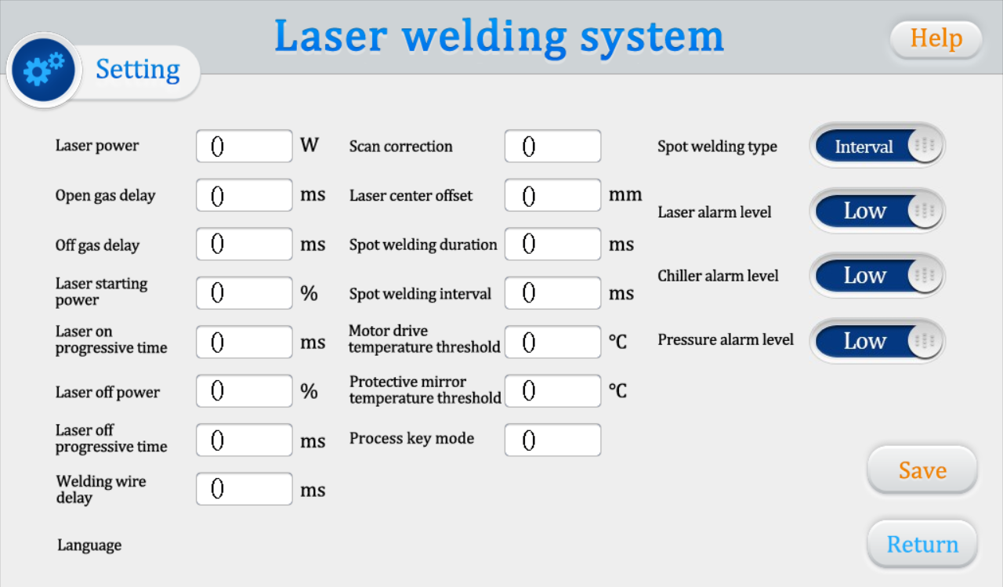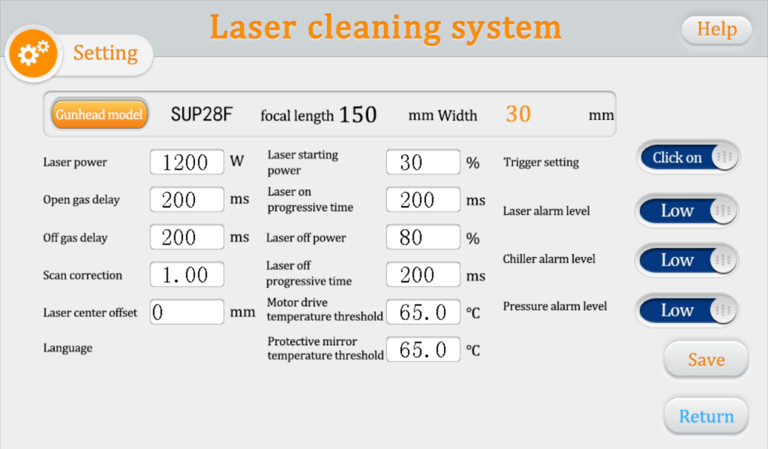
Fig. 4.7 Factory parameter setting page of laser welding and cleaning system
The page shown in Figure 4.7 is used to set the factory parameters, including the power and alarm level of the product.
① [Laser power]: subject to the actual laser.
② [Wire feeding delay compensation]: wire feeding in advance. Example: Set 1000, after pressing the trigger, first feed the wire for 1 s and then send out the light.
③ [Scanning correction]: correction coefficient = target line width/measured line width, used to adjust the actual spot size to make it consistent with the system display.
④ [Laser center shift]: [-] indicates left shift, and [+] indicates right shift. It is used to adjust the light spot to make it centered.
⑤ [Gas opening delay]: release the gas in advance before the light comes out.
⑥ [delay of closing the gas]: after the light is closed, the gas is closed later.
⑦ [On/Off Optical Power] [On/Off Optical Asymptotic Time]: As shown in Figure 4.8, [On Asymptotic Time T1] represents the time from [On Optical Power N1] to [Peak Power N3], and [Off Asymptotic Time T2] represents the time from [Peak Power N3] to [Off Optical Power N2].
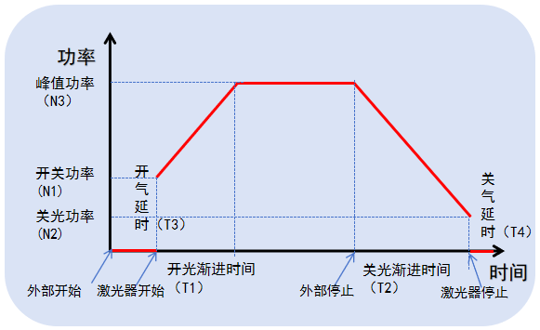
Fig. 4.8 Time Relationship of Glowing and Gassing
⑧ [Temperature threshold]: Maximum 70 ℃. When this value is set to 0, no temperature alarm will be detected.
⑨ [Alarm level-high/low]: set to low level when not in use, according to the external product setting.
⑩ [Spot welding type-Intermittent/Fish scale]: [Fish scale] is applicable to fish scale welding, and [Intermittent] is applicable to sectional welding.
[Spot welding duration] [Spot welding interval]: as shown in Fig. 4.9, [T1] no light, [T2] light.
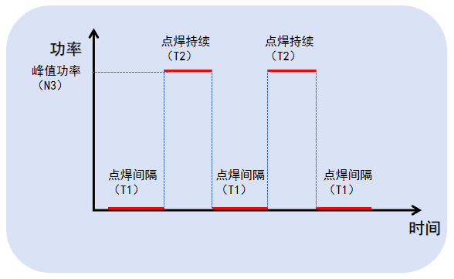
Figure 4.9 Relationship between spot welding power and time
[Trigger setting-single/double click]: In the cleaning mode, control the trigger mode. Usually set to [double-click].
[Gun Model-Focal Length-Width]: Switch the maximum scanning width when using different focusing lenses. The correspondence is shown in Table 4.1.
Table 4.1 Focused Sweep Width
F150mm | 30mm
F400mm | 60mm
F800mm | 120mm

4.4 Monitoring page
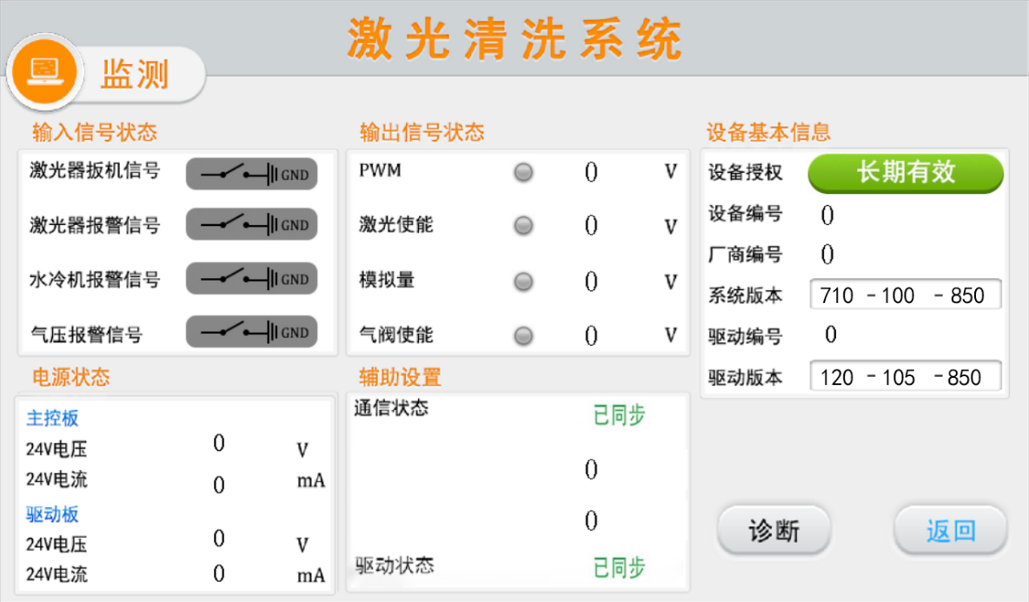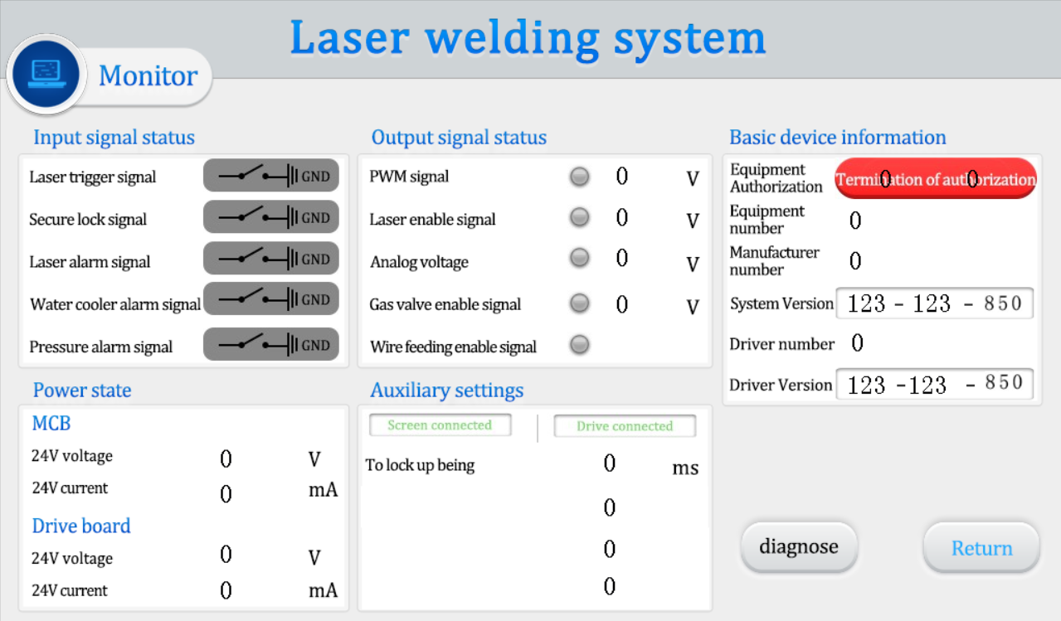
Figure 4.10 Laser welding and cleaning system monitoring page
The page shown in Figure 4.10 displays the monitored real machine information.
① The [input signal transition] [output signal state] [power state] is a real-time monitoring signal, which is used to judge whether the product works normally.
② [Product basic information]:
- [Product Authorization] can be clicked for operation and used for product encryption.
- [Product No.] [Manufacturer No.] [System Version] is a simple display information, which is provided to technicians in after-sales work.
③ [Auxiliary status]:
- [XX temperature] is the measured temperature, and the system will give an alarm when it exceeds the [XX temperature alarm threshold] corresponding to the setting page.
- [Ground lock anti-shake] is the compatible intermittent time in case of poor contact of [safety ground lock] signal, with a range of [0 ~ 300 ms]. Click [Product Authorization] and enter [FFFFFFAAxxx], where [XXX] is the time. Valid in welding mode.

4.5 Diagnosis page
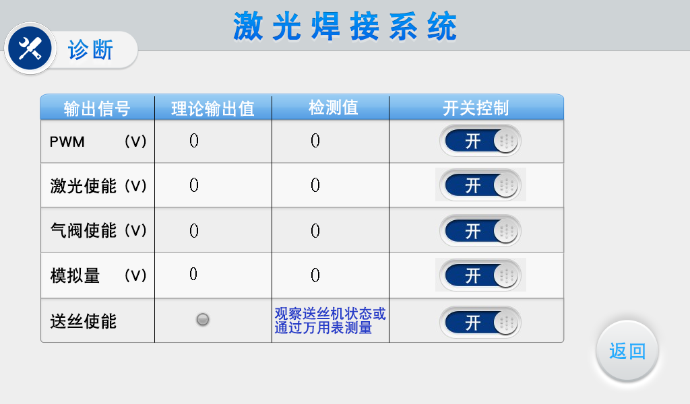
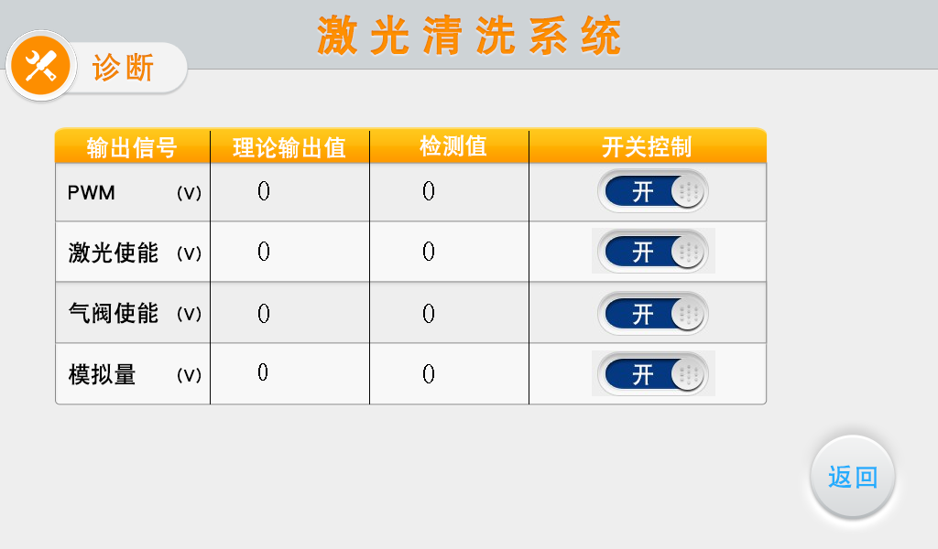
Figure 4.11 Cleaning system diagnosis page
The image above is a demonstration of the diagnostic mode. This mode can only be used for [separate signal] output, which is used to judge whether the output signals of the main control board are normal under safe conditions. This mode cannot emit light.

4.6 Wire feed sheet
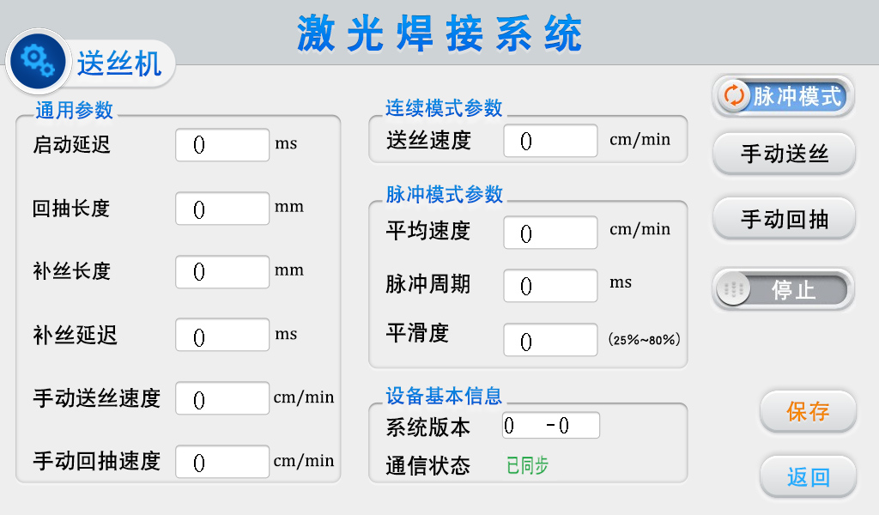
Figure 4.12 Laser Welding System Process Library-Wire Feeder Parameters
① [Wire feeder] interface [1, 2, 3] pin, after connection, the welding system is connected with the wire feeding system. Synchronous adjustment of parameters.
② The wire feeding parameters can be adjusted when the [communication port] is connected to the wire feeder, and the parameters of the wire feeding page are consistent with those of the original [wire feeder].
③ [Continuous mode/Pulse mode] is used to switch the wire feeding status. [Continuous mode] is usually used. [Pulse mode] is used for fish scale welding.
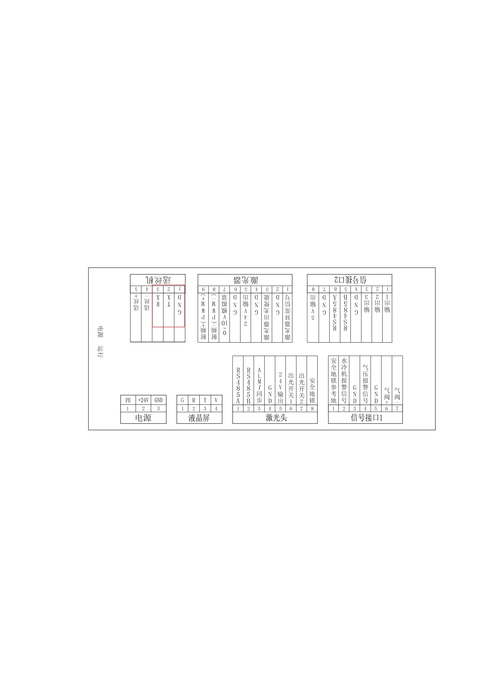
Fig. 4.13 Communication Interface of Wire Feeder

V. Daily maintenance of products
1. It is recommended that users clean dust of the chassis cooling system once a month to keep the chassis ventilated smoothly.
2. Lens maintenance and replacement should be carried out in a relatively clean field environment. When opening the protective lens, focusing lens compartment cover, pulling out the lens bracket and other open operations, they should be well protected (covered with masking paper). The replacement methods of different lenses corresponding to all gun types can be viewed in the WeChat applet → Super Weiye → Lens Installation.
3. Handle with care when using. For complex production environment, please clean dust in time.



VI. Common product problems and handling measures
Warning! Before dealing with any problem, all power must be cut off to avoid any danger!
The repair and maintenance of this product must be completed by professionals! Do not operate without training! If there is any problem, please contact the dealer to find a professional to deal with!
Once the product has any appearance damage, do not repair it, please scrap it directly.
Common alarm descriptions and solutions to problems are as follows:
Problem item | Phenomenon | Solutions
Temperature alarm, indicating that various temperatures are too high | Home page prompt XXX temperature is too high | General lens temperature alarm, usually first check whether the lens is damaged, replace the damaged lens.  If the lens is normal, it is necessary to directly shield the alarm on the setting page, and set the corresponding lens temperature alarm threshold to 0 on the setting page.
Chiller/Laser/Barometric Alarm | Pop-up window on the home page displays chiller/laser/air pressure alarm | Alarm logic of level: the system will compare the wiring mode of the corresponding product with the set level on the setting page, and the alarm will be given if it is different.  Generally, the alarm is caused by the wrong setting of the alarm level. It is enough to change the corresponding alarm level.  If an alarm occurs when an alarm signal is received, no matter how it is set, please unplug the alarm signal line and set it to low level.
The welding effect is poor | At the beginning, the light is very strong, but it gradually becomes weak/weak, resulting in failure to fuse. | Usually, the welding gun lens is damaged, including but not limited to protection lens, focusing, collimation and reflection, any one or more of which may cause this situation. First replace the protective lens and look at the focus, then check the reflection and collimation, and replace the damaged lens. The spark at the copper nozzle may be the focus problem, which should be eliminated first. In addition, check whether the laser fiber head is dirty or damaged.
The motor does not swing | The light spot is a point | I. Whether the software part is set correctly  Setup-Scan Rectification: 1.0 or 1.25  Process-scan width: greater than 0  Home-Indicator Red: Line  II. Hardware inspection (first installation)  The motor driver supplies 24 V power to the motherboard. We should first measure whether the [24V output] [GND] of the [laser head] interface is normal. This interface controls whether the motor can oscillate.
The motor swings abnormally | ① After power on, the motor at the tail of the welding head squeaks/swings abnormally with red light/heats up/the swing width cannot be adjusted  ② The lens is directly burned out, and the sealing ring and the focusing lens are burned out at the same time. | The [RS485A] and [RS485B] of the [laser head] interface control the motor swing width, speed and other parameters. In case of signal error (poor line contact, open circuit), external interference, or mismatching between the driver and the motor, the problem ① may occur.  If the problem of ② occurs, it is recommended to check the surrounding interference source. If there is no interference source, it may be the motor line fault, and the motor line can be replaced directly.
For more troubleshooting options, see the [Troubleshooting] page of the WeChat applet


