Super great cause SUP22C handheld laser cleaning head equipment manual

catalogue
1. Overview 1
Product features: 2
1.1 Operating environment and parameters 2
1.2 Attention information 3
2. Installation and connection 3
2.1 Controller interface definition 3
2.1.1 Power supply terminal of the controller 5
2.1.2 The LCD screen terminal of the controller 5
2.1.3 Controller signal interface 1 5
2.1.4 Controller signal interface 2 6
2.1.5 Controller signal interface 3 6
2.2 Terminal block diagram of the controller 7
2.3 Optical fiber input interface 8
2.4 Protect the gas and the water cooler interface 8
2.5 The connection interface between the cleaning gun and the control box 8
3. Control panel operation guide 9
4. Maintenance 16
5. Common exception handling 17
5.1 Warning of laser / water cooler / air pressure alarm 17
5.2 Screen not bright / click not responsive 17
5.3 No light 17
5.4 Suddenly stop producing light during processing 17
appendix 18
Three-phase power wiring reference: 18

Thank you for choosing the great great laser handheld cleaning head three-in-one system, this user manual provides you with important safety, operation, maintenance and other information. Therefore, please read this user manual carefully before using this product.
To ensure operational safety and optimal product performance, follow the following precautions and warnings and other information in the manual.

1. Overview
This manual covers the general description of the basic installation, factory setting, operation and maintenance services of SUP series 22C handheld cleaning head products.
SUP22C Laser handheld cleaning head is a newly launched application in the field of handheld cleaning single motor scanning swing laser head —— hereinafter referred to as SUP22C. The product covers the handheld laser cleaning head and the self-developed control system, and sets multiple safety alarms and active safety power failure, blackout Settings. It is developed on the basis of our mass production of SUP21C handheld laser cleaning head. Compared with the previous generation, it is further improved in insulation, stability, maintenance and other aspects, and has more compact, lighter and more reliable characteristics.
The product can be adapted to various brands of fiber laser, can work stably for a long time under 3000W, optimize the control program, so that the overall cleaning effect is more uniform.
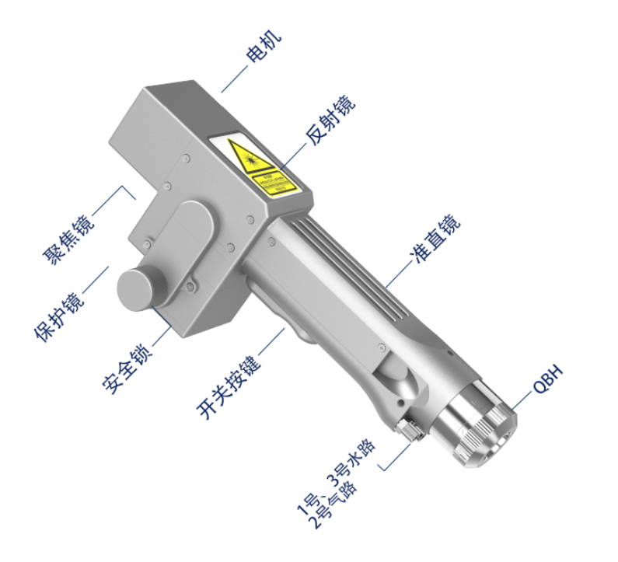
Figure 1.1 Schematic diagram of the SUP-22C cleaning head

Product features:
● Basic features of products: independently developed control system and structural design, adapt to various cleaning requirements within 3000W, set multiple safety alarms, simple and flexible operation.
● The whole machine is more stable: all parameters can be seen, and the state of the whole machine is monitored in real time to avoid problems in advance, facilitate troubleshooting and troubleshooting, and ensure the stable operation of the hand-held cleaning head.
● Unique air knife design: the unique exit "air knife" design, can greatly increase the light port protection gas flow rate, better prevent lens pollution.
● Controlled parameters and high repeatability. Stabilize the mechanical structure and lens state, only to meet the laser power stability, the process parameters must be repeated, greatly improve the efficiency.

Operating environment and the parameters
As shown in Table 1.1, the operating environment requirements and main parameters of SUP22C:
Table 1.1 Operating environment requirements and main parameters of SUP22C
service voltage (V) | 220V±10% AC 50/60Hz
Put the environment | Flat, no vibration and impact
Working environment temperature: (℃) | 10～40
Working environment humidity: (%) | ＜70
cooling-down method | hydrocooling
Applicable wavelength | 1064nm（±10nm）
Applicable power | ≤3000W
alignment | D16*5-F60
focus | D20*3.5-（F400/F600/F800）
reflex | 20x15.2xT1.6
Protection mirror specifications | D30*T5
Maximum air pressure support | 15Bar
Focus of vertical adjustment range | ±10mm
Scan Width-Wash | F400-0~150mm
Scan Width-Wash | F600-0~225mm
Scan Width-Wash | F800-0~300mm
weight | 0.7kg

Pay attention to information
(1) Ensure reliable grounding before power supply.
(2) The laser output head is connected with the hand-held laser head through QBH, please carefully check the laser output head to prevent dust or other pollution. Please use special lens paper when cleaning the laser output head.
(3) If the equipment is not used according to the method specified in the manual, it may be in an abnormal working state and lead to damage.
(4) When replacing the protective mirror, please ensure good protection.
(5) Please note: for the first time, when the red light can not come out of the copper mouth, be sure not to shine.

2. Installation and connection

2.1 Controller interface definition
Hand-held laser head controller interface definition as shown in Table 2.1:
Table 2.1 Definition of the SUP22C controller interface
plug |  | definition | Signal type | Explain in detail
source | 1 | -15V | import | V2 connected to the ± 15V switch power supply to provide the-15V power supply voltage
source | 2 | GND | To refer to | Any COM connected to the ± 15V open power supply
source | 3 | +15V | import | V1 connected to ± 15V switching power supply provides + 15V power supply voltage
source | 4 | GND | To refer to | A-V connected to the 24V switch power supply
source | 5 | +24V | import | A + V connected to the 24V switching power supply
LCD | 1 | G | To refer to | Power to
LCD | 2 | R | transmitting terminal | Data direction: the controller LCD screen
LCD | 3 | T | receiving terminal | Data direction: the LCD screen controller
LCD | 4 | V | output | Provide 24V power supply for the LCD screen
Signal interface 1 | 1 | GND | To refer to | Signal ground
Signal interface 1 | 2 | Air pressure alarm signal | import | The setting page can set the polarity of the alarm signal and the low level alarm when not in use
Signal interface 1 | 3 | GND | To refer to | Signal ground
Signal interface 1 | 4 | Water-cooler alarm signal | import | The setting page can set the polarity of the alarm signal and the low level alarm when not in use
Signal interface 1 | 5 | Safety ground lock reference place | Isolation | Six-core wire-yellow line (reference place for upper mark safety lock)
Signal interface 1 | 6 | Safety lock | import | Six-core wire-blue line (upper safety lock)
Signal interface 1 | 7 | Wash head light switch 1 | import | Six-core-black line (marked light switch 1)
Signal interface 1 | 8 | Wash head light switch 2 | import | Six-core-brown (marked light switch 2)
Signal interface 2 | 1 | Temperature measurement 1 | import | Hang in the air
Signal interface 2 | 2 | Temperature measurement 2 | import | Six-core line-red line (upper temperature 2)
Signal interface 2 | 3 | Protection Gas Valve- | To refer to | Signal ground (reference ground of 2 / 4 feet)
Signal interface 2 | 4 | Protective gas valve + | output | Air valve opening: output 24V;  Valve shutdown: no output.
Signal interface 2 | 5 | wire feed- | output | Hang in the air
Signal interface 2 | 6 | wire feed + | output | Hang in the air
Signal interface 3 | 1 | Laser abnormal signal | import | Laser device alarm signal
Signal interface 3 | 2 | The laser enables light | output | The enabling signal of the laser device
Signal interface 3 | 3 | 24V output | output | 24V output, power directly output 24V voltage.
Signal interface 3 | 4 | GND | To refer to | Reference (foot 1 / 2 / 3 / 5)
Signal interface 3 | 5 | The 0~10V simulation quantity | output | Analog amount of the connected laser, DA +
Signal interface 3 | 6 | RF- (PWM-) | output | Laser pulse-width-modulated signal-
Signal interface 3 | 7 | RF + (PWM +) | output | Laser pulse width modulation signal +

2.1.1 Power supply terminal of the controller
The power supply end uses 5P interface, with random 24V switching power supply and ± 15V switching power supply.
Please note that the 15V switching power supply distinguishes between positive and negative poles, V1 + 15V, V2-15V, any COM on the 15V switching power supply is connected to the 2 pin GND!
Please note that the switching power supply must be grounded!

2.1.2 The LCD screen terminal of the controller
The LCD screen wiring is randomly attached and connected directly. See Table 2.1 above for specific definition.

2.1.3 Controller signal interface 1
Signal interface 1 uses 8P interface and is the input signal interface, and the detailed interface definition is shown in Table 2.2:
Table 2.2 Functional description of the signal interface 1
Signal interface 1
The pin number | Signal definition | function declaration
1 | GND | For the pressure alarm signal input port, if you need to enable (wiring), please set the "pressure alarm level" of the display setting page with the actual air valve alarm level.
2 | Air pressure alarm signal
3 | GND | Water tank alarm signal input port. If you need to enable (wiring), please set the "water cooler alarm level" on the display setting page consistent with the actual water cooler alarm level.
4 | Water tank alarm signal
5 | Safety ground lock reference place | Six-core wire-yellow line (reference place for upper mark safety lock)
6 | Safety lock | Six-core wire-blue line (upper safety lock)
7 | Wash head light switch 1 | Six-core-black line (marked light switch 1)
8 | Wash head light switch 2 | Six-core-brown (marked light switch 2)
Note: Note that normal output signal on the subsequent output port only when there is no alarm and the safety lock and switch signal are displayed in green.

2.1.4 Controller signal interface 2
Signal interface 2 uses 6P interface and detailed functional definition is shown in Table 2.3:

Table 2.3 Functional description of the signal interface 2
Signal interface 2
The pin number | Signal definition | function declaration
1 | Temperature measurement 1 | Hang in the air
2 | Temperature measurement 2 | Protective mirror temperature measurement
3 | Protection Gas Valve- | Air valve open: protection air valve + output 24V;  Air valve close: protection air valve + no output.
4 | Protective gas valve +
5 | wire feed- | Hang in the air
6 | wire feed + | Hang in the air

2.1.5 Controller signal interface 3
The signal interface 3 uses the 7P interface, and the detailed functional definition is shown in Table 2.4:
Table 2.4 Functional description of the signal interface 3
Signal interface 3
The pin number | Signal definition | function declaration
1 | Laser abnormal signal | To enable (wiring), set the "laser alarm level" on the display setting page consistent with the alarm level of the actual laser.
2 | The laser enables light | Enabling +, connected to the laser enabling +.
3 | 24V output | 24V output, power directly output 24V voltage.
4 | GND | Common ground (reference ground for foot 1 / 2 / 3 / 5)
5 | analog quantity + | Analog output (the default is 0-10 V analog voltage).
6 | RF- (PWM-) | PWM-modulating signal
7 | RF + (PWM +) | PWM+ modulating signal

Click for details: Laser wiring definition logic

2.2 Terminal block diagram of the controller
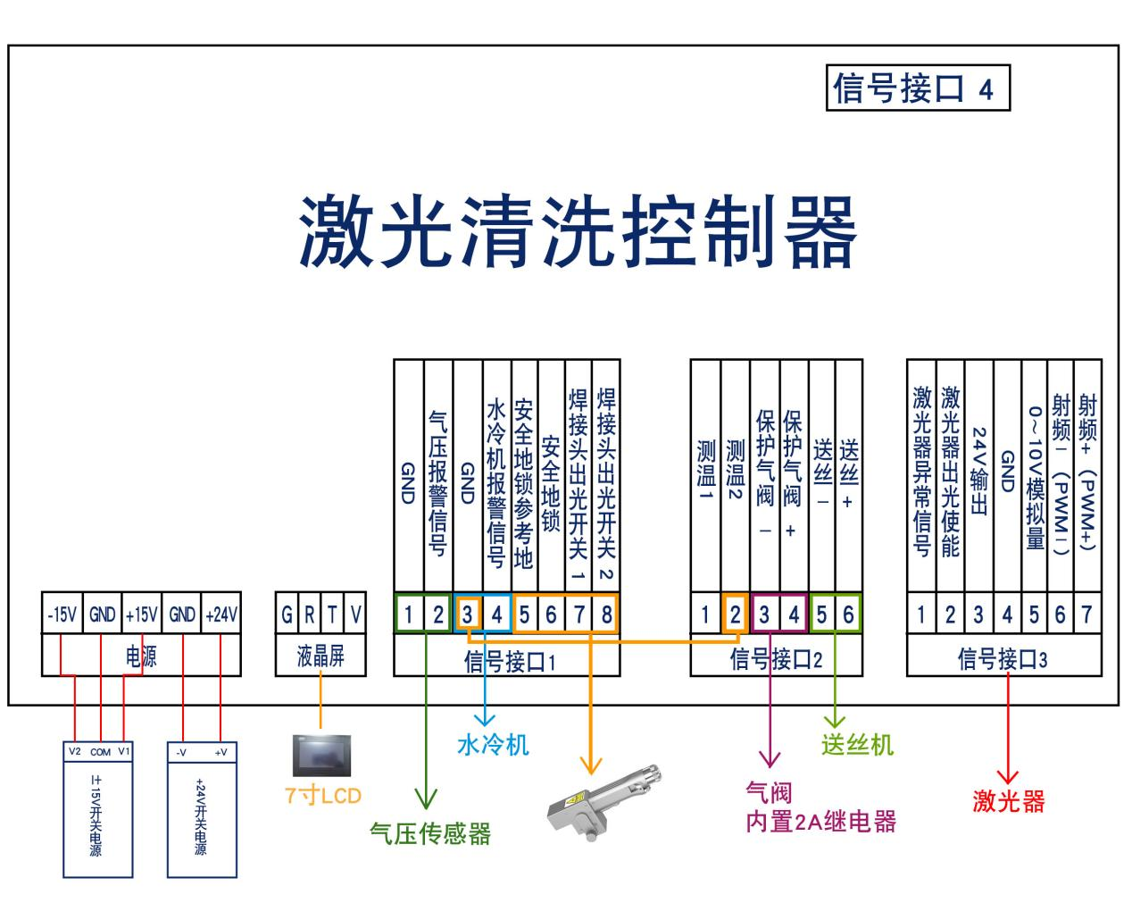
Figure 2.1 Terminal block diagram of the controller
Note: The ground wire of the switch power supply must be effectively grounded!
Note: Both the ± 15V switching power supply COM end and the + 24V switching power supply-V (0V) end should be connected to the GND. The switching power supply shell must be connected to the earth, otherwise there may be no light and other abnormalities.

2.3 Optical fiber input interface
SUP cleaning head is suitable for the vast majority of industrial laser generators, commonly used optical fiber joints including IPG, Ruike, Chuangxin, Feibo, Spurs, Jept, Kaplin, etc. The optics must be kept clean, all dust must be removed before use, and the torch head must be placed horizontally to prevent dust from falling into the interface.
method of erection

2.4 Protect the gas and the water cooler interface
The water pipe and gas pipe interface can be installed with a hose with outer diameter 6mm inner diameter 4mm. Access and exit pipeline of waterway (regardless of entry and exit direction)
The cooling system distinguishes the water part of shampoo and the water part of optical fiber head in series, as shown in the figure below:
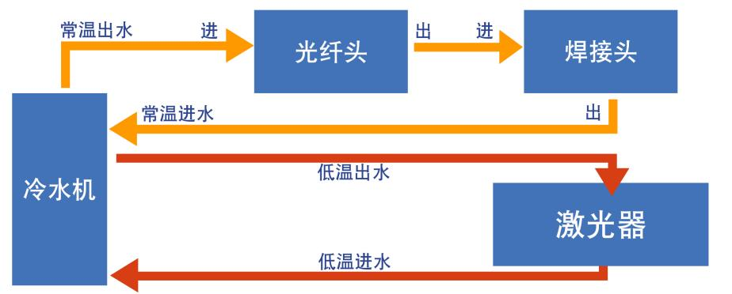
Fig. 2.2 Schematic diagram of cleaning head and optical fiber head waterway

2.5 The connection interface between the cleaning gun and the control box
The handheld cleaning head is connected to the control box through a group of "multi-function system connecting cables". The handheld cleaning head is the aviation plug female head, and the control box end is the aviation plug male head. The six-core wire gun body controls the light and temperature monitoring, and the two-core and five-core wires are the vibrator motor control line.

The Control Panel Operating Guide

This article describes the software description of the version number V5.80-639-550, you can view the system version through the monitoring page, update time-December 28,2022.
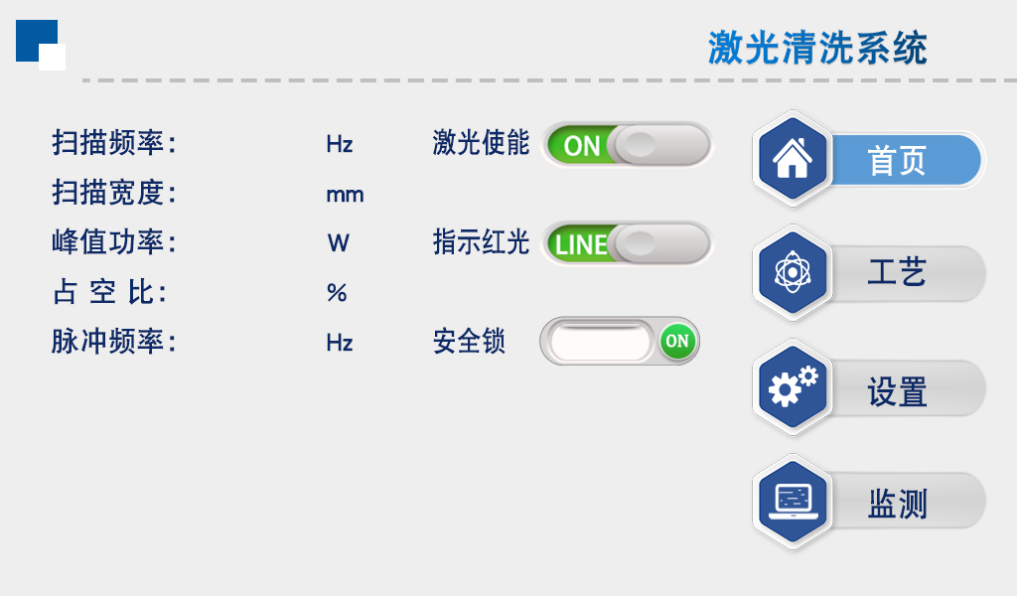
Figure 3-1 Home page-Light out
① This interface can see the current process parameters (this page can not modify the process) and instant alarm information.
② Power ault default ON, red light default LINE,
When the display "OFF" will not send an enabling signal to the laser and can be used to test the vent function
Close the red light indicator and show that the "DOT" motor stops swinging, when the red light is a point to adjust the center
③ "Safety lock", when the gun body "safety lock" is opened, the displayed green "ON" can be normally illuminated, and the closed red "OFF" can not shine.
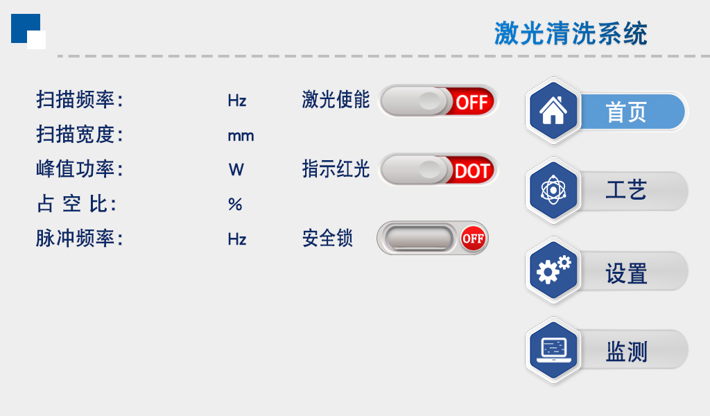
Figure 3-2 Home page-Guan Guang

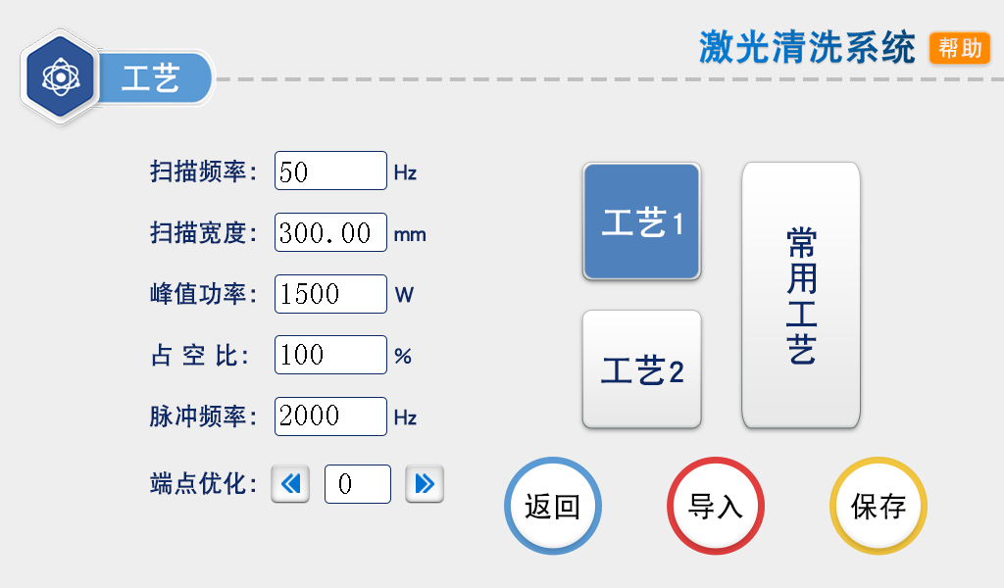
Figure 3-3, the process page
① The process interface contains the process parameters of debugging, click the box (red) to modify, click OK, and then save in the quick process, click import (modify-save-import).
② The scan frequency range is 10-100 HZ, and the scan width range is 0 ^ 300mm.
(Common scanning speed: 50 hz, width of 300mm).
③ The peak power should be less than or equal to the laser power of the parameter page (if the laser power is 1000W, this value is not higher than 1000).
④ Duty cycle range 0 to 100 (default 100, usually not changed).
⑤ The pulse frequency range is recommended from 5-5000Hz (default 2000, usually not changed).
⑥ Click the HELP button on the top right to get more relevant parameter explanations.
⑦ Endpoint optimization: range-20~20, which can eliminate the phenomenon of uneven light out at both ends of the cleaning track. The default is 0, please adjust to the ideal state according to the actual situation.

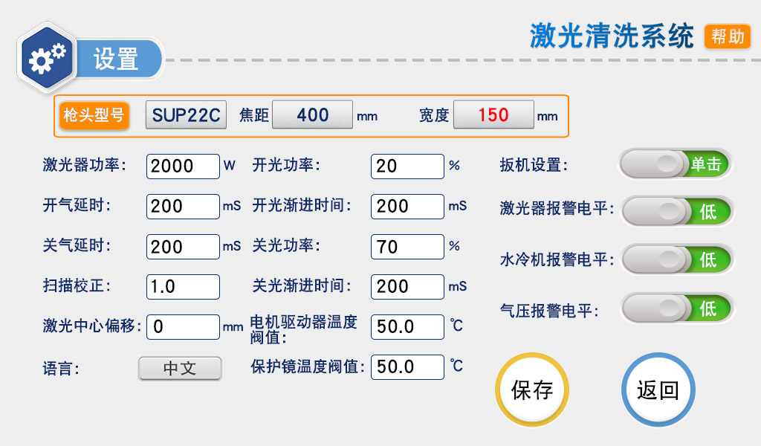
Figure 3-4, the Settings page
Password: 123456
① The laser power is the power of the used laser, please fill in correctly.
② The default gas delay default 200ms, range 200ms-3000ms.
③ From N1% of process power to 100%; from 100% of process power to N2; (as shown in the figure below).
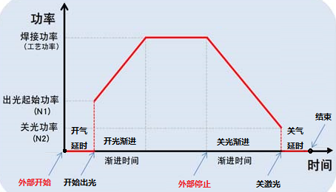
Figure 3-5 Setting page-parameter description
Generally, the preset switch light power is 20%, and the switch light step time is 200ms
⑤ The maximum temperature alarm valve value is 65℃. When the value is set to 0, the temperature alarm is not detected.
⑥ Scan correction coefficient range 0.01~4, coefficient target line width / measured line width: the default is 1.0.
⑦ Laser center offset-75~75mm, reduced to the left, increased to the right shift, applied to adjust the red light center
⑧ The pressure / water cooler / laser alarm level signal is low level by default. When this alarm signal is used, if the external pressure alarm is installed, it will be changed to high level, otherwise abnormal alarm will appear, and other alarm signals should be the same.
⑨ Click the "Chinese" button, you can switch to other languages in the language selection bar. Currently, the standard version supports eight simplified Chinese, traditional Chinese, English, Japanese, Japanese, Korean, Russian, German and French. Please contact us if necessary.
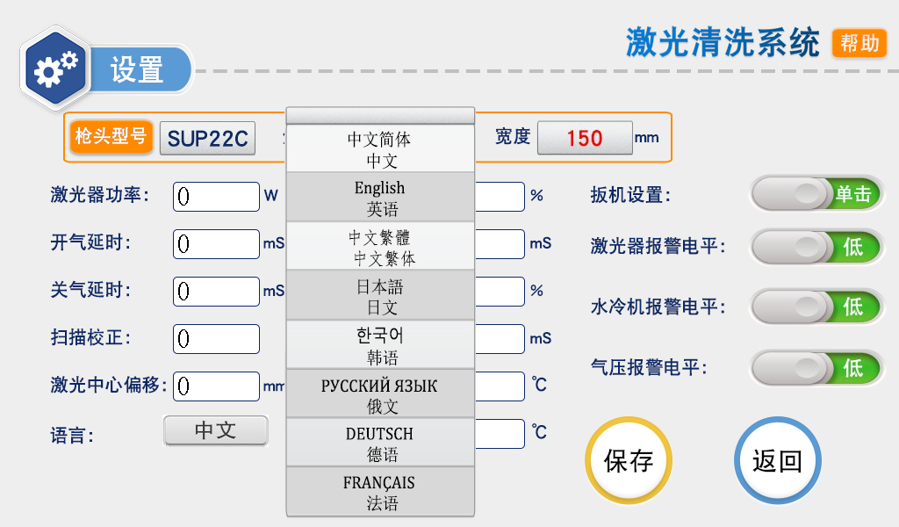
Figure 3-6 Set-up page-language switch
⑩ This page is the setting page help page, long press "Restore factory Settings" for 3 seconds, can restore all set parameters to "factory parameters", long press "Save as factory settings" for 3 seconds, can set the current set parameters to "factory parameters".
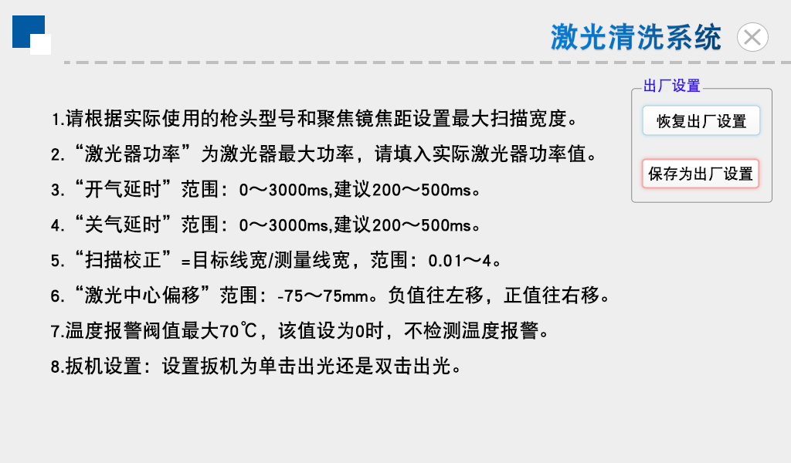
Figure 3-7 Settings page-Restore the factory settings
Click on the "Head Model" area to select the scan width corresponding to different focuses.
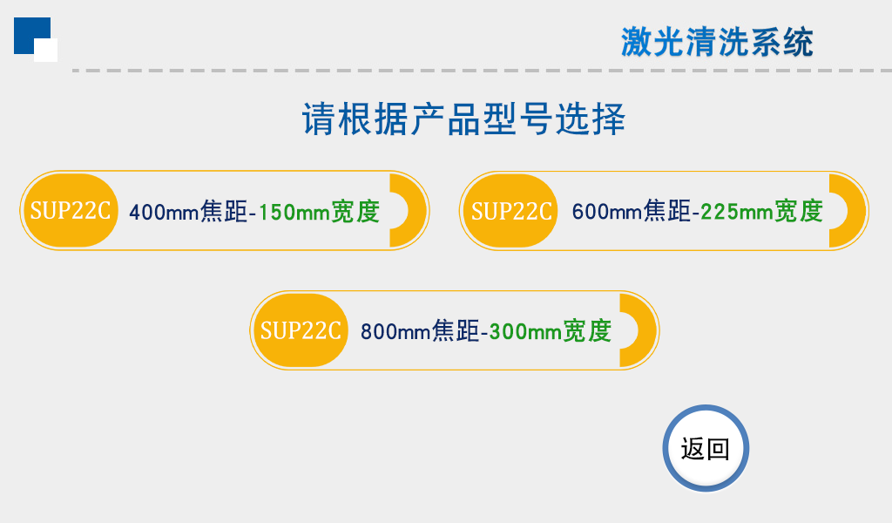
Figure 3-8 Settings page-Switch between different focal lengths

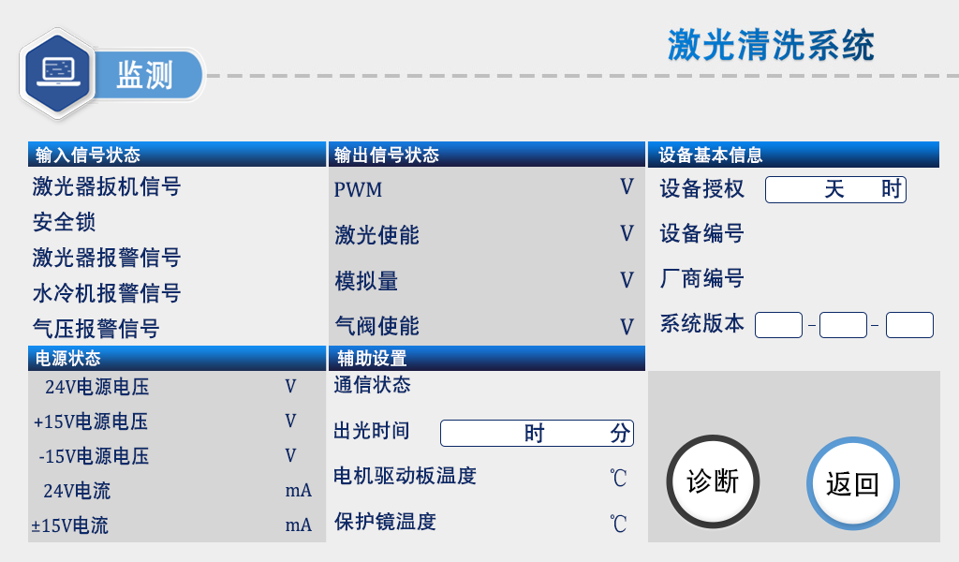
Figure 3-9 Monitoring page
This page displays the status of each signal and the equipment information
① Laser trigger signal: when the trigger is pulled, this state changes from gray to green.
② Laser / water cooler / air pressure alarm signal: the output signal is displayed in the middle of the high and low level page set for monitoring it, and when the signal is output, the green signal is displayed by gray.
③ Equipment authorization: the equipment can be authorized for the use time, when the equipment is used for more than the set time, the authorization will be terminated.
④ Light time: Click "Device Authorization", enter "FFFFFFBB001" on the password page to open the timing, enter "FFFFFFBB000" to clear the data and stop the timing.
⑤ System version: three sets of numbers, the first group is hardware version, the second group is microcontroller program version, the third group is touch screen version.

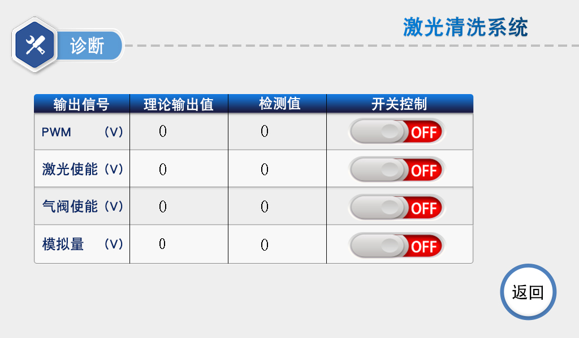
Figure 3-10 Diagnostic page
Click the Diagnostic-button to enter the diagnostic page. Under this page, the laser will not emit light, and can independently output "PWM", "laser enabling", "air valve enabling", "analog" through "switch control", to judge whether the control box detection and theoretical value function is normal.

4. Maintenance
Maintenance and replacement method of related lenses:
① Before operation, please clean your hands and dry them first, and then wipe your hands with cotton and alcohol again.
② Open the protective mirror in a relatively dust-free place, focus the mirror compartment cover, pull out the lens bracket, do a good job of protection (beautiful paper cover), check the protective lens, if there is an obvious burning point on the lens surface, should be directly replaced.
③ Then check the white storage seal ring under the lens.(If the storage sealing ring cannot be used, it must be replaced immediately.
④ Wipe the warehouse mouth and the inside of the warehouse cover with a cotton ball dipped in alcohol, quickly insert the protective lens bracket into the protective mirror compartment, and lock the screws.

5. Common exception handling

5.1 Warning of laser / water cooler / air pressure alarm
① If the above alarm does not using the alarm signal, please change the alarm level of screen setting page.
② If the alarm appears in the above alarm signal, check whether the alarm or the high and low level of the alarm signal is set correctly.

5.2 Screen not bright / click not responsive
① The screen is not bright, make sure the controller is powered on. Check whether the controller and the four-core wire of the screen are connected correctly, and whether the voltage of foot 1 and 4th foot 24V is normal.
② If not clicked in normal use, check whether the temperature of the machine is too high.
③ Click unable to input, check whether the wiring between the controller and the screen is correct, and whether the second and third feet are normal. See 2.1.2 controller display end for details.
④ Newly installed equipment click no reaction may be the system version does not match, use the SD card to rebrush the program can be, please ask us for the specific version.

5.3 No light
① Check whether there is an alarm prompt on the home page, and whether the laser enabling system is ON;
② Check whether the trigger signal and safety lock signal of the monitoring page are displayed in green during cleaning;
③ Check whether the PWM, laser enabling and analog output of the monitoring page are normal during cleaning.
If the above conditions are normal, check the laser for abnormal alarm.
Example: the air supply wire but not the light, for the laser fault or laser wiring error. If neither air nor wire supply, the input signal may be missing, see: 2.1.3 Controller signal interface 1.

5.4 Suddenly stop producing light during processing
Check whether the safety ground lock and other alarm of the monitoring interface are normal.

appendix

Three-phase power wiring reference:
Note: Two-phase or three-phase electricity depends on the power supply required by the laser and the chiller, rather than the amount of wire harness.

