system survey
The third-generation variable-frequency electromagnetic induction heating equipment for superheated steam, newly launched by AIX BOILER, features an integrated modular design. The system consists of six interlocked components: steam superheater tube bundles, electromagnetic induction heating coils, heating controllers, PDI temperature monitoring systems, SOF fluid sensing switches, and overheat protection cooling mechanisms. This complete heating solution employs the world's leading electromagnetic induction heating technology widely adopted in industrial applications.
1. Design objectives
Saturation steam production: 300 kg/h (provided by electric steam generator)
Superheated steam parameters: 500℃ (achieved by electromagnetic steam superheater)
Total system power: 216kW (electric steam generator) + additional power of electromagnetic superheater

2. Process flow chart

Equipment selection and calculation
1. Electric steam generator
Rated power: 216 kW
Steam production: 300 kg/h
Export pressure: design pressure should be specified (e.g. 0.7 MPa, saturation temperature ≈ 170℃)
Power supply: 380V AC, three-phase five-wire
2. Design of electromagnetic steam superheater
3. Steam input:
Temperature: 170℃ (corresponding to 0.7 MPa saturated steam)
Flow rate: 300 kg/h
Target output: 500℃ superheated steam

- Calories required for supplementation:
170℃ Saturated steam enthalpy: ≈ 2763 kJ/kg
500℃ The enthalpy value of superheated steam (0.7 MPa) is about 3487 kJ/kg
The required enthalpy increase value is Δh = 3487-2763 = 724 kJ/kg
- Power demand of superheater:

- Selection parameters:
Power: ≥65 kW (with 10% margin)
Heating method: Electromagnetic induction eddy current heating (high frequency/frequency)
Material: 310S stainless steel pipe (temperature resistance ≥800℃)
Protection class: IP54
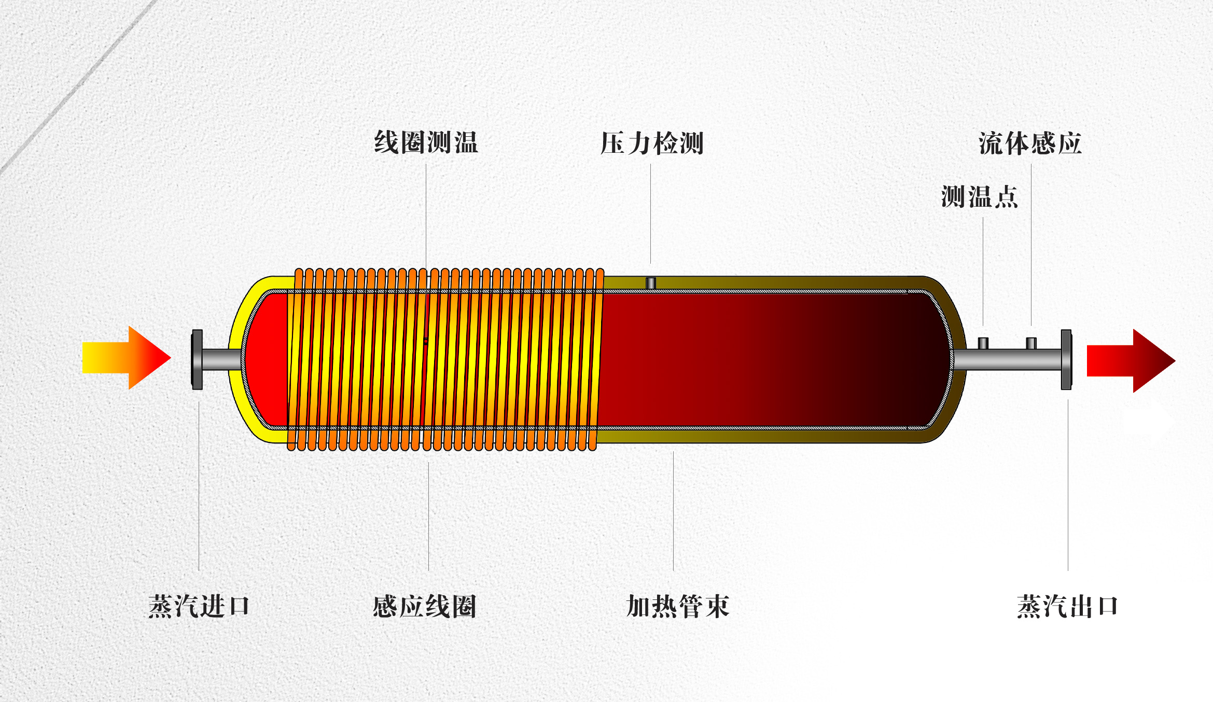

3. System integration design
1. Pipeline and interface
Steam generator outlet: steam and water separator is added to ensure dryness ≥ 98%
Superheater inlet: temperature/pressure sensor (interlock control)
Exhaust of superheater:
High temperature pressure gauge (0~1.6 MPa)
K-type thermocouple (0~600℃)
Safety valve (pressure relief value =1.1 times design pressure)

2. Control system
PLC control cabinet (including touch screen):
Start and stop the electric steam generator
Power regulation of electromagnetic overheaters (PID control, accuracy ±5℃)
- Key interlock protection:
When the steam flow is less than 250 kg/h, the superheater automatically reduces power
Emergency shutdown when the outlet temperature is> 520℃ or the pressure is> 0.85 MPa

IV. Safety protection measures
1. Electrical safety:
The grounding resistance of electromagnetic overheater should be less than or equal to 4Ω
Overcurrent/short circuit protection (circuit breaker + fuse)
High temperature protection:
The temperature of the superheater shell is ≤60℃ (aluminum silicate fiber insulation layer + 304 stainless steel cover)
High temperature pipeline mark + guard net
- Shedding protection:
A spring-loaded safety valve (DN20, trip pressure 0.77 MPa) is installed at the outlet of the superheater
The highest point of the system is equipped with an exhaust valve

Energy consumption and efficiency optimization
- Total power consumption: 216 kW (generator) + 65 kW (overheater) = 281 kW
- Thermal efficiency improvement:
The efficiency of electromagnetic superheater is more than 95%(no heat loss in direct heating)
Steam pipe insulation (λ ≤ 0.035 W/m·K)
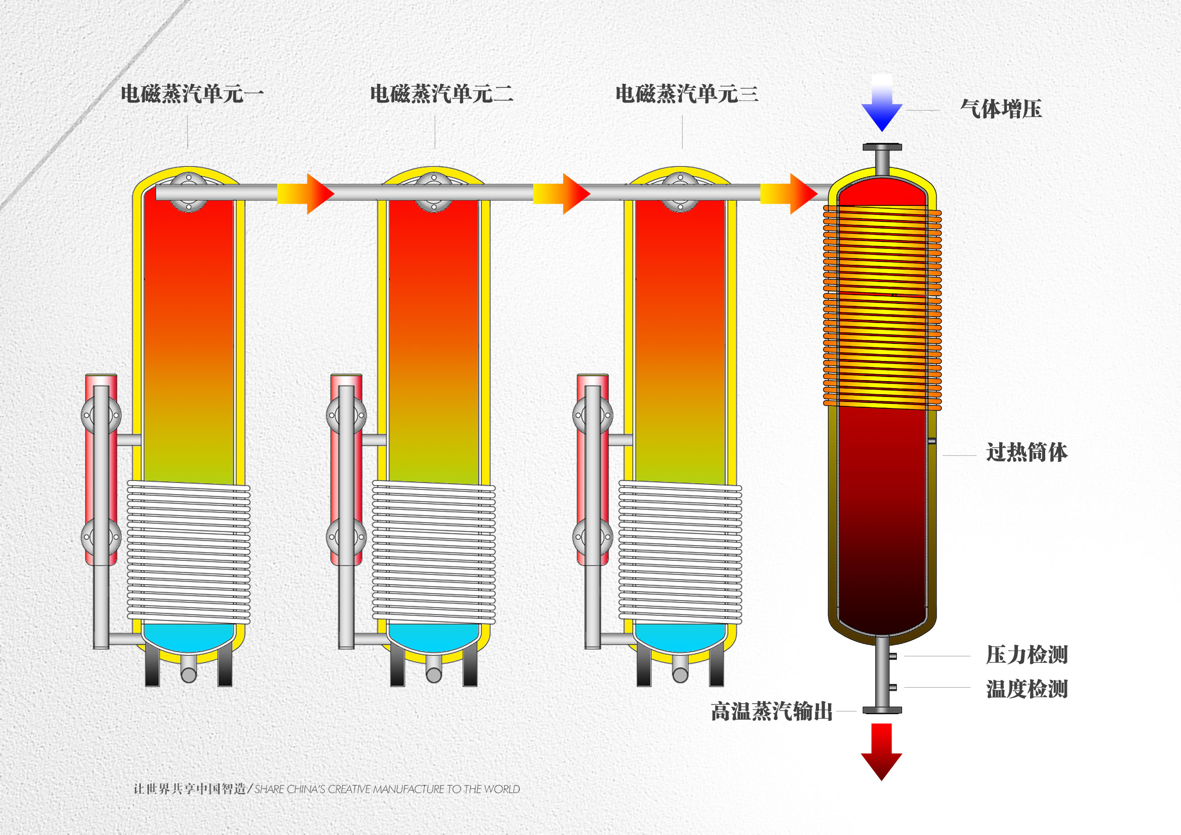
6. Installation and debugging
1. Installation requirements:
The distance between the steam generator and the superheater is more than 0.5m (for easy heat dissipation and maintenance)
The inclination of steam pipe is not less than 5‰ (toward the drain valve)
- Debugging steps:
Stage 1: Electric steam generator single unit operation (verify 300 kg/h production)
Stage 2: Electromagnetic superheater no-load test (frequency 20-50 kHz)
Stage 3: joint adjustment (step up to 500℃, each increase ≤50℃)

VII. Summary of technical parameters
equipment Device | Parameters
Electric steam generator | Power 216kW, pressure 0.7MPa, 300kg/h
Electromagnetic steam superheater | Power 65kW, outlet temperature 500℃±5℃
navar | PLC + PID temperature control, RS485 communication
Overall machine size | ≈3.5m(L)×1.5m(W)×2m(H)

VIII. Spare parts and maintenance suggestions
1. Key spare parts: Electromagnetic coil (1 set), thermocouple (2), safety valve (1)
2. Maintenance cycle:
Clean the inner wall of the superheater tube every month (to prevent carbon accumulation)
Test insulation resistance every quarter (≥ 100 MΩ)
Note: The final design should be adjusted according to the specific steam pressure, water quality (soft water TDS ≤50ppm) and on-site power supply conditions.

- Main configuration list:

order number  No: | name  NAME | quantity  QUANTITY | unit  UNIT | Brand labeling  BRAND | remarks  NOTES
1 | Superheated steam tube bundle | 1 | cover | AIX Aix | Aviation piping
2 | Electromagnetic heating controller | 1 | short for Taizhou | AIX Aix | Infineon IGBT
3 | induction heating coil | 1 | cover | AIX Aix | 35m² copper
4 | Fluid sensing control switch | 1 | single | SOF fluid control | Steam flow control
5 | PT100/K type temperature probe | 1 | single | Shanghai Jingte equipment | 10℃-1200℃
6 | PDI temperature controller | 1 | block | Taiwan AIC thermal control | Precise temperature control ±1℃
7 | Air cooling system | 4 | cover | Taiwan AIC thermal control | Temperature control
8 | System circuit breaker | 1 | short for Taizhou | Zhengtai Electric | CCC certified products
9 | auxiliary relay | 2 | single | Zhengtai Electric | CCC certified products
10 | Fiddly parts | 1 | cover | AIX Aix | cost free

