海淀区九年级第二学期期末练习
英 语
2024.05
学校________________ 姓名_______________ 准考证号__________________
考 生 须 知 | 1.本试卷共8页，共两部分，38道题，满分60分。考试时间90分钟。  2.在试卷和答题卡上准确填写学校名称、姓名和准考证号。  3.试题答案一律填涂或书写在答题卡上，在试卷上作答无效。  4.在答题卡上，选择题用2B铅笔作答，其他试题用黑色字迹签字笔作答。  5.考试结束，请将本试卷、答题卡和草稿纸一并交回。
第一部分
本部分共33题，共40分。在每题列出的四个选项中，选出最符合题目要求的一项。
一 、单项填空(每题0.5分，共6分)
从下面各题所给的 A、B、C、D 四个选项中，选出可以填入空白处的最佳选项。
1. My sister likes watching movies and ____________ favorite movie is Mulan.
A. her B. his C. their D. your
2. Bill often climbs mountains with his grandparents ____________ Sundays.
A. at B. in C. on D. to
3.—Excuse me, ____________ you please tell me where the nearest bus stop is?
—Sure. Turn right at the first crossing. It's on your right.
A. must B. could C. should D. need
4. In my eyes, the spring in Beijing is as ____________ as the autumn.
A. beautiful B. more beautiful C. most beautiful D. the most beautiful
5. — ____________ will we have the graduation party, Jack?
—In Room 102 of the Student Center.
A. Where B. When C. Why D. How
6. The traffic was terrible, ____________ we were late for the meeting.
A. for B. but C. or D. so
7. —Tim, why didn't your brother come to watch your show?
—Because he ____________ an important test at that time.
A. take B. will take C. is taking D. was taking
8. —Sally, what did you do last weekend?
—I ____________ a picnic in the park with my friends. It was great!
A. have B. will have C. had D. have had
9. Next week, our class ____________ on a field trip to the history museum.
A. goes B. will go C. went D. has gone
10. Lisa ____________ in Beijing for five years and she is quite used to the life here now.
A. lives B. has lived C. lived D. will live
11. Our library collection is getting larger and larger because new books ______ every month.
A. add B. were added C. added D. are added
12. —Alex, do you know ____________ ?
—Yes, it's going to be ready for use after the summer vacation.
A. when the new science lab opened B. when did the new science lab open
C. when the new science lab will open D. when will the new science lab open
二、完形填空(每题1分，共8分)
阅读下面的短文，掌握其大意，然后从短文后各题所给的A、B、C、D 四个选项中，选择最佳选项。
Our grandchildren were visiting for the weekend, and they all loved potatoes. So I told my husband we needed some more for dinner.
He said he would get some. Then he asked our grandson, Donovan, to come with him as he walked out of the door. When he realized Donovan wasn't __13__ , he turned around and saw Donovan running towards the car.
“Where are you going, honey?” my husband asked.
“Aren't we going to the store?”
“No, we're going to harvest(收获) potatoes from the garden,” my husband laughed.
“I didn't know you __14__ them, Papa!” Donovan was surprised.
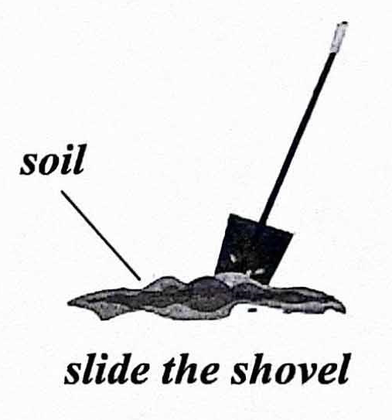
I watched out of the window as my husband showed our grandson how to slide the shovel and lift the plant. Seeing a big bunch of beautiful red potatoes come up, Donovan was very excited.
Then my husband explained to him how __15__ it was to grow potatoes in the right place. “You have to make sure that the soil is sandy and loose(松散的). That's why I grow mine on a hill.”
Thus began the __16__ our grandchildren would learn from our garden.
That was 14 years ago. Since then, the garden has been an amazing place where we have chances to __17__ with our grandchildren. It has seen so much of our laughter and joy. We teach them some basic knowledge about science, nature, and survival from growing their own food. And so much more.
Our granddaughter, Clare, is graduating from college, majoring(专业) in Crop and Soil Science. She always remembers having __18__ working with her grandpa in the garden when she was a little child.
She said, “Gardening is more than just a hobby; it is one of the greatest ways to __19__ you from stress, worries and other worldly troubles. When we plant seeds, we also build hope and trust in the future, and in life itself.” That's exactly what we expect from our grandchildren.
We have a sign in our garden that reads: To Plant a Garden is to Believe in Tomorrow. Teaching our grandchildren today how to live their lives __20__ means we believe in their tomorrows.
13. A. rushing B. leaving C. returning D. following
14. A. stored B. planted C. bought D. cooked
15. A. relaxing B. special C. exciting D. important
16. A. habits B. plans C. lessons D. stories
17. A. train B. travel C. connect D. compete
18. A. fun B. fears C. honor D. regrets
19. A. free B. wake C. excuse D. change
20. A. honestly B. positively C. comfortably D. creatively
三、阅读理解(每题2分，共26分)
(一)阅读下列社团活动介绍，请根据人物喜好和需求匹配最适合的社团，并将社团活动所对应的A、B、C、D选项填在相应位置上。选项中有一项为多余选项。
A
Club Activities
A  Cosplay  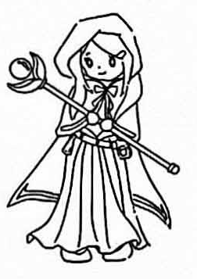  At this club, you can dress up as characters from anime (动漫), video games, or movies. If you're a fan of a certain character or looking for a creative way to express yourself, it's a good choice. | B  Sand Art  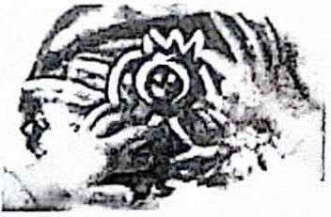  This club is about making art with sand. You pour colored sand onto a surface carefully to make lovely pictures. The whole process needs full attention and creativity. It is a fun activity that can improve your focus.
C  Programming    At this club, you will give instructions to a computer to make it perform tasks. It's like communicating with the computer through a set of rules and symbols. If you are into solving problems on computers, join us! | D  Stargazing    This club is about looking at the night sky and watching things like stars and planets. By exploring the unknown in the sky, you'll feel connected to the universe. Each time you look up, it's like hearing stories from far away.

21. ______ | 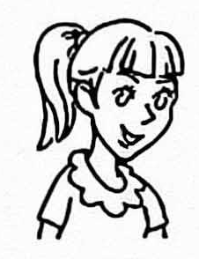  Olivia | I enjoy dressing up as my favorite characters and want to show myself in a creative way.
22. ______ | 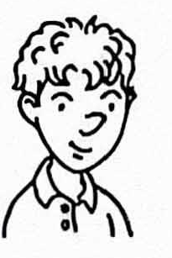  Liam | I like to watch stars and planets at night and I'd like to learn more about the universe.
23. ______ |   David | I'm interested in handmade art and I expect to get better at focusing.

(二)阅读下列短文，根据短文内容，从短文后各题所给的A、B、C、D四个选项中，选择最佳选项。
B
Inside Out
Although I did not speak or understand English, I was still excited about going to school for the first time.
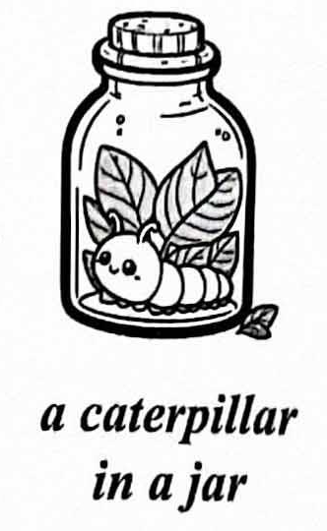
On my first day of school, my teacher, Miss Scalapino seated me closest to the window. Right next to my desk was a caterpillar in a large jar. It moved very slowly without making any sound. Just in front of the caterpillar was a picture book of caterpillars and butterflies. I went through it, page by page, studying all the pictures.
When the bell rang, all the kids walked in quietly. Some of them looked at me. Embarrassed and nervous, I looked at the caterpillar in the jar. I did this every time someone looked at me. In class, I did not understand a word Miss Scalapino was saying. The more she spoke, the uneasier I felt. For days I got headaches from trying to listen. Luckily, the caterpillar brought me some comfort. During breaks, I often stayed with it and fed it with leaves from trees on the playground.
My favorite time in school was when we did art. I drew butterflies in pencil and then colored them using every color in my crayon box. Miss Scalapino even put one of my drawings up on the board for everyone to see. After a couple of weeks it disappeared and I did not know how to ask where it had gone.
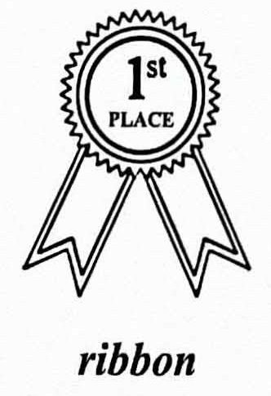
One day after class, I looked for the caterpillar but could not see it. I put my hand in the jar and lightly moved the leaves. To my surprise, the caterpillar had turned into a cocoon(茧).
On Wednesday, May 23, just a few days before the end of the school year, Miss Scalapino took me by surprise. She handed me the drawing of the butterfly that had disappeared weeks before and a silk blue ribbon that had“1st PLACE”printed on it in gold. I received first prize for my drawing! I was so proud that I felt like bursting out of my skin.
That afternoon, I checked on the caterpillar. I was amazed to find a butterfly moving from its cocoon slowly. I opened the jar. Magically, the butterfly came out, fluttering(振翅) in the air, ready for a completely new life.
24. In Miss Scalapino's first class, the writer felt ______.
A. excited B. proud C. uneasy D. surprised
25. Miss Scalapino took the writer by surprise when ______.
A. she took away his favorite drawing
B. she gave him the caterpillar in a jar
C. she handed him his drawing and a ribbon
D. she put one of his drawings up on the board
26. The butterfly fluttering in the air could probably remind the writer that _.
A. they would both stay unnoticed by others
B. he could start a new stage in his life as well
C. he would need to use more colors to draw butterflies
D. they could spend a lot more time together in the future
C
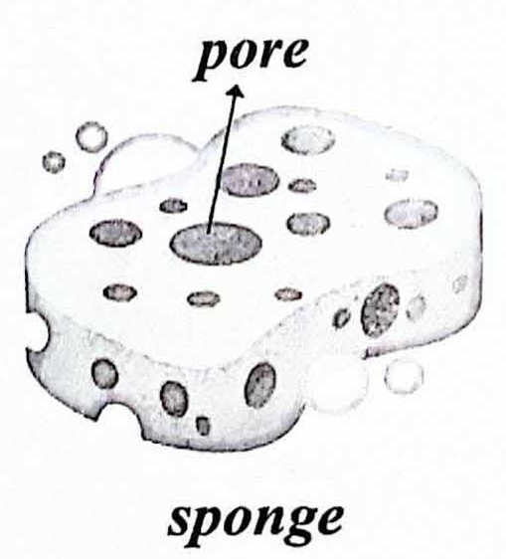
Is there anything sponges can't do? For many years, humans have used dried natural sponges to paint, clean up and take in water. They are good at catching tiny particles(颗粒) in their many pores. Now, as scientists around the world are beginning to show, sponges' pore-filled forms mean that they could offer a solution to a big challenge of our time: microplastic (微塑料) pollution.
Recently, Chinese researchers published a study describing their development of a new man-made sponge. Tests show that when a plastic-filled liquid(液体) is pushed through the sponge, it removes the microplastics from the liquid. Though sponge the effectiveness of sponges differed in experiments depending on the concentration (浓度) of the plastics and the nature of the liquid, researchers could remove up to 90% of the microplastics under the most favorable conditions.
These new sponges are made mostly from starch(淀粉) and gelatin(明胶), making them light and easy to transport. According to a materials chemist at Ocean University of China who got involved in the study, researchers can make sponges more or less porous-by changing the temperature when mixing the ingredients. This decides what size particles can be collected—highly porous sponges have lots of very small pores, which is good for catching very tiny particles.
According to the chemist, the sponges, if produced at an industrial level, could be used in wastewater treatment plants or in food production equipment to take away harmful chemicals. It would also be possible to use sponges like this in washing machines to collect microplastics produced when clothes are washed, suggests a chemist from Zurich.
Yet challenges remain. One of them is that starch and gelatin are important to the food industry, meaning that there could be competition for the key ingredients in the future. However, similar sponges can be made with different materials, such as the sugar taken from the shells of certain ocean animals.
Another challenge is that during the process of producing these new sponges, formaldehyde—a highly harmful chemical—is used. Scientists around the world are working to upgrade the production so that they can make a completely environmentally friendly sponge.
As microplastic pollution is getting more serious, these new sponges give us reason to be hopeful. It's like giving the earth a helping hand to stay clean and healthy.
27. According to the passage, the new sponges could be used to ______.
A. take microplastics out of a liquid
B. test the nature of the plastics in a liquid
C. change the temperature of a plastic-filled liquid
D. replace plastics with harmless materials in a liquid
28. What can we learn from the passage?
A. It's difficult to find the ingredients for the new sponges.
B. The new sponges would increase food production in factories.
C. The production of the new sponges is environmentally friendly.
D. How porous sponges are decides what size particles can be collected.
29. Which of the following would be the best title for the passage?
A. New Sponges: A Modern Tool to Recycle Plastics
B. New Sponges: A New Invention for Plastic Production
C. New Sponges: A Hopeful Solution for Microplastic Pollution
D. New Sponges: A Green Product to Break Down Microplastics
D
At a climate meeting, some scientists suggested giving up tree planting as a solution to climate change. To many people, this may seem shocking because they think ecosystem restoration(生态系统恢复) means planting as many trees as possible.
However, seeing ecosystem restoration as tree planting can be very dangerous because tree planting is often used as an excuse to avoid cutting carbon emissions(碳排放). In fact, if the oil and gas industry continues to increase in size, even 10 planets full of trees could not deal with the destruction that would result. At the same time, these monoculture carbon farms, where only one type of plant is grown to store carbon, are not truly the restoration of nature. They often cover landscapes with trees at the cost of the biodiversity(生物多样性) in that area or the living of the local people.
As these problems have been stressed in plenty of media articles, some environmental protection organizations, like Greenpeace, have even called for an end to all the nature-based solutions to climate change. However, nature is not the problem. Trees are rot the problem. The problem is our misuse of them as a quick fix to offset carbon emissions.
To get things straight, hundreds of scientists recently joined forces to publish a related study in the journal Nature. The study shows that the recovery of natural forests has the potential (潜能) to help with ⅓of our carbon drawdown needs in the fight against climate change. But it also shows that these climate benefits will not be achieved if we don't cut carbon emissions. If emissions continue, then natural fires and global warming will endanger the forests that we have left.
The study also shows that the full potential- of forests will not be achieved by monoculture tree plantations, which store less than half as much carbon as diverse ecosystems do. Most of the forest potential can be achieved by protecting and managing the ecosystems that we have left, allowing them to recover. The rest can be achieved by encouraging local communities to take active steps to strengthen biodiversity in areas where the ecosystem has been destroyed.
While the diverse ecosystem positively influences the climate, its benefits for local people are far more important. The real value of ecosystem restoration lies in the rich biodiversity supporting local living. By protecting nature, people get what they need for living in return. As a Zambian farmer put it, “no trees, no bees; no honey, no money”. When natural biodiversity becomes a practical choice for local people, that is when we get the long-term climate benefits of nature as a wonderful byproduct.
30. The second paragraph is mainly about ______.
A. the problems of misunderstanding ecosystem restoration
B. the methods of cutting down greenhouse gas emissions
C. the importance of the biodiversity for the local people
D. the purpose of developing monoculture carbon farms
31. The word“offset”in Paragraph 3 probably means“______”.
A. put off B. add to C. speed up D. balance out
32. What can we learn from the study published in the journal Nature?
A. Natural forest recovery can meet most carbon drawdown needs.
B. Local communities are expected to play a role in ecosystem restoration.
C. Protecting the remaining ecosystems takes more time than planting trees.
D. Monoculture carbon farms work better than natural forests in storing carbon.
33. The writer probably agrees that ______.
A. people get what they need for living in return by protecting nature
B. it makes no sense to stop monoculture tree planting for climate benefits
C. people should put an end to nature-based solutions for restoring ecosystem
D. developing monoculture carbon farms can improve the living of the local people
第二部分
本部分共5题，共20分。根据题目要求，完成相应任务。
四、阅读表达(第34-36题每题2分, 第37题4分, 共10分)
阅读短文，根据短文内容回答问题。
The day had been good, but school was tiring. I was lying on my sofa, mindlessly scrolling(滚屏) through social media, obsessed (痴迷) with someone else's fancy life. Without even knowing it, I was comparing myself to others.
In fact, I'm not alone! Comparing is something we struggle with every day. Studies show that anytime a thought comes to our minds, there's a 1-in-10 chance that we're comparing ourselves to others. Social comparison theory states that people would judge their own social and personal worth by comparing themselves to others around them.
Comparison had been the thief of my joy for long until one day I realized that it is pointless to compare ourselves with others—we are comparing our weaknesses to someone's strengths. I still remember several moments when I thought the worst of myself because I thought the best of someone else. For example, every time I saw Kayla performing well at her schoolwork, the first thing that popped into my mind was a wish that I could be as smart as her. I kept asking myself,“Why couldn't I just be like her?” I practically praised Kayla while hating myself at the same time.
I decided to change. I started to focus on improving myself instead of comparing with others. I took up reading one book every month. I started new hobbies. This helped me to discover a new self.
I learned to appreciate(欣赏) what I had. Every day, I wrote down things I was happy about and chose to be around people who made me feel good. This made me value my life and see how special it is.
And I changed how I used social media. Instead of aimlessly scrolling, I customized (定制) my social media feeds(推送) to include more educational and inspirational information. I felt happier and was less likely to compare myself to others.
In our lives, it's important to ask ourselves a key question: are we tending to(照料) our own garden or are we only visitors, admiring the beautiful gardens of others while failing to care for our own? Try not to get lost in comparing yourself to others since everyone is different. Discover your gifts and let them shine!
34. What was the writer obsessed with on social media?
35. How do people judge their social and personal worth according to social comparison theory?
36. Why does the writer think it is pointless to compare ourselves to others?
37. What do you think of the ways the writer took to avoid pointless comparison? Why? (Please give two reasons.)
五、文段表达(10分)
38.从下面两个题目中任选一题，根据中文和英文提示，完成一篇不少于50词的文段写作。文中已给出内容不计入总词数。所给提示词语仅供选用。请不要写出你的校名和姓名。
题目①
假设你是李华。你校将为来访的国外学生举行“寻迹中华(Exploring China)”文化交流活动。请你用英文写一篇演讲稿，向他们推荐你认为最具中国特色的一种美食、一处名胜、一项手工艺或一个风俗等， 对其作简要介绍，并说明推荐理由。
提示词语: paper cutting, dragon boat race, traditional, attract, symbol
提示问题: ·What do you want to recommend(推荐)? Please describe it.
·Why do you recommend it?
Dear friends,
Welcome to China!_____________________________________________________________
________________________________________________________________________________________________________________________________________________________________
Hope you'll enjoy yourselves here.

题目②
培育提升青少年网络素养，是我国网络强国战略的重要组成部分。
假设你是李华。你校正在举行“提升网络素养,争做校园好网民(Be a Good Teen Netizen)”的主题教育活动，请你用英文写一篇短文向学校英文网站投稿，阐述提升青少年网络素养的重要性，并说明具体做法。
提示词语: online community, benefit, polite, protect, personal
提示问题: ·Why do you think it is important to be a good teen netizen?
·What would you advise students to do to be a good teen netizen?
As the Internet has become part of our lives, it's important to be a good teen netizen. ________________________________________________________________________________________________________________________________________________________________

