CD3E Servo Drive
Quick Start Guide

ORIGINAL DOCUMENT
Revision: 1.0
Firmware Version 1.0.0.1



Revision History
Doc. Rev. | Date | Remarks
1.0 | 31 July 2024 | Initial release

Copyright Notice
© 2024 Servotronix Motion Control Ltd.
All rights reserved. No part of this work may be reproduced or transmitted in any form or by any means without prior written permission of Servotronix Motion Control Ltd.

Disclaimer
This product documentation was accurate and reliable at the time of its release. Servotronix Motion Control Ltd. reserves the right to change the specifications of the product described in this manual without notice at any time.

Trademarks
CD3E and ServoStudio+ are trademarks of Servotronix Motion Control Ltd.
CANopen and CiA are registered trademarks of the CAN in Automation User's Group.
EtherCAT is a registered trademark of Beckhoff Automation GmbH.
Windows is a registered trademark of Microsoft Corporation.

Contact Information
Servotronix Motion Control Ltd.
21C Yagia Kapayim Street
Petach Tikva 49130, Israel
Tel: +972 (3) 927 3800
Fax: +972 (3) 922 8075
Website: www.servotronix.com

Technical Support
If you need assistance with the installation and configuration of the CD3E drive, contact Servotronix technical support: tech.support@servotronix.com

Contents
1 Introduction 5
1.1 CD3E Product Description 5
1.2 Product Models – Ordering Information 5
1.3 Product Package 6
1.4 Product Label 6
2 Safety 7
2.1 Safety Symbols 7
2.2 Safety Guidelines 7
3 Specifications 9
3.1 Standards Compliance 9
3.2 Mechanical Specifications 9
3.3 Electrical Specifications 11
3.4 Control Specifications 11
3.5 Environmental and Protection Specifications 13
3.6 STO Specifications 13
3.7 Communication Specifications 14
3.8 I/O Specifications 14
3.9 Motor Feedback Specifications 15
4 Installation 16
4.1 Installation Overview 16
4.2 Mounting 17
4.2.1 Mounting the CD3E 17
4.2.2 Mounting Multiple Units 17
4.3 System Wiring Guidelines 18
4.3.1 Grounding 20
4.3.2 Shielding and Bonding 21
4.3.3 Input Power Filtering 21
4.3.4 Regeneration 21
5 Interfaces – Pinouts and Wiring 22
5.1 Power Interface 22
5.2 C1 Interface – STO 23
5.3 PC–Ethernet Interface 25
5.4 C2 / C3 Interfaces – EtherCAT 26
5.5 C4 Interface – I/Os 27
5.6 C5 Interface – Encoder / Motor Feedback 29
5.7 C6 Interface – Gantry 31
6 ServoStudio+ Software 33
6.1 Software Installation 33
6.2 Activation 33
6.3 Parameter Values 34
7 Basic Drive Configuration 35
7.1 Motors 35
7.1.1 Load Motor Parameters 35
7.1.2 Modify Motor Parameters 36
7.1.3 Copy Parameter Values to Another Motor 37
7.1.4 Save Motor Parameters 37
7.2 Motor Brakes 38
7.3 Limits 38
7.4 Save Configuration 39
7.5 Autotune the Drive 40
7.6 Test and Evalute 41
8 Drive Status 42
8.1 Operator Panel and LED Display 42
8.2 Operator Panel Modes 43

Introduction

CD3E Product Description
CD3E is a high-performance, cost-optimized drive that is intended especially for linear motors. It is designed to work with 50W to 750W motors. Higher power motors will be supported in future versions.
The drive has a broad range of features, as well as a new and advanced commissioning tool –ServoStudio+ software.

Product Models – Ordering Information
The following diagram shows the ordering options that comprise the various model numbers of the drives in the CD3E product line.

 |  |  |  |  | CD3E | – | 003 |  | 2A |  | EB | – | 0 |  | 0
 | CD3E Servo Drive
 | Rating
 | 200–240 VAC
 | Cont.  [A rms] | Cont.  [A rms]
003 | 3 | 9
5D5 | 5.5 | 17
 | AC and Controller Input Power Supply
2A | Medium voltage input power supply  1-phase 200 VAC ±10%, 50/60 Hz
 | Communication Interfaces
EB | EtherCAT, Ethernet
EG | EtherCAT, Ethernet, Gantry
AP | Pulse train reference
 | Analog Input
[blank] | Default
1 | One analog input, 16-bit
 | Customized
[blank] | Default

Product Package
Upon delivery, open the package and remove all packaging materials.
Check to ensure there is no visible damage to the products. If damage is detected, notify the carrier immediately.
After unpacking, check the part number label on the product. Make sure it matches the product your ordered, and that the voltage meets your specific requirements.
The CD3E package includes the following items:
- CD3E servo drive
- Power mating connector
- STO bypass plug

Product Label
Table ‎1-1. CD3E Product Label Codes
Item | Description
Model | Catalog number (ordering information)
S/N | Product serial number.  Digits 1–14 = Material code  Digits 15–20 = Production year, month and day  Digit 21 = Production workshop  Digit 22 = Production type  Digits 23-27 – Production serial number
HW | Hardware version
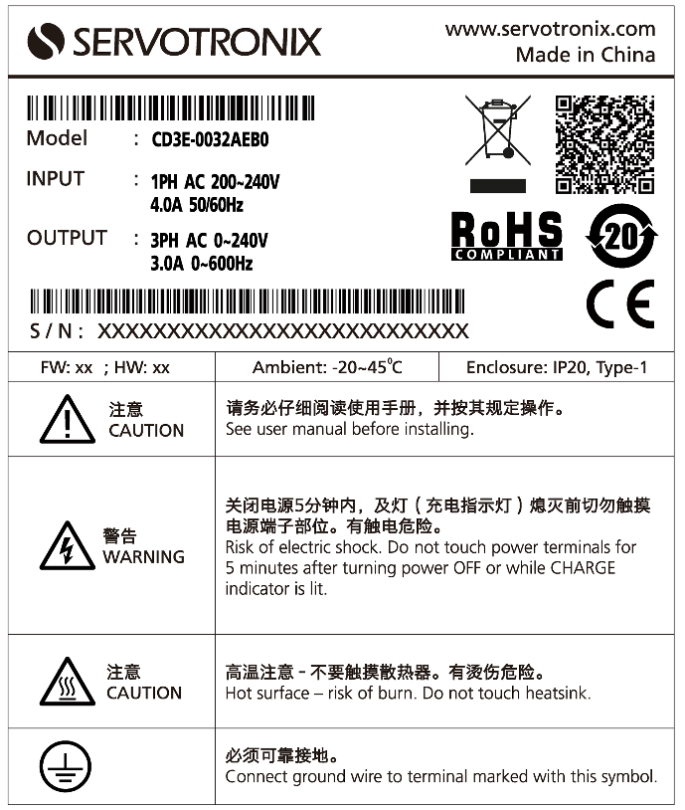
Figure 1-1. CD3E Product Label – Example

Safety

Safety Symbols
Safety symbols indicate a potential for personal injury or equipment damage if the prescribed precautions and safe operating practices are not followed.
The following safety-alert symbols are used on the drive and in the documentation.
Symbol | Meaning | Description | ISO 7000/  IEC 60417
 | Caution | Indicates caution is necessary when operating the device. Also indicates the current situation needs operator awareness or operator action to avoid undesirable consequences. | 0434
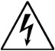 | Dangerous voltage | Indicates hazards arising from dangerous voltages. | 5036
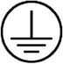 | Protective earth;  protective ground | Identifies any terminal which is intended for connection to an external conductor for protection against electric shock in case of a fault, or the terminal of a protective earth (ground) electrode. | 5019
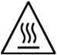 | Caution, hot surface | Indicates the marked item can be hot and should not be touched without taking care. | 5041

Safety Guidelines
Only qualified personnel may perform installation, operation, service and maintenance procedures. These persons must have sufficient technical training and knowledge to foresee and recognize potential hazards that may occur when using the product, modifying settings, and operating the mechanical, electrical and electronic components of the entire machine system.
- All persons working on and with the product must be fully familiar with all applicable standards, directives, and accident prevention regulations when performing such work.
- The CD3E servo drive is intended for use as a component within a machine system.
- The machine builder and integrator must ensure the protection of both personnel and the complete machine system.
- The machine builder and/or integrator must perform a risk assessment in view of using the CD3E drive in the intended application. Based on the results, the appropriate safety measures must be implemented.
- The CD3E drive must be used in compliance with all applicable safety regulations and directives, and all technical specifications and requirements.
- Before installing the CD3E, be sure to review the safety instructions in the product documentation. Failure to follow the safety instructions may result in personal injury or equipment damage.

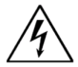 | The CD3E drive utilizes hazardous voltages. It must be properly grounded.

 | When connecting the CD3E to other control equipment, be sure to follow two basic guidelines to prevent damage to the drive:  - The CD3E must be grounded via the earth ground of the main AC voltage supply.  - Any motion controller, PLC or PC that is connected to the CD3E must be grounded to the same earth ground as the CD3E.

The machine builder and the machine owner are responsible for the safety of the machine operators.

The machine owner and the machine operator are responsible for ensuring personnel cannot enter the hazard zone while the machine is energized unless adequate functional safety mechanisms are in place.

Specifications

Standards Compliance
The product has been developed and produced in accordance with the following standards.
Certification is pending.
Certification | Directive | Standard(s)
Electrical, thermal and energy safety | EU Low Voltage Directive 2014/35/EU | IEC 61800-5-1
Electromagnetic compatibility for power drive systems | EMC Directive 2014/30/EU | IEC 61800-3
RoHS  Assessment of electrical and electronic products with respect to the restriction of hazardous substances |  | EN 50581

Mechanical Specifications
Table ‎3-1. Mechanical Specifications
Feature | Specification | CD3E-003-2A | CD3E-5D5-2A
Dimensions | L (mm)  W (mm)  H (mm) | 173  45  160 | 173  50  160
Weight | kg | 1.105 | 1.232
Connection Hardware | PE ground screw Size/Torque | M4/1.35 Nm | M4/1.35 Nm
Mounting | Vertical, horizontal
Clearance Distance | Side-to-Side (mm) | 20 | 20
Clearance Distance | Top/Bottom (mm) | 50 | 50

The external dimensions of the CD3E drive are shown in the following figures.
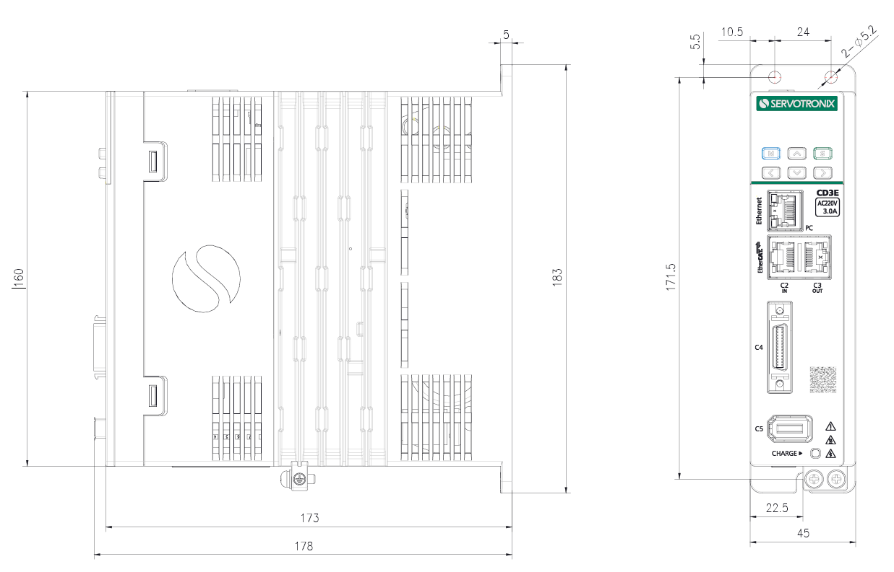
Figure 3-1. CD3E-003 Dimensions (mm)

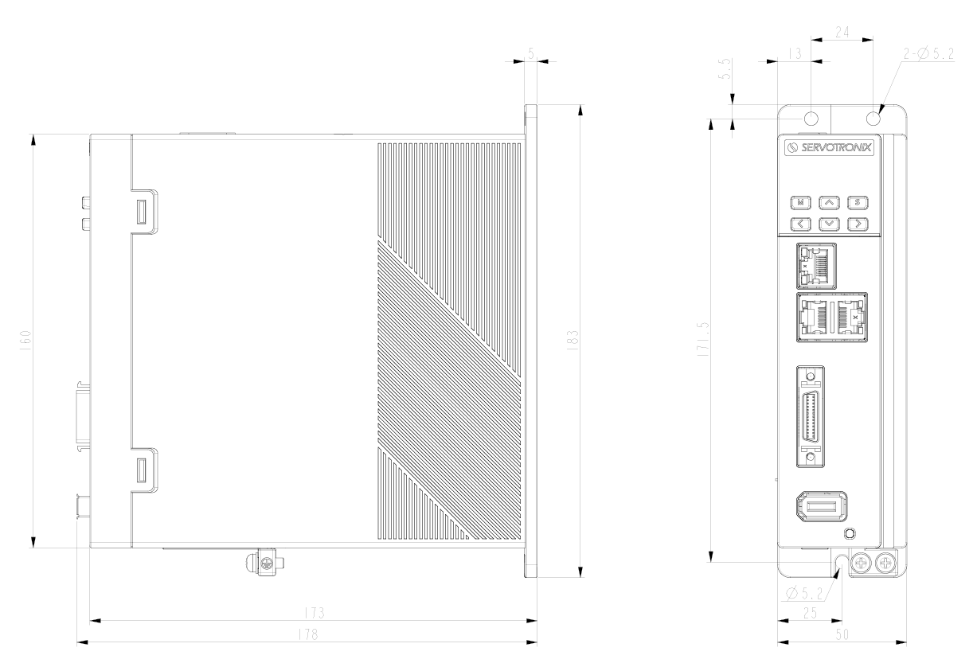
Figure 3-2. CD3E-5D5 Dimensions (mm)

Electrical Specifications
Table ‎3-2. Electrical Specifications
Feature | Specification | CD3E-003-2A | CD3E-5D5-2A
Max motor power |  | 400 W | 750 W
Input power | Input voltage | 1-phase 220 VAC ±10% | 1-phase 220 VAC ±10%
Input power | Line frequency | 50/60 Hz | 50/60 Hz
Input power | Continuous current | 4.2 Ams | 7.9 Arms
Input power | Line fuses (FRN-R, LPN, or equivalent) | 6 A | 16 A
Drive output | Continuous output current | 3 Arms | 5.5 Arms
Drive output | Peak output current @2 sec | 9 A | 17 A
Drive output | PWM frequency | 8 kHz | 8 kHz
External regenerative  resistor requirements | Peak current | – | 5.5 A
External regenerative  resistor requirements | Minimum resistance | – | 40 Ω
External regenerative  resistor requirements | Power rating | – | 50 W
Application Information | Internal bus capacitance | 660 µF | 940 µF

Control Specifications
Table ‎3-3. Control Specifications
Feature | Specification
Motor | Types | Linear motor  Rotary motor
Motor | Motor phasing | Automatic configuration of motor phasing and encoder direction
Motor | Motor direction | Clockwise/counter-clockwise, encoder direction
Operation Modes | Control modes | - Current (torque) control  - Speed control  - Position control
Current (Torque) Control | Update rate | 8 kHz
Current (Torque) Control | Control loop | DQ, PI, Feedforward
Current (Torque) Control | Reference command | Ethernet/EtherCAT
Current (Torque) Control | Autotuning | Automatic setting of current control loop parameters
Current (Torque) Control | Parameter tuning method | Automatically sets the parameters of the current control loop
Speed Control | Update rate | 4 kHz
Speed Control | Control loop | PDFF
Speed Control | Reference command | Ethernet/EtherCAT
Speed Control | Filter | First-order low-pass filters, notch filters, load disturbance observers, velocity observers
Speed Control | Parameter tuning method | Rigidity table, automatic parameter setting (load inertia ratio identification), manual parameter setting, load adjustment-free function.
Position Control | Update rate | 4 kHz
Position Control | Control loop | PID feedforward
Position Control | Reference command | Ethernet/EtherCAT
Position Control | Parameter tuning method | Rigid table, manual parameter setting, load adjustment-free function
Brake | Method | Dynamic braking, electric motor regenerative braking
Advanced Control Functions |  | Velocity observer, Friction compensation, Harmonic compensation, Collision detection, Input shaping, Gain scheduling
Tuning | Methods | Autotuning, Frequency analyzer, Inertia and friction estimation
User Interface | GUI | ServoStudio+, web-based, can run on PC and other platforms
User Interface | Operator panel | 6 keys, 5-digit LED display
User Interface | Functions | Set up connections, drive information, power information, motor, feedback, input/output selection/configuration, action setting/tuning, fault history/display, setup wizard, expert view.
Movement units | Position | count (user unit), mm, µm, pitch
Movement units | Velocity | mm/s
Movement units | Acc/Dec | mm/s^2

Environmental and Protection Specifications
Table ‎3-4. Environmental Specifications
Feature | Specification
Protection class | Degree of protection: IP20  Pollution level: IEC 60664-1 class 2  Do not use in environments where exposed to: corrosive or flammable gases, water, oil or chemicals, dust (including iron powder), and salt
Operating temperature | 0° to 45°C without derating  45° to 55°C with derating
Storage temperature | -20° to 70°C
Humidity | 10 to 90% (no condensation)
Altitude | <1000 m, according to IEC 61800-5-1
Vibration | 5.88 m/s², 10–60Hz
Protection features | Includes but is not limited: dynamic braking (hardware) low/overvoltage, overcurrent, drive and motor overheating, motor overload protection, driver overload protection, feedback loss, non-configuration, circuit failure.

STO Specifications
Functional safety has been verified by the manufacturer.
Table ‎3-5. STO/Functional Safety Specifications
Feature | Specification
Nominal voltage | 24 VDC
Voltage levels | 15–30 VDC STO function not active (motion allowed)  0–5 VDC STO function active (motion not allowed)  5–15 VDC STO function not defined and not guaranteed
Power supply – external | SELV/PELV required
Power supply – internal | STO jumper required
Maximum reaction time | 30 ms

Communication Specifications
Table ‎3-6. Communication Specifications
Feature | Specification
Type | EtherCAT over Ethernet (CoE), 100 Mbit
Communication cycle time (minimum) | 1 ms
Device configuration file | IEC61800-7 Profile type1 (CiA402)  CoE (CANopen over EtherCAT)
Communication object | PDO (Process Data Object)  SDO (Service Data Object)
Synchronization type | SYNC0 Event Synchronization

I/O Specifications
Table ‎3-7. Digital Inputs/Outputs Specifications
Feature | Specification
Digital inputs | Quantity | 5
Digital inputs | Signal format | Opto-isolated. Configurable as either PNP (sourcing) or NPN (sinking).
Digital inputs | Voltage level | 24V
Digital inputs | Maximum input current | 6 mA
Digital inputs | Transmission delay time | 1 ms
Digital inputs | Maximum frequency | 1 kHz
Fast digital inputs | Quantity | 2, for touch probe.
Fast digital inputs | Signal format | Opto-isolated. Configurable as either PNP (sourcing) or NPN (sinking).
Fast digital inputs | Voltage level | 24V
Fast digital inputs | Maximum input current | 12.5 mA
Fast digital inputs | Transmission delay time | 1 µs
Fast digital inputs | Maximum frequency | 500 kHz
Digital outputs | Quantity | 3
Digital outputs | Signal format | Opto-isolated. NPN (sinking)
Digital outputs | Voltage level | 24V
Digital outputs | Maximum output current | 50 mA per output (total 100 mA)
Digital outputs | Short-circuit protection
Digital outputs | Transmission delay time | 1 ms
Fast digital outputs | Quantity | 1, in EG models only.  For PCOM function, gantry application
Fast digital outputs | Signal format | Opto-isolated. NPN (sinking)
Fast digital outputs | Voltage level | 5 to 24 V
Fast digital outputs | Maximum output current | 50 mA
Fast digital outputs | Short-circuit protection | Yes
Fast digital outputs | Transmission delay time | 1 µs

Motor Feedback Specifications
Table ‎3-8. Motor Feedback Specification
Feature | Specification
Supply voltage from drive | 5.2 VDC
Max. supply current from drive
Recommended cable type | Shielded twisted-pair copper wire
Encoder type | BiSS-C, AB incremental

Installation

Installation Overview
Perform the following steps to install and setup a CD3E system.
- Mount the CD3E.
- Make all wiring and cable connections, as required by your application.
- After completing all hardware connections, you can power on the drive and PC.
- Install ServoStudio+ software on the PC.
- Activate ServoStudio+ and connect to the drive.

Mounting

Mounting the CD3E
Using the bracket on the back of the CD3E, mount the CD3E on a grounded conductive metal panel. The panel must be sufficiently rigid.
For mounting dimensions, refer to section Mechanical Specifications.

Mounting Multiple Units
When multiple CD3E units are mounted side-by-side within a cabinet or enclosure, the recommended minimum spacing between units is 20 mm. The recommended minimum top and bottom clearance is 50 mm for all CD3E models.
It is important to maintain an ambient temperature within the enclosure that does not exceed 45°C. If CD3E units are mounted on a backplane, also make sure the backplane temperature does not exceed 45°C. It is recommended that a cooling fan be installed at the bottom of the cabinet for best circulation.
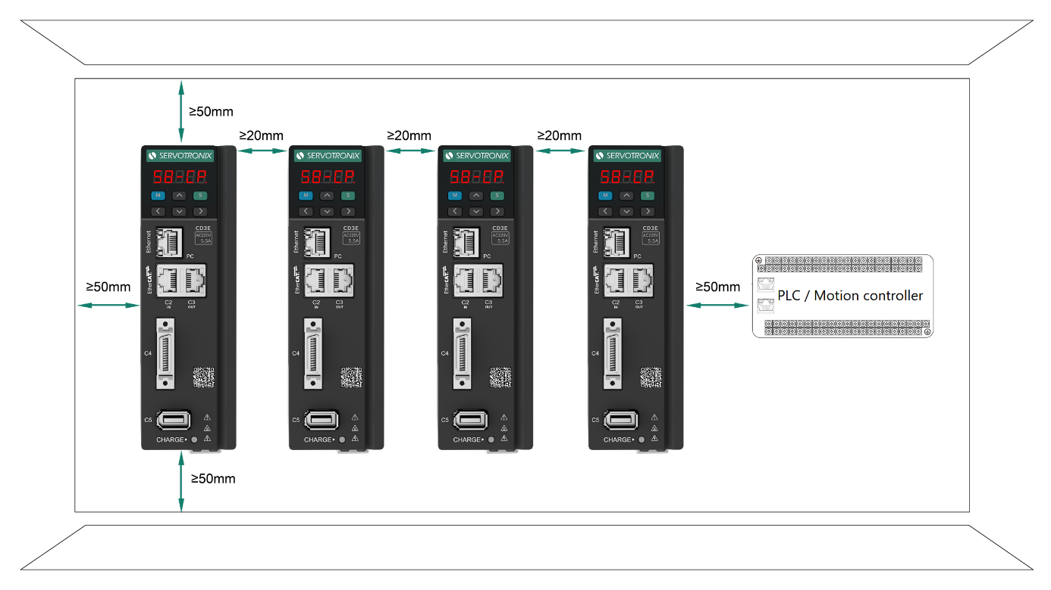
Figure ‎4-1. Mounting Multiple CD3E Units within Cabinet

System Wiring Guidelines
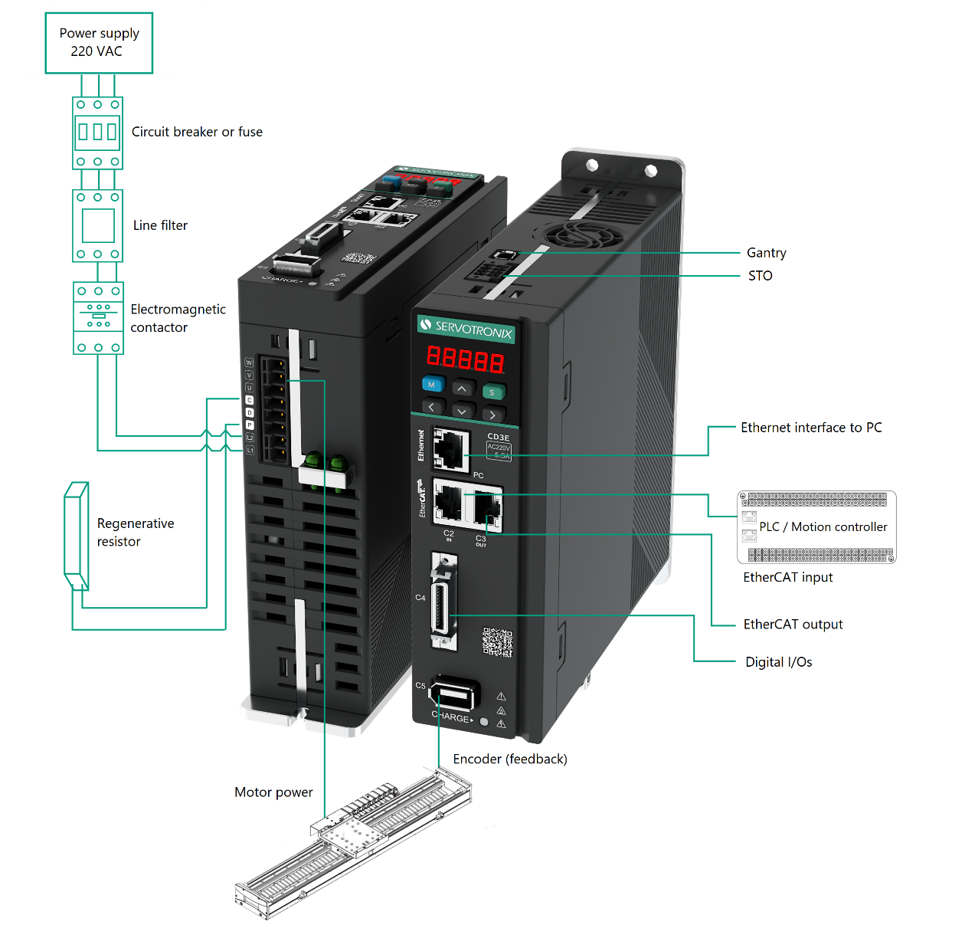
Figure ‎4-2. System Wiring

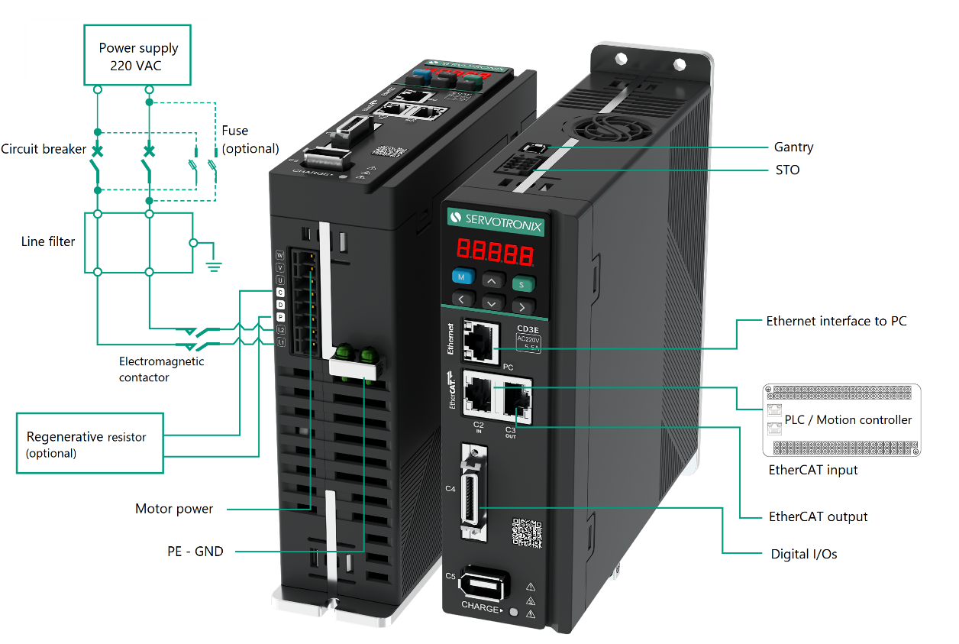
Figure ‎4-3. System Circuitry

Grounding
When connecting the CD3E to other control equipment, be sure to follow two basic guidelines to prevent damage to the drive:
- The CD3E must be grounded via the earth ground of the main AC voltage supply.
- Any motion controller, PLC or PC that is connected to the CD3E must be grounded to the same earth ground as the CD3E.
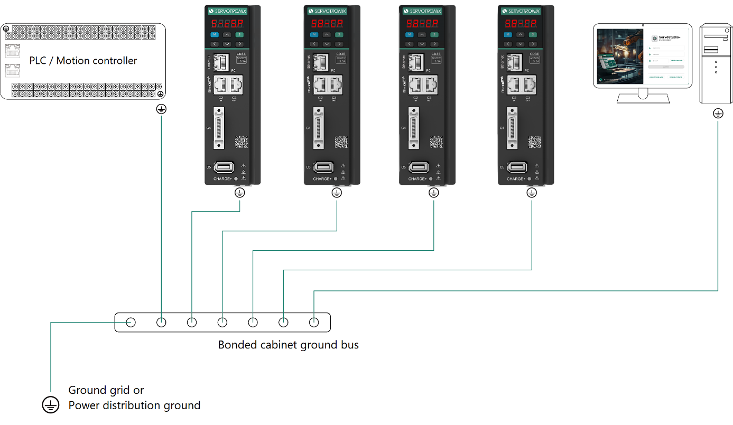
Figure ‎4-4. System Grounding
System grounding is essential for proper performance of the drive system.
The AC input voltage ground wire must be connected to a PE terminal on the drive. This is necessary for both safety and EMI reduction.
Use a single point ground for the system (star wiring) to avoid ground loops.
It is strongly recommended that the CD3E be mounted to a metallic back panel, and that a high frequency ground be provided to connect the back panel to earth ground. Provide an electrical connection across the entire back surface of the drive panel. Electrically-conductive panels such as aluminum or galvanized steel are recommended. For painted and other coated metal panels, remove all coating behind the drive. The objective is to provide an extremely low impedance path between the filters, drives, power supplies, and earth ground for high-frequency signals that might cause EMI. Use a flat braid or copper busbar to achieve high-frequency grounding. Use the shortest braid possible when connecting high frequency grounds.
Ensure good connections between the cabinet components. Connect the back panel and cabinet door to the cabinet body using several conductive braids. Never rely on hinges or mounting bolts for ground connections. Ensure good ground connection from cabinet to proper earth ground. Ground leads should be the same gauge as the leads to main power or one gauge smaller.
The PC must also be properly grounded.

Shielding and Bonding
To minimize noise emissions and maximize the immunity levels of the drive system, motor and feedback cables must be shielded and properly bonded to a grounded surface.
The shield must be connected to ground at both ends of the cable. Its effect is to reduce the impedance between the cable shield and the back panel.
It is recommended that all shielded cables be bonded to the back panel.
The motor and feedback shielded cables should be exposed as close as possible to the drive. This exposed cable shield is bonded to the back panel using either non-insulated metallic cable clamps or cable bonding clamps.
It is recommended to use a star point shield connection with a shielding busbar.

Input Power Filtering
To meet the CE requirements for industrial environments, the electronic system components in the CD3E require EMI AC line filtering in the input power leads.
Care must be taken to adequately size the system. The type of filter is determined according to the voltage and current rating of the system and whether the incoming line is single phase or three phase.
Implementation of the input power filter must adhere to the following guidelines:
- Maintain separation of leads entering and exiting the mains filter.
- Filter must be mounted on the same panel as the drive.
- Filter must be mounted as close as possible to the drive, to prevent noise from being capacitively coupled into other signal leads and cables.
- When mounting the filter to the panel, remove any paint or material covering. Use an unpainted metallic back panel, if possible.
- Filters are provided with a ground terminal, which must be connected to ground.
- Filters can produce high leakage currents. Filters must be grounded before connecting the supply.
- Filters should not be touched for 10 seconds after removing the supply.

Regeneration
When a motor and load decelerate rapidly, kinetic energy of the load drives the motor shaft energy back to the drive. This regeneration energy must be dissipated or absorbed.
Regenerative energy that is not dissipated is added to the electrical energy already stored in the capacitors of bus module. If the capacitors can absorb the energy, the system does not require a regeneration resistor. However, if excessive energy is added, the voltage on the capacitors will exceed the over-voltage threshold, which then disables the drive.
To prevent over-voltage, and potential damage to the system, excessive regenerative energy must be dissipated by a regeneration resistor.
If your application requires a regenerative resistor for braking a high inertia load during emergency stops, connect an external regenerative resistor to terminals C and P on the Power interface.

Interfaces – Pinouts and Wiring

Power Interface
The power interface serves to connect the AC power supply to the CD3E.
The interface is also used to supply power to the motor phases.
In addition, it provides the connection to an external regenerative power resistor to dissipate energy generated by the motor, typically during deceleration.
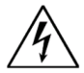 | Make sure the main voltage rating matches the drive specification. Applying incorrect voltage may cause drive failure.  Do not apply power until all hardware connections are complete.

Prevent inrush surge: Bus power (L1-L2): After switching off bus power, wait 1 minute before switching on again.

Power Pinout
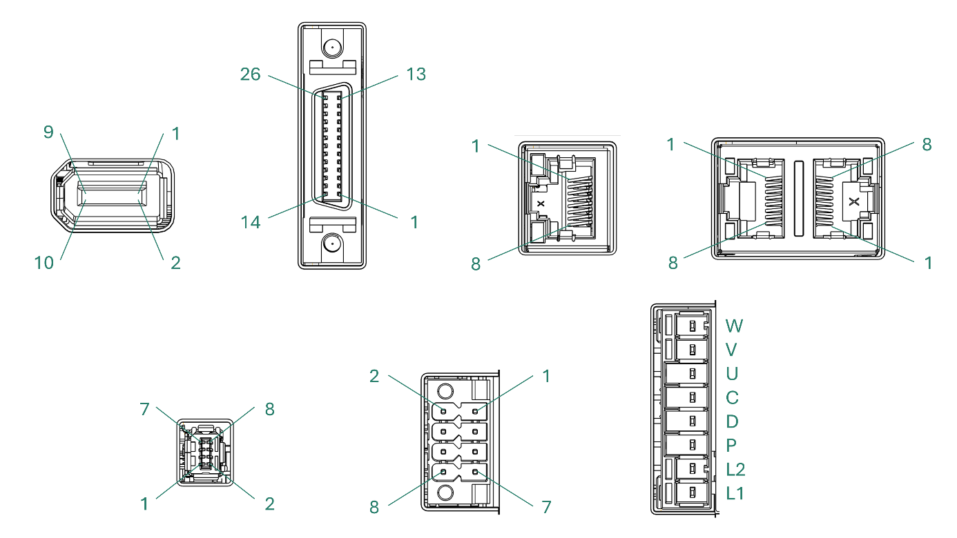
Figure ‎4-1. Power Interface
Table 5-1. Power Interface
Pin | Name | Description
1 | WOUT | Motor phase W
2 | VOUT | Motor phase V
3 | UOUT | Motor phase U
4 | C | Regenerative resister C
5 | D | Regenerative resister D
6 | P | Regenerative resister P
7 | L2 | AC power supply – line L2
8 | L1 | AC power supply – line L1

Mating connector | Sunchu: SC-T3005008SB0XT-45
Wiring | 14–12 AWG
Strip length | 7 mm

Procedure: Connecting Power
The CD3E has 2 ground PE terminals, located on bottom panel next to the Power interface.
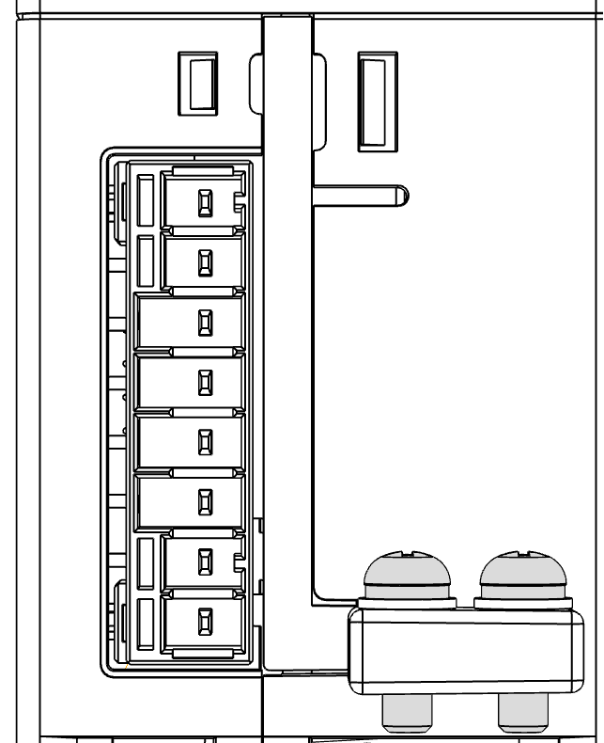
Figure ‎4-2. PE terminal screws
- Connect the AC input voltage ground wire to one of the PE terminals. Use an M4 ring or a spade terminal.
- Connect L1 and L2.
- If the main voltage is from a single-phase source, connect line and neutral to L1 and L2.
- If the main voltage is from a 3-phase source, connect any two phases to L1 and L2.

C1 Interface – STO
Safe torque off (STO) is a safety function that prevents the drive from delivering power to the motor, which can generate torque.
Pins 1 and 2 (24V and 24V_COM) must be connected to enable drive operation.
The STO-enabled signal voltage must be 24 VDC.
Note | If the application does not require STO control, use the STO bypass plug supplied with the drive.

C1 Pinout
Figure ‎4-3. Interface C1
Table 5-2. Interface C1
Pin # | Name | Description
1 | 24V+ | 24V power supply positive
2 | 24V_COM | 24V power supply ground
3 | EXT_STO_1 | STO1 switch input
4 | EXT_STO_COM | STO switch circuit ground
5 | EXT_STO_2 | STO2 switch input
6 | EXT_STO_COM | STO switch circuit ground
7 | NC | not connected
8 | NC | not connected

Description | Bypass plug
Mating connector | Weiling: Part number 12115000001401

C1 Wiring – External Power Supply – STO
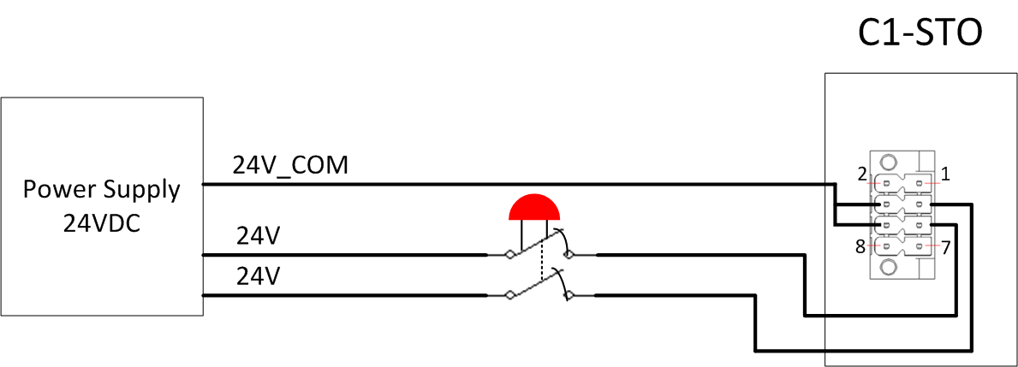
Figure ‎4-4.

C1 Wiring – Internal Power Supply – STO
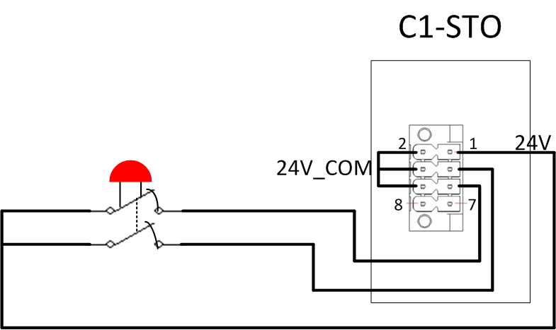
Figure ‎4-5.

PC–Ethernet Interface
For commissioning, the drive is connected to the PC through the Ethernet port.

PC–Ethernet Pinout
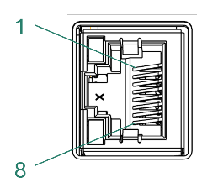
Figure ‎4-6. Interface PC-Ethernet
Table 5-3. Interface PC-Ethernet
Pin | Name | Description
1 | RXP | Ethernet receive – differential positive
2 | RXN | Ethernet receive – differential negative
3 | TXP | Ethernet drive transmit – differential positive
4 | NC | not connected
5 | NC | not connected
6 | TXN | Ethernet drive transmit – differential negative
7 | NC | not connected
8 | NC | not connected

Mating connector | Any CAT5e compatible shielded connector
Cable | CAT5e or higher, standard Ethernet straight cable

C2 / C3 Interfaces – EtherCAT
Interfaces C2 and C3 are RJ45 ports that serve as transmitter and receiver for drives operating on an EtherCAT network.

C2/C3 Pinout
Figure ‎4-7. Interfaces C2 / C3
Table 5-4. Interfaces C2 / C3
Pin | Name | Description
1 | RXP | EtherCAT receive – differential positive
2 | RXN | EtherCAT receive – differential negative
3 | TXP | EtherCAT drive transmit – differential positive
4 | NC | not connected
5 | NC | not connected
6 | TXN | EtherCAT drive transmit – differential negative
7 | NC | not connected
8 | NC | not connected

Mating connector | Any CAT5e compatible shielded connector
Cable | CAT5e or higher, standard Ethernet straight cable

C4 Interface – I/Os
Interface C4 enables the connection of external I/O devices to the CD3E.

C4 Pinout
Figure ‎4-8. Interfaces C4
Table 5-5. Interface C4
Pin | Name | Description
1 | OZ- | Encoder emulation output Z-channel – differential negative
2 | OZ+ | Encoder emulation output Z-channel – differential positive
3 | OA+ | Encoder emulation output A-channel – differential positive
4 | OA- | Encoder emulation output A-channel – differential negative
5 | OB+ | Encoder emulation output B-channel – differential positive
6 | OB- | Encoder emulation output B-channel – differential negative
7 | P_COM_GND | PCOM signal GND
8 | EXT_DI_2 | External digital input 2
9 | EXT_DI_3 | External digital input 3
10 | COM_DO | Common digital output
11 | EXT_DI_1 | External digital input 1
12 | EXT_DO_2+ | External digital output 2
13 | EXT_DO_3+ | External digital output 3
14 | OZ_OC | Incremental encoder Z-channel single-ended output
15 | GND | Signal GND
16 | P_COM_PWR | PCOM signal power supply
17 | GND | Signal GND
18 | GND | Signal GND
19 | Fast_P | PCOM signal output
20 | EXT_DO_1+ | External digital output 1
21 | COM_PD | Fast digital input common
22 | COM_INPUT | Common digital input
23 | PULSE_SI | Fast digital input pulse signal
24 | DIR_SI | Fast digital input direction signal
25 | EXT_DI_5 | External digital input 5
26 | EXT_DI_4 | External digital input 4

Description | SCSI-26 pin
Mating connector | Goldconn Precision Electronics: KSCS026MACAAAXX1

C4 Wiring – Digital Inputs – Source (PNP)
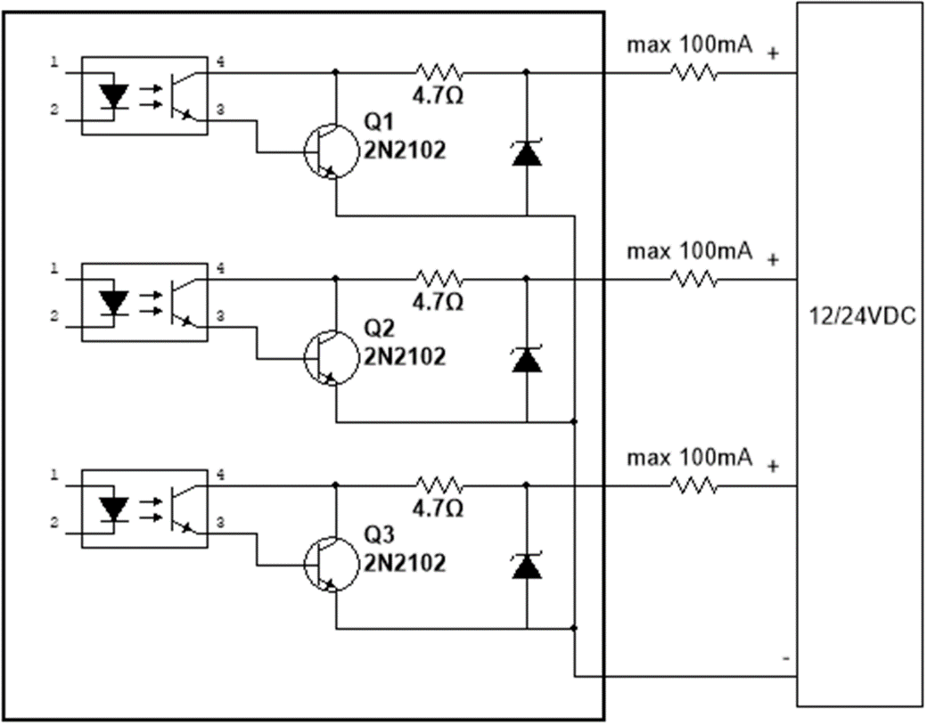
Figure ‎4-9.

C4 Wiring –– Fast Digital Output PCOM
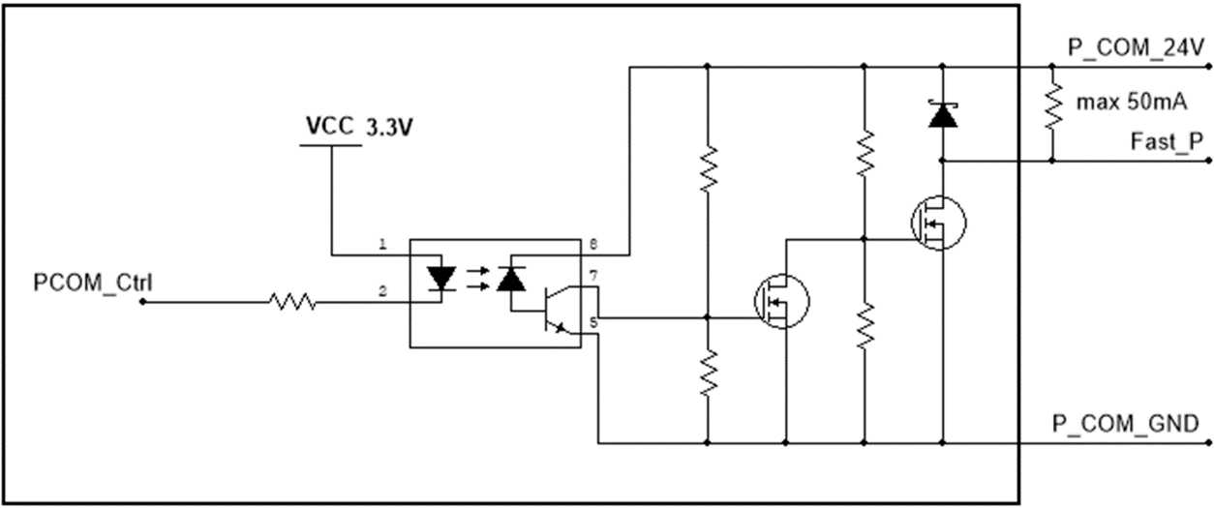
Figure ‎4-10.

C5 Interface – Encoder / Motor Feedback
The interface supplies power to the motor encoder.
The connection supports AB incremental encoders and absolute BiSS-C encoders.

C5 Pinout
Figure ‎4-11. Interface C5
Table 5-6. Interface C5
Pin | Name | Description
1 | Encoder_5V | Encoder power supply 5V
2 | GND | Encoder power supply GND
3 | A+/CLK+ | ABZ encoder A channel – differential positive  or  ABS encoder Clock – differential positive
4 | A-/CLK- | ABZ encoder A channel – differential negative  or  ABS encoder Clock – differential negative
5 | B+/DATA+ | ABZ encoder B channel – differential positive  or  ABS encoder Data – differential positive
6 | B-/DATA- | ABZ encoder B channel – differential negative  or  ABS encoder Data – differential negative
7 | Z+ | ABZ encoder Z channel – differential positive
8 | Z- | ABZ encoder Z channel – differential negative
9 | NC | not connected
10 | NC | not connected

Description | 10 pin 1394 connector
Mating connector | WCON-Dongguan: 6131-10FS0BAGA1

C5 Wiring – Motor Feedback
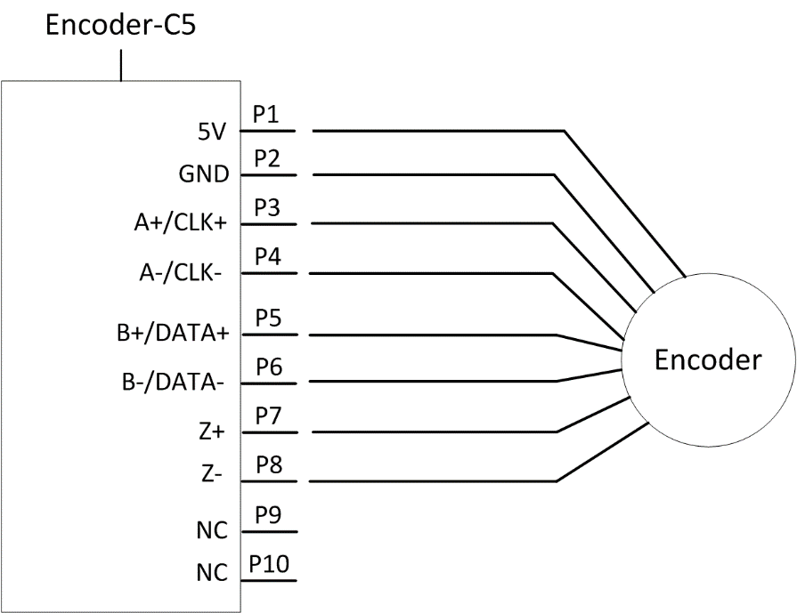
Figure ‎4-12.

C6 Interface – Gantry

C6 Pinout
Figure ‎4-13. Interface C6
Table 5-7. Interface C6
Pin | Name | Description
1 | FSI_TX0_CLK_P | Gantry drive transmit – Clock differential – Positive
2 | FSI_TX0_CLK_N | Gantry drive transmit – Clock differential – Negative
3 | FSI_TX0_D0_P | Gantry drive transmit – Data differential – Positive
4 | FSI_TX0_D0_N | Gantry drive transmit – Data differential – Negative
5 | FSI_RX1_CLK_P | Gantry receive – Clock differential – Positive
6 | FSI_RX1_CLK_N | Gantry receive – Clock differential – Negative
7 | FSI_RX1_D0_P | Gantry receive – Data differential – Positive
8 | FSI_RX1_D0_N | Gantry receive – Data differential – Negative

Description | 8-pin Micro connector
Mating connector | WCON-Dongguan: 6362-08MDHSXMCBA1

C6 Wiring
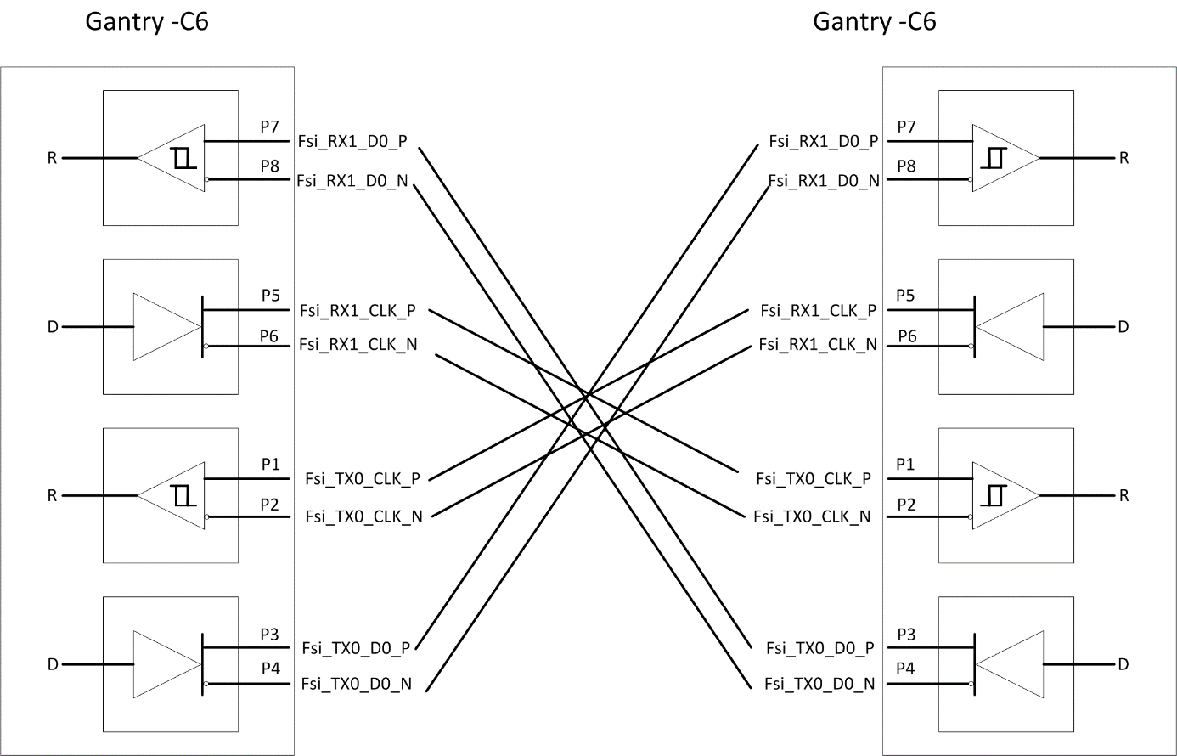
Figure ‎4-14. Interface C6

ServoStudio+ Software

Software Installation
ServoStudio+ is compatible with Windows 10 and later operating systems. If you require assistance with an older version of Windows, contact Servotronix Technical Support.
Download the ServoStudio+ software installation file from the Servotronix website, or contact Technical Support.
Run the file.

Activation
- Activate ServoStudio+ from the desktop icon or the Start menu.
- ServoStudio+ opens to the home screen.
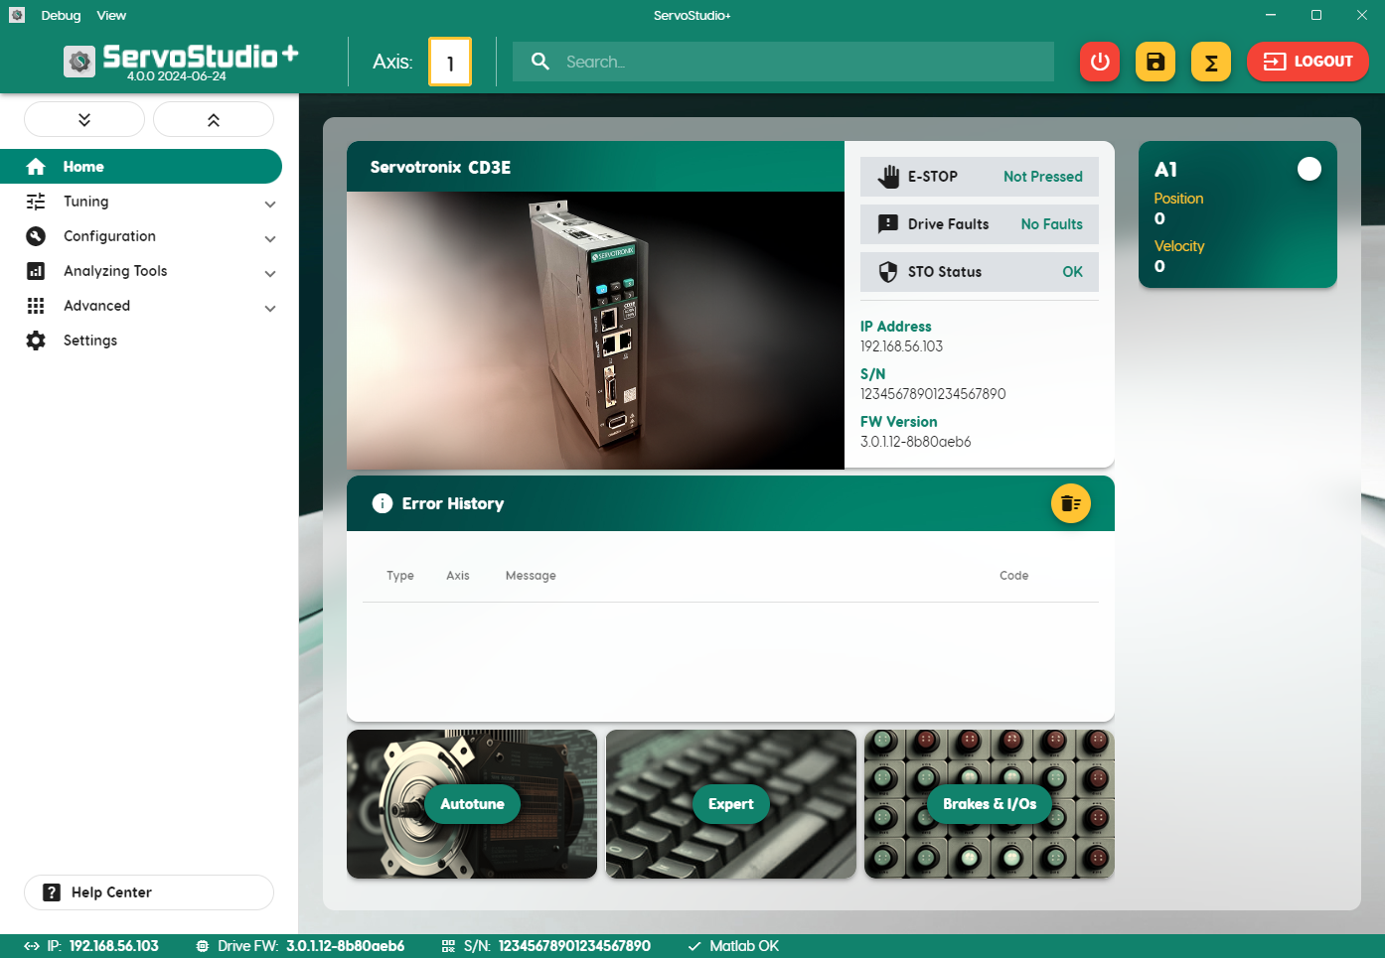
Figure ‎7-1. Home screen
The axis should be disabled during the basic configuration. If the axis icon is lit (green), it indicates the axis is enabled.
To disable the axis, do either of the following:
- Click the enable/disable button (the POWER icon) in the toolbar at the top of the ServoStudio+ window.
- Click the axis number in the toolbar. Then use the axis toggle button in the axes pane.
Axis color | Meaning
White | Axis disabled
Green | Axis enabled
Yellow | Axis disabled with a warning
Red | Axis disabled with a fault
Green/Yellow split | Axis enabled, with a warning

- Open the ServoStudio+ navigation menu.
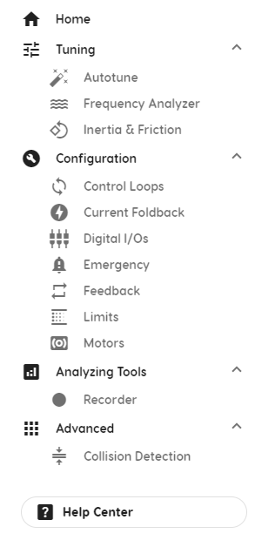
Figure ‎7-2. Navigation menu

Parameter Values
The first time a new drive is connected to ServoStudio+, the software displays the drive’s factory-defined (default) parameter values.
ServoStudio+ reads and displays values from the drive RAM.
- After you edit a parameter value, press Enter, or press Tab to move the next field. The new value is sent to the drive RAM, and an update message is displayed.
- To save parameter values to the drive’s non-volatile memory at any time, press the Save button on the ServoStudio+ toolbar. If not saved, modified parameter values are lost upon power cycle.

Basic Drive Configuration
This chapter describes the main steps for configuring the drive system using the ServoStudio+ interface. Depending on your specific drive model and configuration requirements, you might need to configure additional parameters or use other features in ServoStudio+.

Motors
Use the Motors screen to select a motor from ServoStudio+ databases. When you select the motor family and model, ServoStudio+ sets the appropriate motor and feedback parameters.
ServoStudio+ contains two databases of motor settings.
- The ServoStudio+ library contains a database of motors already defined and supported by Servotronix. These motor settings cannot be modified by users.
- The User library contains all other motors defined by users.

Load Motor Parameters
To load a set of motor parameters:
- In ServoStudio+, select Configuration > Motors.
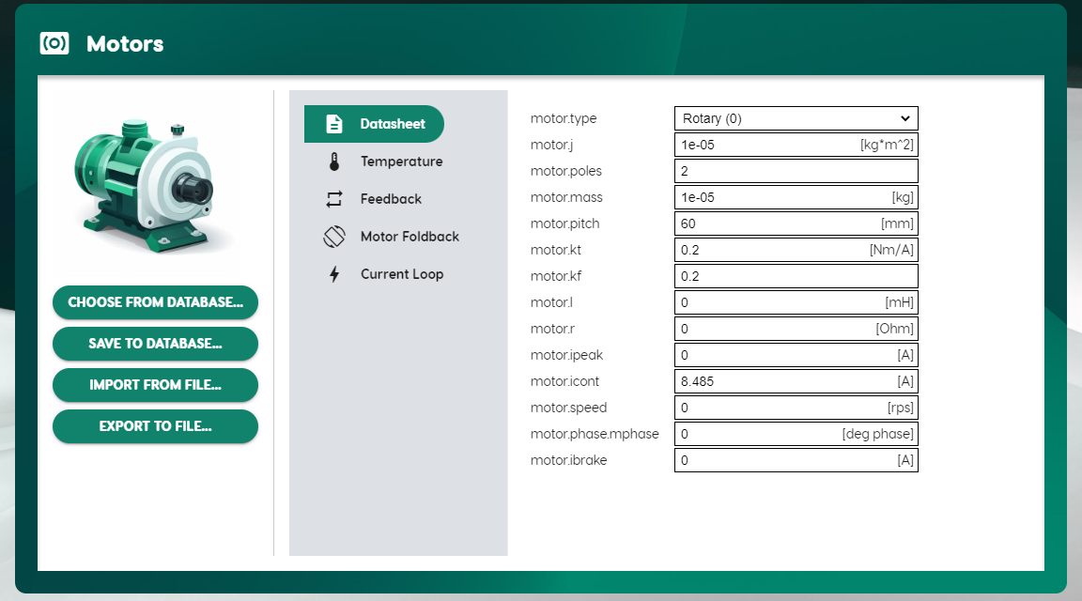
Figure 7-1. Motors
Choose from Database | Opens a menu that lets you select a motor from either the ServoStudio+ database or the User library.  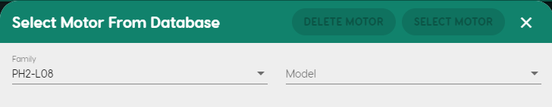  Family.  Predefined. ServoStudio+ has a number of databases containing predefined sets of parameters for motors.  User Motors contains a list of motors whose parameter sets have been created by the user, either by modifying a predefined set, or by defining an entirely new set of parameters for a motor.  Model.  A list of all models in the selected Motor Family that have a predefined set of parameters in ServoStudio+. After choosing the motor, press Select Motor to write this motor’s parameter set to the drive.
Import from File | Prompts you to load motor parameters to ServoStudio+ from a JSON file.

- Select an axis from the menu bar at the top of the ServoStudio+ screen.
- Select a motor from one of the ServoStudio+ motor libraries.
- Select Choose from Database.
- Select a motor from the Family and Model lists.
Alternately, select a motor parameter file.
- Select Import from File.
- Select the JSON file containing the required motor parameters.
ServoStudio+ loads and displays the appropriate motor and feedback parameters.
- Repeat for each axis.

Modify Motor Parameters
To modify parameter values:
- Click in a parameter field, and enter a new value.
The modified field is highlighted, and you are prompted to save or discard the changes.
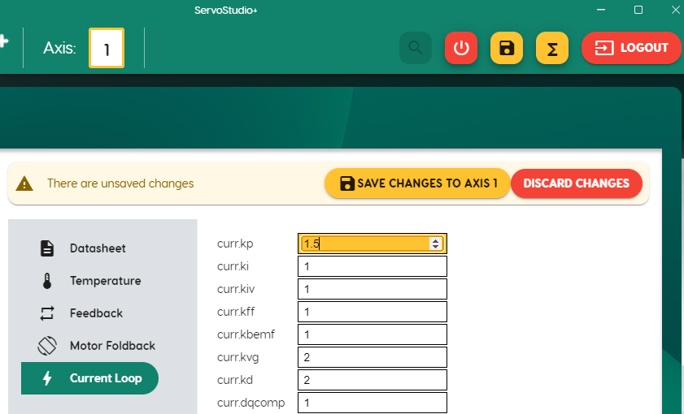
Figure 7-2. Save changes to axis (saves parameter in drive)
- Select Save Changes to Axis n.
Save Changes writes the new parameter values to the drive, but does not save the parameter values to the database or a file.

Copy Parameter Values to Another Motor
To copy parameter values from one motor to another:
- With modified parameter fields highlighted, select the number of the axis you want to copy to.
- Select Save Changes to Axis.

Save Motor Parameters
Save to Database | Saves motor parameter settings to the database. Does not write to the drive.  - New. When modifying parameter values of a motor in the ServoStudio+ motor library, you can save the changes only by defining a new motor in the User library.  - Replace Existing. You can overwrite a file in the User library.  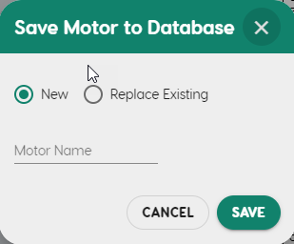
Export to File | Prompts you to save motor parameters from ServoStudio+ to a JSON file.

Motor Brakes
Use the Brakes pane in the Digital I/Os screen to activate brake functionality and to monitor the state of all brakes.
ServoStudio+ displays the actual number of brakes connected to the drive, as configured in the drive firmware.
Motor brakes are controlled by dedicated outputs, as configured in the drive firmware.
- In ServoStudio+, select Configuration > Digital I/Os.
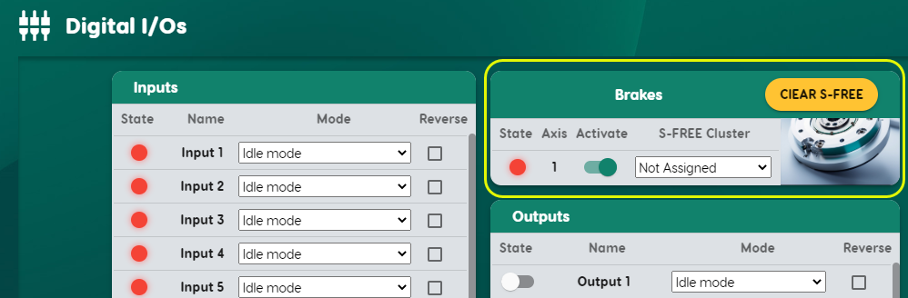
Figure 7-3. Brakes
- In the Brakes pane, use the toggle button to activate the brake functionality for the axis.

Limits
Use the Limits screen to view and set parameters for position limits, velocity limits and your application’s current limit.
- In ServoStudio+, select Configuration > Limits.
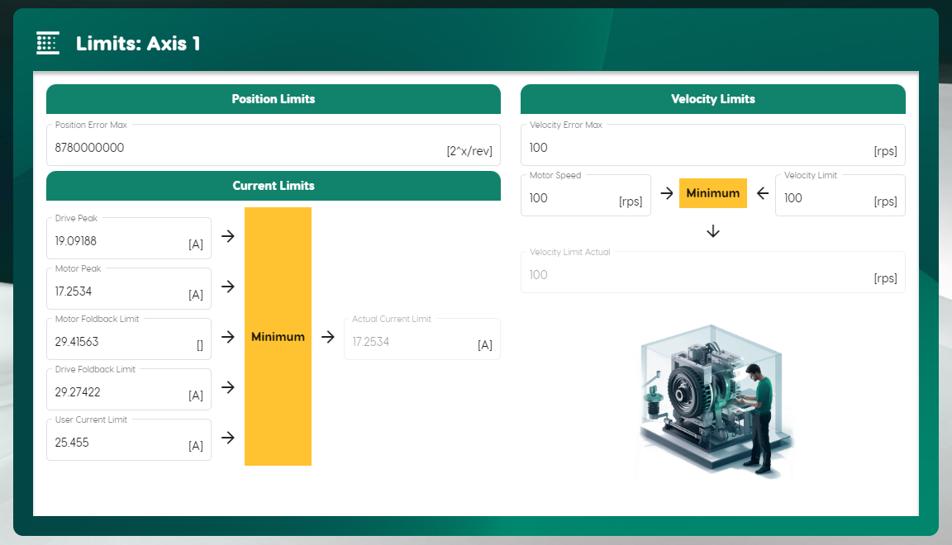
Figure 7-4. Limits
In the Limits screen, confirm and/or configure the position, velocity and current limits as required by your application.
Position Limits
Position Error Max | The maximum position error value that does not produce a fault for the axis.
Velocity Limits
Velocity Error Max | The maximum velocity error value that does not produce a fault.
Motor Speed | The maximum motor speed, according to the motor datasheet.
Velocity Limit | The maximum (user-defined) velocity limit for the application.
Actual Velocity Limit | Read only. The actual velocity limit for the application, which is the lowest (minimum) value of all velocity limit inputs, such as motor speed and velocity limit (user limit).
Current
Drive Peak (Max) | The peak (maximum) current of the axis.
Motor Peak (Max) | The peak (maximum) current of the motor, according to the motor datasheet.
Motor Foldback Limit | Motor foldback current limit
Drive Foldback Limit | Drive foldback current limit.
User Current Limit | The maximum (user-defined) current limit for the application.
Actual Current Limit | Read only. The actual current limit for the application. This value is the lowest (minimum) value of all current limit inputs, such as drive peak, motor peak, and current limit (user limit).  The default Current Limit Actual is determined by the parameters in the motor library.

Save Configuration
After completing your configuration, click the Save button on the ServoStudio+ toolbar to save all parameter values to the drive’s non-volatile memory.
If not saved, modified parameter values are lost during a power cycle (reboot) of the drive. Saved parameters are restored when drive is powered on.
Refer to section Parameter Values.

Autotune the Drive
Caution! Tuning is potentially dangerous. Before starting any tuning routines, make sure there are no persons or obstructions within the motion envelope. Also make sure the emergency stop button is within your reach.

Autotuning serves to tune the drive’s velocity and position controllers, such that good performance and quiet operation is achieved with minimal user input.
The autotuning process performs repeated back-and-forth trapezoidal motion profiles while monitoring performance metrics such as current command noise level and position error settling time, and adjusting drive control parameters incrementally between each motion.
The autotuning process has three main stages:
- The first stage is setting an appropriate trapezoidal motion profile. The profile requires an acceleration/deceleration value that generates an actual peak current that is adequate for operation; that is, higher than the motor continuous (rated) current, and lower than the motor peak current.
- The second stage is estimating values of unknown mechanical parameters: LMJR, static friction, dynamic friction, and (optionally) resonance frequency. These values are used for tuning the control parameters according to a motor-load model.
- The third stage is tuning the control gains and filters in order to reach an optimal compromise between tracking performance and robust and quiet operation. This is achieved through trial and error; that is, performing a motion, observing the results, and incrementally adjusting parameters while keeping track of the values that produce the best results.
During autotuning, the drive moves the motor back and forth repeatedly using the trapezoidal profile.
- In ServoStudio+, select Tuning > Autotune.
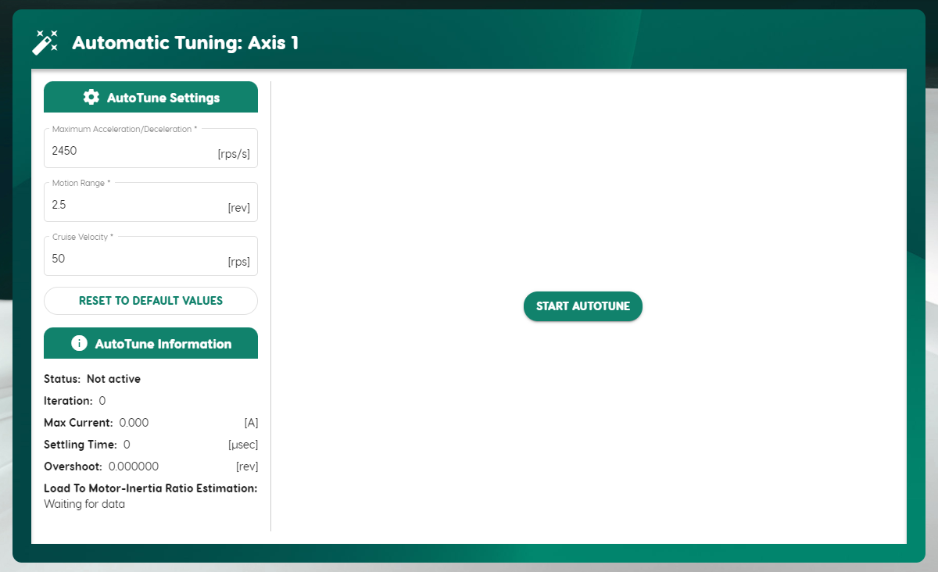
Figure 7-5. Autotuning
- Make sure the displayed values in Autotune Settings are suitable for your application.
Maximum Acceleration/ Deceleration | Maximum acceleration/deceleration value during autotuning.
Motion Range | Number of motor revolutions during autotuning.
Cruise Velocity | Speed during autotuning.

- Select Start Autotune. Confirm the prompts.

Test and Evalute
- When autotuning is complete, view the results on the graph.
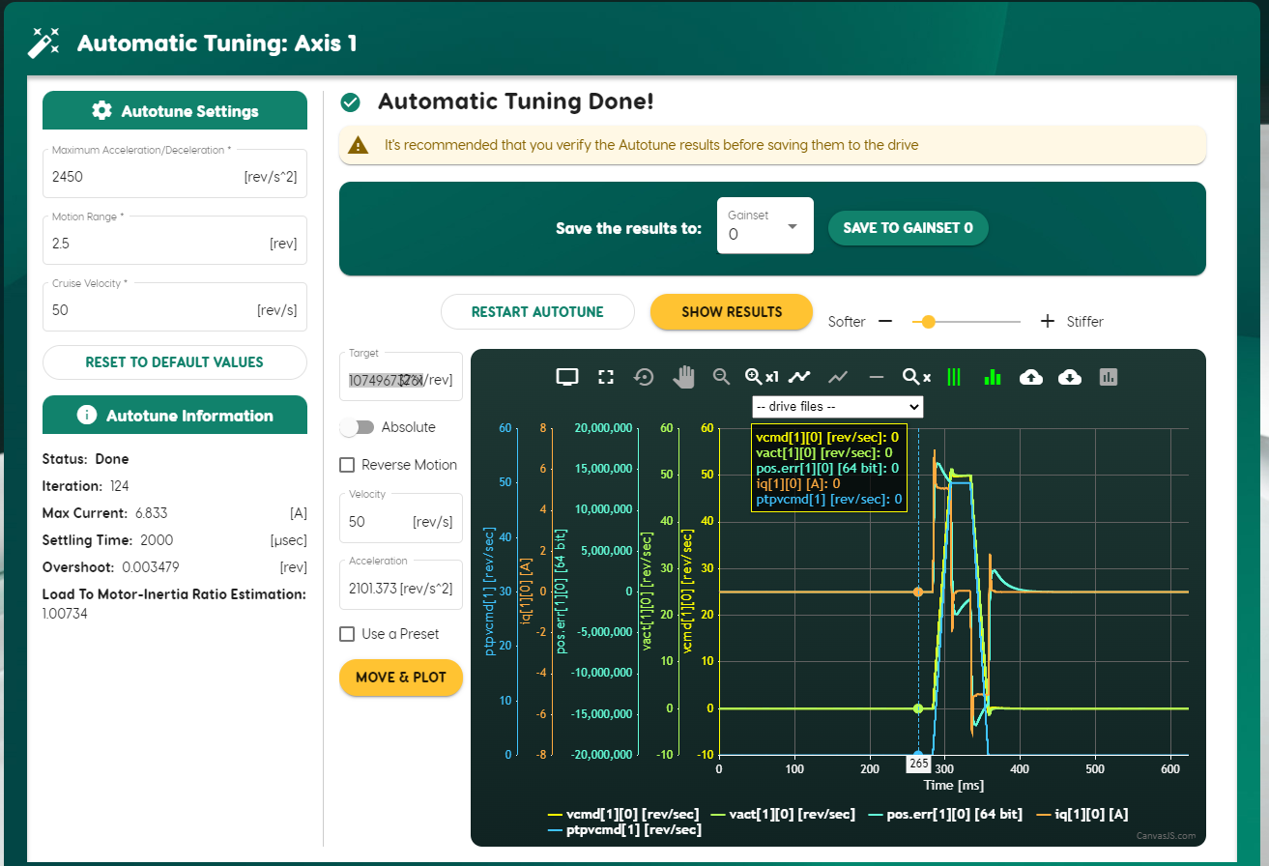
Figure 7-6. Autotuning test results
- If the results are not satisfactory, modify the settings and/or use the Softer/Stiffer slider to adjust the controller performance.
- If necessary, restart the autotuning process.
- When you are satisfied with the Autotuning test results, save the parameters to the drive.
- You can then proceed to optimize drive parameters for your particular application.
- Use the Analyzing Tools and the Recorder feature to test and validate your drive configuration under real operating conditions.
- Adjust any parameters as necessary based on your observations.

Drive Status

Operator Panel and LED Display
The CD3E 5-digit display provides indications of drive status, such as operation modes, drive enable status, warnings, and fault conditions.

Digit 5 | DP | Digit 4 | DP | Digit 3 | DP | Digit 2 | DP | Digit 1 | DP
Figure 8-1. 5-digit LED display panel
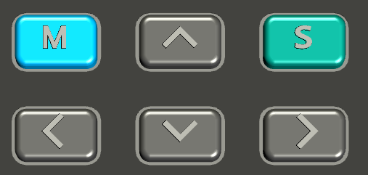
Figure 8-2. Operator panel control keys
Key | Name | Function
M (mode) | Short press | Switches to next panel display mode (Status > Parameter > Command > Monitor > Fault > Status).  While editing, cancels the edited value and returns to mode menu.
S (set) | Short press | Sets the entered value or parameter number.
Up arrow | Short press | Selects and increases the value of digit (value or parameter number).
Up arrow | Long press | Increases the value rapidly.
Down arrow | Short press | Selects and decreases the value of digit (value or parameter number).
Down arrow | Long press | Decreases the value rapidly.
Left arrow | Short press | Moves the cursor one digit to the left.
Right arrow | Short press | Moves the cursor one digit to the right.

Operator Panel Modes
Use the M button to scroll through the display modes.
The operator panel has several modes:
Status (S) | S | Indicates the drive’s operating mode.
Status (S) | HH | Homing mode
Status (S) | CP | Cyclic Synchronous Position mode
Status (S) | CT | Cyclic Synchronous Torque mode
Status (S) | 00 | Velocity control mode, using serial commands
Status (S) | 02 | Torque control mode, using serial commands
Status (S) | 08 | Position control mode, using serial commands
Warnings | A | Indicates a warning.  Displays the 4 digits of a CANopen error code, as defined in CiA402*.
Faults | E | Indicates a fault.  Displays the 4 digits of a CANopen error code, as defined in CiA402*.
* CiA 402-2, Version 5.0.0, February 6, 2024 (Table 25)

